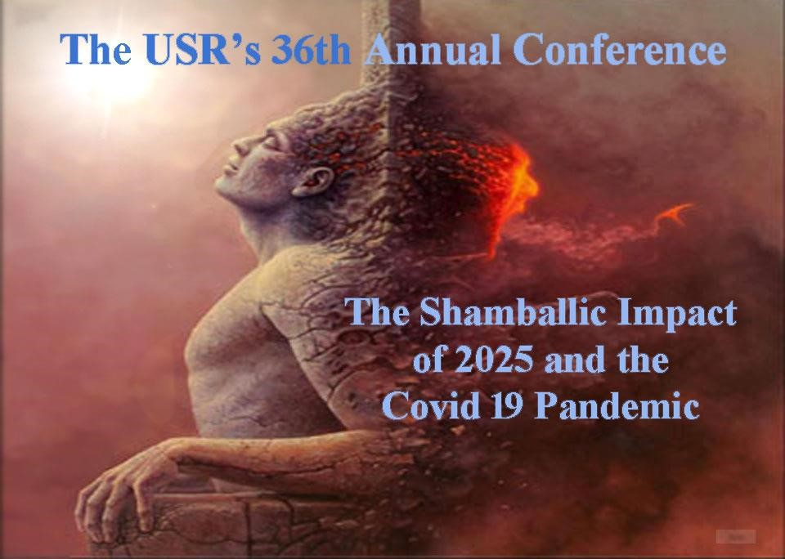
Artist unknown

COVID-19 AND THE AGELESS WISDOM TEACHINGS

A GUIDE TO THE ESOTERIC UNDERSTANDING OF THE COVID 19 PANDEMIC AND ITS RELATIONSHIP TO ESOTERIC HEALING

By Duane Carpenter
© 2022
edited and compiled by Vicktorya Stone
Part I Medical Science and Occult Science

THE ONLY CURE FOR MAGNETIC CORRUPTION IS PURIFICATORY FIRE
A Treatise on Cosmic Fire, p. 838

The title image symbolically summarizes the whole process of what Master Djwhal Khul terms invocation and evocation. [The Master DK is also referred to as The Tibetan, for whom Alice A. Bailey is the amanuensis.] All quotes that are not otherwise indicated are from the books by DK, all published under Alice Bailey’s name, by Lucis Publishing Companies.] See complete works by Alice A. Bailey online here: https://drive.google.com/file/d/1IYN8ZINsD534y5dKPBuhgQUecdM1wYa4/view?fbclid=I wAR14msZQheSGKBRK5oheWAxJbKfF_IA4NDJRrxUkTz9VMEIZATmtniqEc5Q
This process of invocation and evocation is found in these writings on the six stages of building the rainbow bridge, or antahkarana. This process builds the true natural immunity conferred to the student from above, downwards, and not simply from below upwards. (All other approaches we examine may fall into a lesser and more peripheral category.)
When the solar fires descend into the auric field of a student, and are grounded in the physical-etheric body, the lunar elementals, under the law of sacrifice, are eventually transmuted into their higher spiritual correspondences. Alternately, these elementals are driven out of the auric sheathes to be dealt with at a later period when the true laws of transmutation and radiatory substitution are better understood.

INTRODUCTION
I have stayed out of the political controversies in the esoteric community, avoiding them because they often distract the student from more important spiritual work that must be accomplished at this time. It is important to understand what the masters of the ageless wisdom may have stated over the centuries on this subject. If what the masters and initiates have to say stirs up controversy, then this point of tension may be necessary and creative for additional light to be thrown upon COVID-19.
This outline is an attempt to expose some seminal truths, which have been either distorted by certain members of the greater occult group, or simply overlooked out of ignorance. If students of the ageless wisdom teachings want to argue or undermine these priceless teachings, they do so at their own risk and will surely be responsible at some point for their karmic oversights.
If we find strong and diverse opinions about what we already think, which makes us feel uncomfortable or which are annoying, imagine if it was costing you your job? What if your reputation was at stake? Your financial security? New ideas and insights can actually be creative if we are willing to rethink some of our habitual beliefs and opinions. Self-care and self-preservation are very important, as well as numerous other service activities that we may have chosen. But, if you find spiritual controversy stressful, and you want everyone in the spiritual community to just get along, is it possible you may not see a bigger picture or a more inclusive whole?
There are people literally fighting for survival, and having their personal and professional lives destroyed now in order to defend your right to think freely and make your own choices. We must take care that we never abuse this honor and privilege of upholding what is true and should be considered our natural rights. While many may see this commentary as an attack upon sacred institutions, or a tearing down of what has existed for centuries and worked well, in spite of obvious flaws, the real motivation behind this commentary is, however, really quite different. My goal is based upon the need to improve and change that which is broken and clearly needs rehabilitation and correction.
There is never change without its attending discomforts, and this is particularly relevant in the realms of spiritual energy and force – where change is constant. Sacrifices are demanded from all disciples historically, and now, in new and dynamic ways.
Part of that sacrifice may be taking the time to read this commentary and others like it.
The Masters, therefore, Who are endeavoring to sound the note that is needed for the new age have to look for two things in Their instruments: First, ability to hear the note, and capacity to vision the new ideal; and secondly, a certain tough fighting spirit and a certain willingness to be peculiar and to be considered unique which is to be found as a general rule only in those of a peculiar make-up and temperament, of a certain eccentricity of outlook, and of certain original views. Could this combination be found in the conservative normal man or woman, gladly would they be employed, but their very conservatism forms a barrier…

An extract from Spiritual Leadership, by Alice A. Bailey, reprinted from The Beacon, November 1925

We have therefore been asked by the masters of wisdom to stop periodically in our service work and question if there may be new and better ways to serve humanity. We are asked to break away from well-worn avenues of repetitious habit and behavior, which for all of their value and goodness can, and should, be upgraded with newer and more advanced types of assistances to the masters.
Our financial stability, wealth, race, gender – as well as our standing in our spiritual communities to which we belong – can easily insulate us from a host of important subjects and different planetary crises that are now taking place. Privilege comes in many forms, and often allows one to live a life free from personal attacks, bigotry and false labeling. People often don’t want to get involved in any controversial subjects because it might upset their personal equilibrium, especially if it is not their lives or safety that may be at stake. If one man or woman, or a group, is marginalized in their struggle to understand the bigger picture, or preserve the integrity of a greater truth, we will all be affected by that, irrespective of our geographical distance or social brackets.
It is always difficult to bring up issues that rock the proverbial boat, or that bring any type of discomfort to friends, relatives, or partners, as well as spiritual co-workers where bonds have been established for many years, often lifetimes. The division over COVID19 vaccines has created a huge cleavage in many spiritual communities which should, by group law, be working together and trying to look at this problem with new eyes and interest, as well as taking into consideration what the masters have said on this important subject.
Recent scientific studies indicate that although creating a temporary boost in immunity, COVID-19 vaccines can ultimately compromise the immune system and hurt the health of the general public over an extended period of time.

Overview
Part 1 of this commentary will cover what the masters have said about viruses, disease, and vaccines. Part 2 is a detailed outline of why contemporary science and medicine has ignored this wisdom of the masters and what may be some of the limitations that are blocking a greater and more holistic view of the subject.
If the reader of this commentary peruses only the quotes by the Masters of Wisdom given here and disregards all the rest, they will get a seminal view of a much larger perspective which may contribute to their own healing and insulate them from the current danger of the COVID virus. All else is simply supportive information. If only ten percent of what is presented here is proven accurate, then humanity has much to do before the full impact of the externalization of the hierarchy and the Reappearance of the Christ can be more fully initiated and grounded.
The entire commentary that follows is based almost exclusively on these next two quotes given by Alice Bailey in her Unfinished Biography, and by Master DK in Esoteric Healing, which will set the stage for a more expanded view of the COVID-19 crises in which we are now engulfed.
I believe firmly that when I can, through the process of evolution, fully express the divinity that is in me I shall have perfect health.
Unfinished Autobiography, Alice A. Bailey, p. 38

You see, therefore, how medical science must eventually seek solution in a simplification of methods and a return from a complexity of drugs and operations to an understanding of the right use of the energies which pour through from the inner man, via the etheric body, to the physical.
Esoteric Healing, p. 109

The Treatise Esoteric Healing was written in the 1940s and remains to this day one of the most important outlines on the subject of the emergence of newer types of healing that have been used and recognized by initiates and spiritual disciples for centuries. These newer and more advanced types of healing have been attempting to emerge on a larger scale since the turn of this century (2000), and will begin to be slowly adopted by those in the mainstream medical professions as they become more illuminated and enlightened by the higher mind and spiritual intuition.
Regretfully, as we will demonstrate, the majority of medical professionals may have been manipulated and coerced into developing far less effective and inferior types of medicinal techniques in their attempts to deal with the COVID-19 pandemic, which they as yet cannot comprehend nor understand from an esoteric perspective.
The author of this paper is not randomly against all vaccines under all circumstances; however, these COVID-19 vaccines fall under a somewhat different category, as I will attempt to describe.
One of the main points of this outline is that vaccines may not be needed by those who have conformed to the requirements for advanced discipleship training and have faithfully followed the preventative measures outlined not only by DK, but many other qualified and advanced luminaries such as Aurobindo, Rudolf Steiner, Helena Roerich, as well as H. P. Blavatsky.
In fact, a vaccine administered to an occult body that is highly refined and adequately tuned to the sound, light, and radiance of the souls impulse, may actually have the opposite effect of healing and make them ill, because of known toxins contained in these new corona virus vaccines and that are distinctly different from previous vaccines.
To argue that disciples are so advanced and pure, that then these inoculations should have little effect on them is an argument based on a lack of information.
Unfortunately, little attention has been paid to the difference between organic toxins like the corona virus itself, and additional medicinal toxins that have been put into the vaccine to purportedly increase its effectiveness. This includes toxins like mercury and graphene, phosphates and propylene glycol, all of which are known to the medical profession, for years now, to cause irreversible harm to the human organism.
It is important that the reader recognize that the author of this commentary supports many of the advances in science and the medical profession, and acknowledges their many important contributions.
New research into the vaccines may reveal that they do in fact change the human genome. More on this important subject in a later section in this document. Also see here: https://www.fda.gov/vaccines-blood-biologics/safety-availabilityhttps://www.fda.gov/vaccines-blood-biologics/safety-availability-biologics/thimerosal-and-vaccinesbiologics/thimerosal-and-vaccines
To quote Rudolph Steiner, who was an initiate of some standing as well as an esoteric healer and medical doctor, he spoke extensively on pandemics and viruses and we will utilize his wisdom and insight:
Nothing will here be said against the bacterial theory which to a certain extent is very useful. In the various ways by which bacilli arise here or there one can naturally find out many things; for purposes of diagnoses one can generally get a lot of information. In no way do I want to say anything against official medicine, except that it needs to be augmented and developed further when it arrives at certain boundaries – and it can be developed further when the points of view of Anthroposophy can be applied to it. Steiner, Polarities in Health, GA 319

We acknowledge the importance and value of conventional medical knowledge, so well summed up in A. A. Bailey’s writings:
Academic medicine is the result of the God-given gifts of the human mind; it is a proven divine expression and a most beneficent force in the world, in spite of human weakness, commercial exploitation and many mistakes.
Esoteric Healing, p. 280

We will explore in this commentary some of these weaknesses and commercial exploitation that is presently slowing down the hierarchy’s progress of externalization of the ancient wisdom teachings, as well as thwarting the recognition of advanced healing techniques.

PLANETARY CRISIS THROUGH EMERGENCE OF COVID 19 PANDEMIC
In this next quote, Alice Bailey acknowledges the value of contemporary science in dealing with pandemics and that many pandemics can span long periods of time (fifty years) but with mixed results from any type of true scientific control. We must also consider that the present COVID vaccines that are now being administered are of a new and different variety and there use may create in the future unforeseen complications and difficulties that we will later explore.
Such epidemics have a serious effect upon the human race after the war cycle is over and after the consequent epidemic has spent itself. Humanity, particularly in Eastern Europe, had not completely recovered from the epidemics, incident to the first part of the world war, when the second part took place. The psychological effects continue; the scars and the results of the second phase of that world war will persist for fifty years, even though—owing to man's greater scientific knowledge—the epidemic factor may be kept surprisingly within bounds. This, however, still remains uncertain. “Time alone will demonstrate how successful humanity is in offsetting the penalties which outraged nature is apt to exact.
Esoteric Healing, p. 250

This previous quote was written in the late 1940s. Since wars have been a continuous plague on humanity for thousands if not millions of years, and there is a clear link esoterically speaking between wars and the psychic distress as well as ill health of the planet, one wonders how there can ever be any permanent healing and the subsequent eradication of plagues, viruses and diseases.
Even now as I write these sentences, the Russians have just invaded the Ukraine (2/25/2022) with many causalities amassing on both sides. It is common knowledge that viruses, pandemics and flus spread lethally in the cramped conditions that soldiers experience such as a lack of good nutrition, clean water, as well as the continuous exposure to numerous chemicals and toxins.
The COVID-19 pandemic, if viewed from another esoteric point of view, indicates that humanity is now undergoing a huge crises both materially and spiritually, and all indications are that this COVID-19 pandemic is part of a greater purging and purification of not just man but the entire planet itself. The environmental crises and global warming and pollution that is emerging historically in its full devastation is clearly the result of a number of factors, ignorance, human greed and mismanagement of the planets natural resources being one of the most important.
(For a deeper occult inquiry see commentary titled Solar Minimums by the author for additional information and his recent Power Point presentation given at the University of the Seven Rays 36th annual conference, The Shamballic Impact of 2025 and the Covid
19 Pandemic. This can also be found at the University of Seven Rays’ Makara site; https://makara.us.)
These unfortunate facts will only be remedied by a group of souls pouring into the planet who understand the complexity of the problems and new and alternative solutions of healing that must be implemented. These new methods must not just be motivated by some new, utopian ideals, but because the members of this group see the clear connection between cause and effect, as well as mind and matter.
The older generations have created planetary crises through their mismanagement of the world’s resources that they cannot understand and refuse to acknowledge, hence they cannot help eliminate these issue we are outlining.

The New Laws of Health
A readjustment of the medical knowledge of man, resulting in a truer understanding of the physical body, of its treatment, and of its protection, and thus producing a juster apprehension of the laws of health. The aim of the physician will then be to find out what it is in a man's life which is preventing egoic energy from flooding every part of his being; to find out what lines of thought are being indulged in which are causing that inertia of the will aspect which is so conducive to wrongdoing; to ascertain what it is in the emotional body which is affecting the nervous system, and thus obstructing the flow of energy from the love petals of the egoic lotus (via the astral permanent atom) to the astral body, and from thence to the nervous system; to discover what is the hindrance in the etheric body which is preventing the right flow of prana, or of solar vitality to every part of the body.
It is essential that in days to come medical men should realise that disease in the physical body is incidental to wrong internal conditions. This is already being somewhat considered but the whole question will remain but a beautiful theory (even though an incontrovertible one in view of the achievements of mental scientists and of the various faith healers) until the true nature of the spiritual ego, its constitution, its powers, and its field of influence are duly apprehended.
This revelation will come when medical men accept this teaching as a working hypothesis, and then begin to note, for instance, the powers of endurance shown by the great souls of the earth, and their capacity to work at high pressure, and to remain practically immune from disease until (at the close of a long life of usefulness) the Ego deliberately chooses to "die-out" of physical existence. It will come when the medical profession concentrates upon preventative action, substituting sunshine, a vegetarian diet, and the application of the laws of magnetic vibration and vitality for the present regimen of drugs and surgical operations. Then will come the time when finer and better human beings will manifest on earth. When also physicians learn the nature of the etheric body, and the work of the spleen* (see chart of spleen) as a focal point for pranic emanations, then sound principles and methods will be introduced which will do away with such diseases as tuberculosis, debility, malnutrition and the diseases of the blood and of the kidneys.
When doctors comprehend the effect of the emotions upon the nervous system, they will turn their attention to the amelioration of environal conditions, and will study the effects of the emotional currents upon the fluids of the body, and primarily upon the great nerve centres, and the spinal column. When the connection between the dense physical and the subtler bodies is a fact established in medical circles, then will the right treatment of lunacy, [see suicides as first category of death in the USA], of obsessions, and of wrong mental conditions be better comprehended, and the results more successful; finally, when the nature of egoic force, or of energy is studied, and the function of the physical brain as the transmitter of egoic intent is better comprehended, then the coordination of man's entire being will be studied, and illness, debility and disease, will be traced to their just cause, and will be treated through the cause and not just through the effect. Esoteric Healing, pp. 812-813

I am concerned with diseases arising in wrong internal conditions.
Esoteric Healing, p. 182

It must always be remembered that the etheric body is a physical body, though composed of subtler material than the one we can see and touch. It is made of substance or of that which "substands," or underlies, every part and particle of the dense physical vehicle. This is a point which will later receive attention from healers and from enlightened medical men in the New Age. When this relationship existing between the nadis and the nerves, and their joint relationship to the centres and spinal column is recognised, we shall see a great revolution in medical and psychiatric methods. Experience will tend to show that the more closely the interplay between these two—the nadis and the nerves—can be brought about, the more rapidly will the control of disease also be implemented.
Esoteric Healing, p. 197

Developing Natural Immunity through Activation of the Vital Body
Medical men in the New Age will eventually know enough to relate these various ray forces to their appropriate centers; hence they will know which type of force is responsible for conditions— good or bad—in any particular area of the body. Some day, when more research and investigation have been carried forward, the science of medicine will be built upon the fact of the vital body and its constituent energies. It will then be discovered that this science will be far simpler and less complicated than present medical science. Today, medicine has reached such a point of complexity that specialists have perforce been needed who can deal with one area of the body and with its effect upon the entire physical vehicle. The average general practitioner cannot cope with the mass of detailed knowledge now gathered in the physical body, its various systems, their interrelation and their effect upon the many organisms which constitute the whole man. Surgery will remain occupied with the anatomical necessities of the human frame; medicine will shift its focus of attention, before long, to the etheric body and its incident circulatory systems of energy, its interlocking relationships and the flow between the seven centres, between the centres themselves and the areas which they control. This will mark a tremendous advance in wise and useful approach; it will produce a basic simplification; it will lead to more correct methods of healing.
Esoteric Healing, pp. 274-278

[See figure 1]

To hear the note and to then sound that note requires an ability to first tune what DK called the inner or etheric ear. This internal hearing leads the student to the recognition of the personality note, and later the soul note (the Lost Word), and assists in allowing those groups of advanced devas to pour unimpeded through the different centers or vehicles purifying and throwing out older elemental substance that brings illness and disease. This building in and throwing out of lower grades of elemental substance will be addressed in a later section of this commentary.
See Devas, parts 1 and 2, by the author: http://www.light-weaver.com/content/devas-part-1 http://www.light-weaver.com/content/devas-part-2

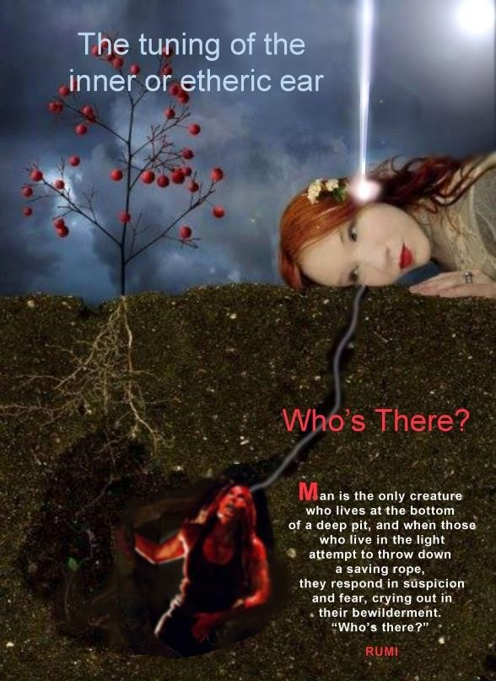
artist unknown

In this understanding and pursuit to more perfect health and a stronger and more robust immune system it is important to recognize that there are seven different ray approaches to human healing as outlined by Alice Bailey on page 706 in A Treatise on Esoteric Healing.
We can however add to those seven categories three additional types of receptivity that relate to the three primary spiritual rays. Ray 1 deals more with the disciple’s receptivity to internal sound; ray 2, with receptivity to internal light and color; and ray 3, receptivity to vibrations felt in one or other of the different centers or auric sheaths. It is also not usual for disciples to experience other secondary attributes found in the other two, along with their primary source of ray contact with the soul.
Alice Bailey gives us additional information about the importance of the etheric body and its relationship to the physical brain, as well as the etheric brain, in the next quote that we will explore.
Scientists will learn how to scientifically stimulate the matter of the etheric brain to make the physical brain receptive to higher truths.
A Treatise on Cosmic Fire, p. 441

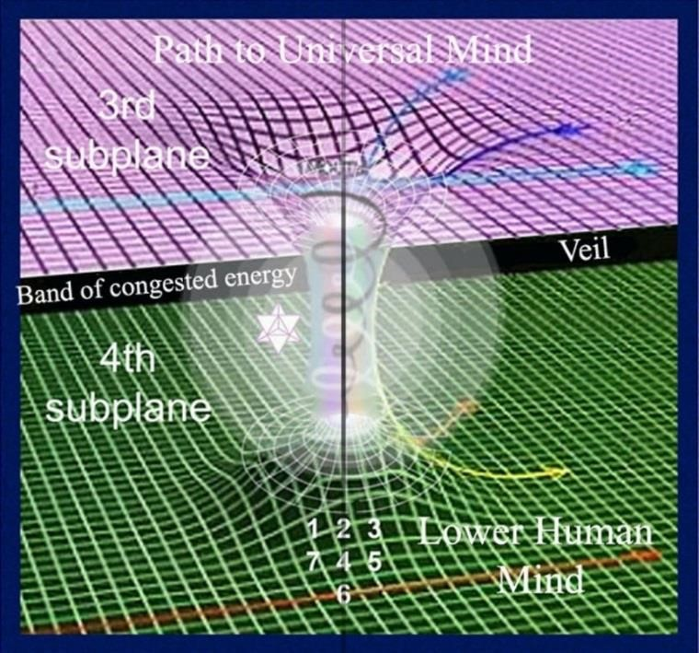
The gap between the physical and etheric plane and the lower and higher mind

The diagram above is a generic demonstration of the crossover place from the fourth subplane of the mental plane (counting from below up) to the higher three subplanes. This crossover point or bridge is where average humanity, operating on the lower three subplanes, moves up and over to a more spiritual orientation.
[The crossover points are not shown in the image above; see figure 4 to view the bridges between higher and lower.]
The fourth subplane of the mental plane is where the average person becomes an aspirant to the spiritual mysteries, as outlined in DK’s teachings in his many books. The three higher subplanes are the gateway to the higher initiations. Until this bridge is built from the three lower subplanes to the three higher subplanes of the mental plane, one should consider themselves a prisoner of the planet, according to DK.
This chart also gives us an idea of the difference between the concrete brain, which operates on the lower subplanes of the mental plane, and the etheric brain, which when receptive to higher impressions acts as an intermediary between the lower and higher principals in man.
DK stated when outlining the work of the fifth Kumara, also known as the Lord of the seventh that:
He works, therefore, through the etheric body of all forms and it is through His inflowing force that we may look for that increased stimulation of the matter of the etheric brain which will make the physical brain receptive to the higher revealing truth, and will put into the hands of scientists the secrets of the fourth and third ethers… we may look to see the mind of man assume proportions, and attain achievement, as yet unthought and undreamt.
A Treatise on Cosmic Fire, p. 442

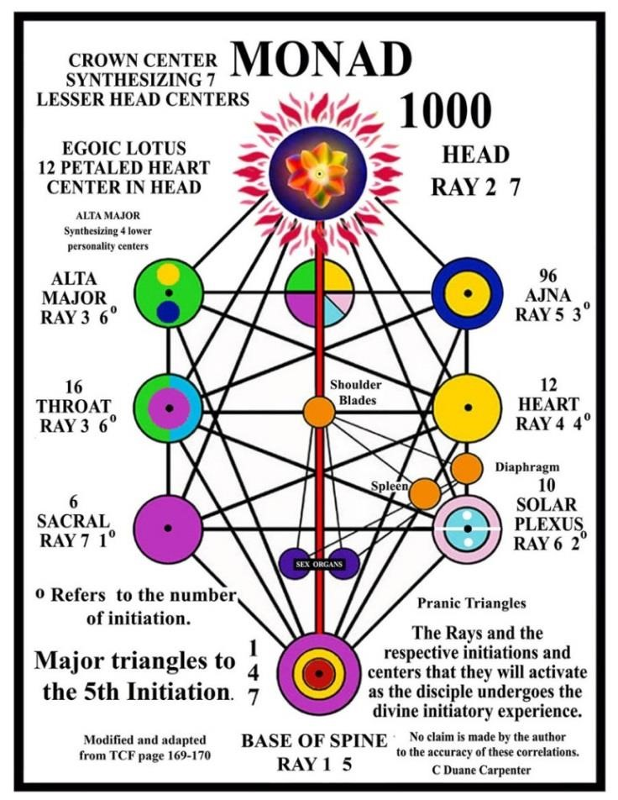
figure 1
Centers and Triangles

THE SPLEEN IS A FEEDER OF THE KUNDALINI FIRE
Note in figure 1, that the lesser etheric triangles between the sexual organs, the spleen, the diaphragm, and the center between the shoulder blades constitute triangles of force, which circulate etheric energy on the lower levels of the human constitution. The spleen, when highly charged and circulating its etheric force correctly through these lesser centers becomes instrumental in activating the kundalini fire at an advanced stage on the path.
When properly activated, these minor centers bring a condition of good health, and also constitute at the third initiation the galvanizing power or etheric potency that is necessary, along with a combination of other forces, to properly activate the kundalini fire. This fire can be tentatively felt stirring at the first and second initiations, but reach their full potency and power from between the third and fifth initiations.
Only a disciple who has activated this kundalini fire in its higher aspect can claim to be a true Agni Yogi which is so extensively outlined by Helena Roerich’s writing as well as DK’s, because it is only then that the three higher head centers seen in the chart above are activated and can now work in collaboration and unity with the Will, Love and Active Intelligence of God.
Although strict celibacy is never a requirement for spiritual growth, and is even warned against in the ageless wisdom teachings, this etheric force can be dissipated during physical orgasm. When this etheric energy we are discussing can be dammed up or held in an elevated charged state, it can flood the entire etheric body with highly vitalized healing energy which can assist in both grounding higher causal forces as well as charging the immune system with healing energy. This highly attuned etheric body is the students first line of defense from debilitating diseases of every conceivable type.
These higher initiations referred to may lie far ahead for most disciples at this time, but the etheric counterpart to initiation should be better grasped and understood for optimal physical health.

“GATHERING IN OF THE ARHATS”
We are now entering a historical period of what DK called the Gathering in of the Arhats and is a period similar to the time of the Buddha where there is a drawing in of those who have come into incarnation to take the third initiation.
This activation of 1st and 7th ray fire, through Uranus as well as the constellation Draco, assists along with other important star systems in raising the kundalini fire from its lower placement at the base of the spine up to the higher head centers in those who have done the preparatory work. In contradistinction, the pouring in of these powerful 1st and 7th ray forces will have a tendency to over-stimulate the sacral centers in average humanity and lead to an abnormal and exaggerated activity of that sexual center.
Figure 1 above (centers and triangles) is a chart constructed from information provided by DK (A Treatise on Cosmic Fire, pp. 169-170) on the primary triangles that must be linked, and force circulating around the three points of that triangle for the students to advance on the path of initiation. All the major triangles between the first and fifth initiations are provided. Each center below the diaphragm has a higher corresponding center in which this lower energy can be lifted by correct visualization techniques for initiation to scientifically to take place. It is in the circulation of healing energy around the three points of each triangle that eventually brings perfect health and natural immunity to the practitioner.
Color, sound, and sacred geometry are all aspects of spiritual vibration and are all important considerations in this purification process of lifting the lower into the higher. This is how lower elemental substance, which can be considered involutionary, becomes the primary cause of illness and disease in the world at this time.
The forces seated below the diaphragm can only be lifted into their higher correspondences seated above the diaphragm when the proper techniques are initiated. It is here during these five initiations that man, looking from below up, finds his means of escape from ill health and disease. Looking from above downwards, he finds the correct techniques for perfect world service.
Because those in the conventional mainstream medical profession do not understand these laws of transmutation that we are outlining, they are forced out of necessity to rely upon lesser and more inferior techniques of healing. In spite of many wonderful advances in allopathic medicine, most medical professionals cannot heal their patients because they have not first done this purificatory work on themselves, therefore they cannot convey or transfer these healing energies onto the patients if they do not exist first and foremost within themselves, nor can they prescribe the correct healing techniques for their patients to follow.
It is in the circulation of these spiritual fires through and around these different triangles that man finds freedom from illness and disease, and develops a type of natural inner immunity. The medical profession that is mainly polarized in the lower mind has yet to find this linking bridge between cause and effect, or mind and matter, and how all illness is the direct result in most cases of wrong interior conditions.
This is only a general outline, since two or more triangles can be activated and may be working simultaneously, and no two disciples will follow exactly the same timing in the enfoldment of these triangles and there linking centers.
To further complicate this somewhat abstruse science of the centers, or what DK designates as the new laya yoga, as each center below the diagram becomes purified the polarities switch, so that which was first negative now reverses and becomes positive, and what was positive now become negative. Here we see electrically that the apex of any triangle will in time, and according to occult law, become the foundation of an even higher triangle that becomes activated so that there is always a steady progression from the lower to the higher and from one level to another.
This rather lineal and superficial description of how triangles operate on the inner planes will be better comprehended when we explore later in this commentary how rotary, and cyclic–spiral motion, as well as the vortex and vacuum, interface with triangles to create a more seamless progression from the trammels of matter to full liberation.
As an example, one can see a practical demonstration of this idea on page 183 of Discipleship in the New Age, II, where The Tibetan speaks about the first esoteric triangle the student must create, which is more in the “nature of a funnel of reception” i.e. the vortex.

THE PHYSICIANS OF THE FUTURE
In this next quote by DK, we can see how far conventional medicine has yet to go to understand the complexity of the etheric body and the chakras or force centers:
That the basic energies pouring into the etheric body and conditioning the physical body will be of two major types: the ray energy of the soul and the ray energy of the personality, qualified by the three minor forces or the rays of the mental nature, the astral body and the physical vehicle. This therefore involves five energies which are present in the etheric body which the physician of the future will have to consider.

Esoteric Healing, pp. 276-277

These five ray energies that AAB just outlined that must eventually be grounded and present in the physical-etheric body are:
- The physical-etheric ray itself
- The astral ray
- The mental ray
- The personality ray
- The soul ray

The following image, if we add the monadic ray, demonstrates a six-fold ray chart of an individual and demonstrates these different ray expressions in a circular fashion. This chart also includes the esoteric and exoteric colors associated with these six rays:

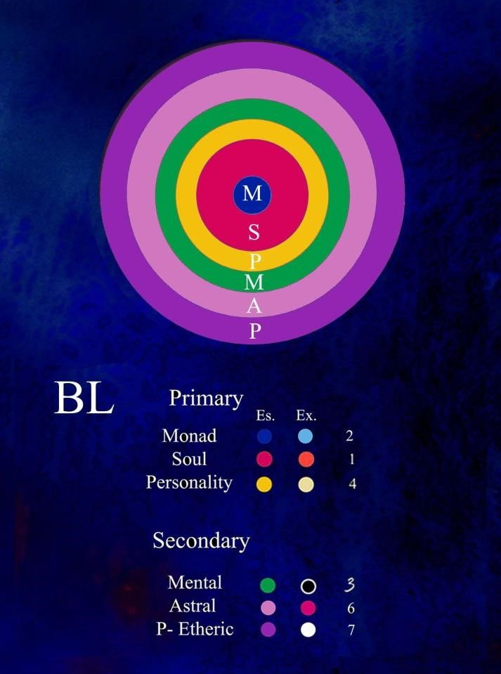
figure 2

Expanding upon this figure, we can demonstrate these six ray influences overlapping each other at the edges and creating additional secondary or mutated colors. See the attached video of a six-fold ray structure in motion and set to dynamic spiritual music. This type of presentation is the way of the future and creates a type of “livingness” of the rays and their unique color combinations. Add BL animation

BL video 6 rays.mp4

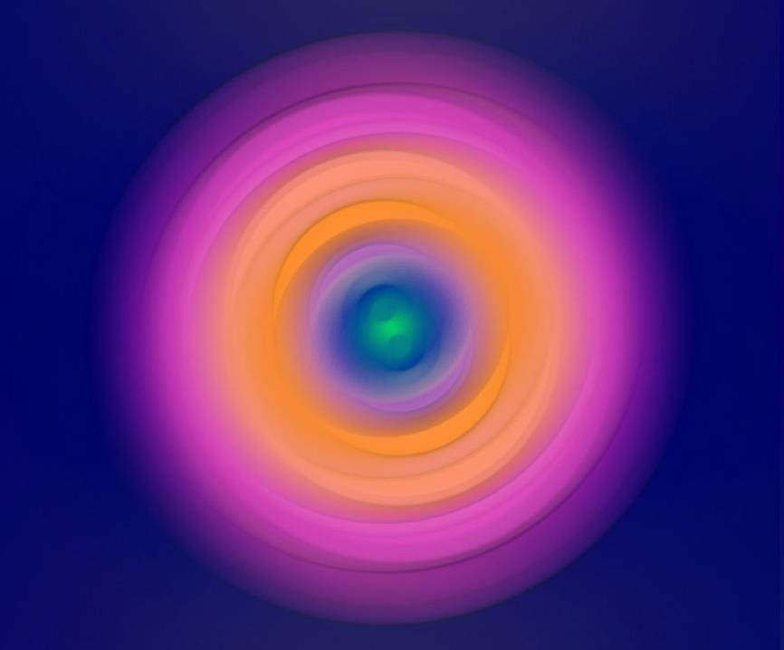

With just cursory research into literally thousands of new age sites on the internet, one can find instructions on how to lift the lower energies seated below the diaphragm up into their higher correspondences are provided. Granted most of these sites would hardly qualify as esoteric, and are often just vague generalizations of a more advanced science of energy and force manipulation, but they do demonstrate an interest in this subject. They also demonstrate a willingness and capacity to work outside of the mainstream medical profession and strive towards a more holistic approach to psychological and spiritual growth.

APPLICATION OF THE LAWS OF MAGNETIC VIBRATION
What did Alice A. Bailey mean when she stated that the application of the laws of magnetic vibration will be revealed and man will understand he lives in an ocean of electrical and magnetic forces that are constantly shifting and changing that we call the deva and elemental kingdoms?
On this subject of electrical and magnetic evolution, many insights can be found in A Treatise on Cosmic Fire that outlines what can be expected in the next Aquarian cycle to emerge. As those who have reviewed this treatise understand, it is a major outline on the three spiritual fires and how they, through infinite sub-divisions, create the many myriad levels of human and spiritual existence.
Also see THE COLORS OF THE RAYS AND THE PLANES, by the author: http://www.light-weaver.com/sites/default/files/rays_and_planes1.pdf
The following illustration gives a simple outline of these three fires and the infinite crossover points where triangles are created. All triangles have three points, and each point is found on a different level or plane. When energy or force is circulating, the lower is lifted up into the higher, and then the higher in turn descends as a saving force to aid the lower. The little dots situated in a vertical line between the ray and plane triangles, and seen at the very center of the chart, is a symbol of fohat – which is the stimulus emanating from the divine will.
Fohat, although hidden on abstract levels, stimulates the rays and planes to build or destroy any of the required forms for any given cycle of activity.

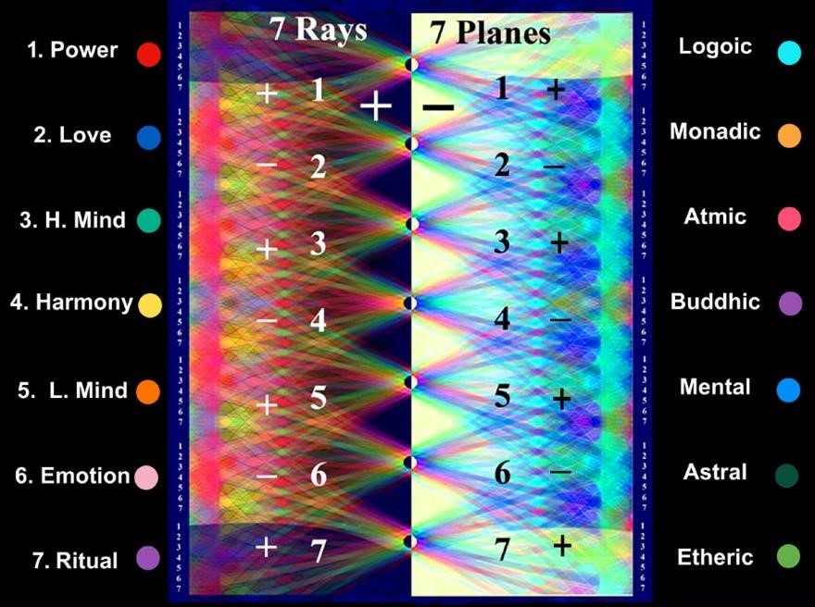
Figure 3
Electrically speaking, the seven planes are the polar opposite of the seven rays.

Also see Justin Wilkinson’s Electric Bridge video series at Monadic
Media:https://www.youtube.com/results?search_query=monadic+media

THE UNDERSTANDING OF SPIRITUAL LAW & THE LIGHTS WHICH EVER BURN
Next, let’s share one of DK’s most definitive quotes on the importance of magnetic and electrical evolution. It is a key quote that clearly has a microcosmic, as well as a macrocosmic, application, and gives us a broad understanding of how spiritual growth, inner healing, as well as evolution, takes place. One becomes inoculated from illness and disease by activating these progressively unfolding triangles and is the basis of all white magic and spiritual alchemy, irrespective of what spiritual tradition to which you belong or adhere.
If this treatise, serves no other purpose than to direct the attention of the scientific and philosophic students to the study of force or energy in man and in groups, and to interpret man and the human family in terms of electrical phenomena, much good will have been accomplished. The polarity of a man, of a group, and of a congery of groups, the polarity of the planets and their relationship to each other and to the Sun, the polarity of the solar system and its relationship to other systems, the polarity of one plane to another, and of one principle to another, the polarity of the subtler vehicles, and the scientific application of the laws of electricity to the totality of existence on the physical plane will bring about a revolution upon the planet second only to that effected at the time of individualisation. I would point out here a certain significant fact which students will do well carefully to consider.
In the third rootrace individualisation took place. It was an event which became possible through certain conditions and polar relationships, and because the scientific laws were understood and the Knowers took advantage of a peculiar electrical condition to hasten the evolution of the race. It was electrical phenomena of a stupendous kind, and produced the "lights which ever burn." It was the result of the knowledge of natural law and its adaptation to opportunity.
A Treatise on Cosmic Fire, pp. 715-716

NATURAL LAW
Time alone will demonstrate how successful humanity is in offsetting the penalties which outraged nature is apt to exact.
Esoteric Healing, p. 248 (Written in the 1940s)

The Tibetan uses in the previous quote the phrase natural law, which relates to the recognition of the evolution of the planet in its lowest expression, as well as human karma that has been evolving on this planet for millions of years. This natural law can only be superseded by certain spiritual laws that will come to the aid of humanity when his destructive and perverse lifestyles are reoriented and changed. The necessity of adopting these inner spiritual laws stands in direct contrast to much of what the medical profession is now using in their attempts to stem the present COVID-19 pandemic.
As we will demonstrate in a future section of this commentary humanity is so far removed from certain spiritual principals, he is – in his limited understanding – forced to compensate for this fact by the intervention of certain mineral substance such as vaccines that are elemental and devic in nature and that were never intended to be comingled in the human body.

THE ABRAMS METHOD AND THE NEW AND CREATIVE USES OF ELECTRICITY AS A HEALING MODALITY
Alice Bailey mentions Doctor Abrams, who promoted an idea that electrons were the basic element of all life. This was called the ERA, for Electronic Reactions of Abrams, and introduced a number of different machines which he claimed were based on this idea. By 1921, there were claimed to be 3,500 practitioners using ERA technology. Conventional medical practitioners were extremely suspicious ^{[17]} about these principles.
Psychologist Donovan Rawcliffe claimed that Abrams' devices had no scientific validity but his successors had "founded a good many special clinics in the United States and their number has by no means diminished in the ensuing years." (Truncated from WIKIPEDIA, see ^{[25]} https://en.wikipedia.org/wiki/The_Psychology_of_the_Occult.)
Naturopaths of many kinds, professors of methods of healing by electricity or light and colour, food dietitians with infallible cures for all diseases, the many who practice systems founded on the Abrams mode of diagnosis, and many advocates of the chiropractic methods, as well as the various healing systems which are completely divorced from medicine but which undertake to bring about cures, are all indicative of new and hopeful trends; they are nevertheless extremely experimental in nature, and are so fanatically endorsed, so exclusive of all recognized methods of healing aid (except their own), so violently opposed to all the findings of the past, and so unwilling to cooperate with orthodox medicine that, in many cases, they constitute a definite and real danger to the public. It is largely their own faulty approach which is responsible for this; their undoubted ignorance of the nature of the human body, their attack on existent medical practices (even of proven value), and their biased belief in the infallibility of their experimental techniques, have brought them under the attack of the rigidly orthodox medical practitioners and of the fundamentalists within the ring-pass-not of academic medicine. Yet within the ranks of medicine are many enlightened men who would gladly cooperate if the small and vociferous cults would relinquish their exclusiveness and be willing to cooperate and accept that which the divine instinct in man down the ages has taught in connection with the healing of the human body. It will be through the collaboration of the new experimental schools and the older and proven methods that the medicine of the future will be developed. The value of all the many groups—good and indifferent—lies in the fact that they point the way towards new trends and indicate the lines along which the medicine of the future can enrich itself and become better adapted to man's need …
Both of these great sciences (allopathic and progressive) must eliminate the reactionary and fundamentalist positions, and then proceed with an open mind into the new ways of approach to divinity and of approach to physical well-being.
It might therefore be said that the main contribution which I am making at this time is to indicate the causes of disease and ill health which are not recognized by orthodox medicine, which deals with the effects of these subtle causes as they work out in the physical body and the nervous system. I am not dealing (as I have earlier warned you) with the symptoms of disease, with medical diagnosis or with systems of applied physical means to bring about cures or to ameliorate conditions. These have kept pace with man's growing capacity to discover and to know.
Let me reiterate that I am laying the foundation for an approach to the subject of the physical body in health and disease which will deal primarily with the etheric body. This should eventually lead to an accumulation of knowledge anent energy, its focal points and distribution in the etheric body, which will equal that already gained in the field of exact physical knowledge, and that exact knowledge is a fact.
Esoteric Healing, pp. 280-281

See this next link for greater understanding of electricity and light: https://www.youtube.com/watch?v=-r7vweFUJdM
ELECTRICAL STIMULATION can help speed wound healing by increasing capillary density and perfusion, improving wound oxygenation, and encouraging granulation and fibroblast activity. https://bioelecmed.biomedcentral.com/articles/10.15424/bioelectronmed.2015.00005 https://www.ncbi.nlm.nih.gov/pmc/articles/PMC3776323/
BRAIN STIMULATION THROUGH ELECTRICITY:
http://www.iflscience.com/brain/researchers-boost-memory-using-magnetichttp://www.iflscience.com/brain/researchers-boost-memory-using-magnetic-stimulation - kyKfVwt1CbjZMd6c.99stimulation#kyKfVwt1CbjZMd6c.99

ELECTRIFICATION OF THE PLANET AND RISE OF THE PANDEMIC AND MUTATIONS IN THE PHENOMENAL WORLD
The present pandemic which is sweeping the globe when seen from a spiritual perspective may herald the inauguration of a great spiritual event that will only emerge in its fullness in future retrospect and reflection. Until then man with his lack of vision and inadequate spiritual comprehension will see this event only in its most superficial form and become a direct threat to his life and physical wellbeing.
To understand this great spiritual event we must understand how the cyclic inflow of spiritual light and electricity bring to the surface the roots of planetary and human evil which has only been theoretically recognized and not in fact actually dealt with. All esoteric research and study indicates man is a prisoner of his own desire nature and confined in his conscious perceptions to this planet until the third initiation when he becomes aware of his own soul and inner spiritual roots.
Those groups and individuals that cannot properly respond to the group requirements of the soul and who cannot measure up to the demands of the new emerging Civilization & Culture, become an obstruction to the free flow of the group life and essentially are selfeliminated.

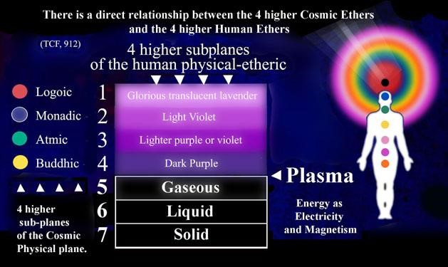
figure 4
Colored Light and Etheric Evolution

A further chain of ideas may be followed up in the remembrance that the fourth ether is even now being studied and developed by the average scientist, and is already somewhat harnessed to the service of man… A Treatise on Cosmic Fire, p. 116

See the fourth physical-ether, colored dark purple in the figure above.
Also see ‘star in a jar’ from the Electric Universe theory and the Thunderbolts Project: WE ARE ALL STARS IN A JAR, Sonoluminescence. https://www.youtube.com/watch?v=urTcitL66YI&t=58s
Also here: https://www.thunderbolts.info/wp/2018/03/31/turning-sound-into-light/
There is an occult parallel to a phenomena called sonoluminescence when fohat, or cosmic electricity, expressing itself through sound when impacting lesser levels of form life, can cause a type of friction in which these lesser lives begin to glow and give off light. This is why Mercury, conveying the fourth ray of yellow-golden light, is so important, not simply because it is humanity’s soul ray and embodies the principal of Buddhi, but because it is the mediator and bridge between the three primary unmanifested rays: 1, 2, and 3, and the lesser secondary or subsidiary rays of 5, 6, and 7, which express the form nature.
The solar angel is essentially composed of sound, light and vibration and any impact it has on the lesser elemental lives of the three periodic vehicles will cause them to glow which demonstrates transmutation in action. Under the impression of the soul’s superior radiatory power these lower elemental lives will either, become keyed up to this higher vibration, or if unable to respond, be broken up and dissolved back into their original devic and elemental reservoirs from which they were originally drawn.
Recent discoveries into the phenomenon, sonoluminescence, where sound manifests itself as light, indicate that we are on the threshold of powerful discoveries that will provide the potential to create unlimited energy supplies in the future.

PLASMA
The fourth state of matter discovered by physicists, plasma, is energy or force that has electrical and magnetic qualities of a new potency and power than previously recognized by science. It is also the force that connects all matter together on the subatomic level, supporting the central idea of holism, which states everything is connected on hidden levels of energy and force. This plasma will eventually become recognized by esotericists as prana and is one of the key entry points or cross over places into the higher etheric planes that Master DK prophesized science would begin to discover in this century.
All spiritual bodies, centers, or auric fields, are separated by different qualities and densities of electrical and magnetic fluids, and all initiation is the fusion or replacement of a lower group of electrical lives with a higher and more advanced group. This is the rationale of why we need to understand the laws and principles upon which this dynamic works. This idea of spiritual transmutation falls under a number of categories, the most important of which is titled by DK the science of radiatory substitution where a lesser energy is thrown out of the auric field and replaced or substituted by a higher one of a greater power and radiatory frequency.
A recent development in the scientific field of physics that demonstrates the value of trapping plasma magnetically and how it will be used in the future for practical application. PrimerFusion links:
https://www.youtube.com/watch?v=9q_IvxWoY4E https://www.youtube.com/watch?v=SmZ59U_oq-c

MAGNETIC FLUIDS AND ELECTRICAL RAYS
I have touched on this matter as it lies back of all instruction along occult lines. If you can grasp somewhat its meaning, and understand how the law is but the adaptation of the form to someone or other of these great streams of force, you will illuminate your whole life and be carried on those streams of force, those magnetic currents, that vital fluid, those electrical rays (no matter what the terms used) right to the heart of the unknown. Letters on Occult Meditation, p. 181

The following image is titled Penrose’s Twister, named for the famous physicist, Roger Penrose, for his work with super-symmetries and string theories which can give us a visual idea of this inner process. All atomic lives have electrical and magnetic signatures that twist into discreet spherical bands or shells when sufficiently stimulated. These semi-permeable bands when properly stimulated by the intervention or alignment with a higher and more powerful force then itself can jump to a higher and more radiatory frequency. This dynamic is the foundation for the divine initiatory experience seen and understood in electrical terms.
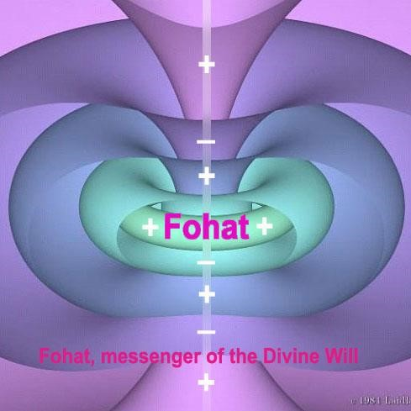
figure 5
Penrose’s Twister

The inner spiritual bodies of each person are held in place or suspended by rotating bands or clouds of electrical fluids or forces that owing to the nature of their constitution or viscosity keep them in their rightful place, much as when oil or water – although both are liquids – will always separate themselves into their primal density when brought together. This is the rationale and importance of understanding electricity and the training in the attractive and repulsive forces of the universe.
Man will eventually be seen and categorized as a unit of electrical voltage and magnetic charge. Ohm’s Law and other electrical theories, which can be found in the basic principles of the physical sciences, will eventually be seen as a prototype for understanding the antahkarana or rainbow bridge outlined by the Master DK in his many occult theories and writings.
It is the creative imagination and the power of the spiritual will that can set in motion a host of building forces which inhabit the inner emotional and mental planes, and proves conclusively that man is the ruler of his own destiny, and can be free from illness and disease when he understands these hidden laws, and consequently, acts upon them.
To help clarify what DK has said about advanced alignments and healing techniques that will be coming in the future (which he outlined in the 1940s), we will explore what he meant by the importance of his advanced meditational practices: linking the four higher cosmic ethers with the four lower human ethers. It is this linking of the higher with the lower that will help eliminate the many human ills that reside not just on the physical-etheric levels, but astral and mental levels as well, where real illness and disease is found.
See chart above, figure 4 titled: COLORED LIGHT AND ETHERIC EVOLUTION
The building of the antahkarana or rainbow bridge is a seminal part of the teachings of Master DK’s work. The construction of this bridge is composed of seven different colored ray strands of creative electrical life that link the lowest to the highest levels, and represents all seven of the divine spiritual qualities.

THE SEVEN SPIRITUAL RAYS AND THEIR HEALING QUALITIES OF LIGHT AVAILABLE FOR DEVELOPING ADVANCED HEALING MODALITIES

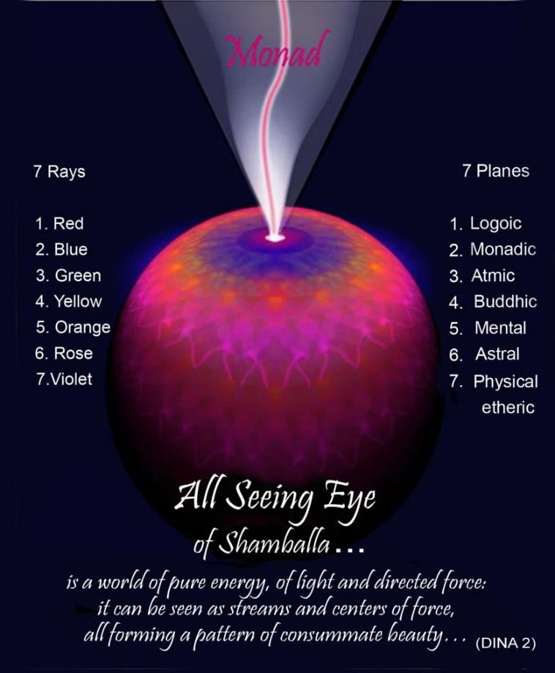
figure 6

Figure 6 is a composite of the many triangles earlier mentioned in figure 3, and seen here as a sphere, which is the true shape of spiritual entities on the inner planes.
To those who practice and want to understand triangle work in its advanced stages, this image can give a better grasp of the interconnectedness of the rays as they build the antahkarana or rainbow bridge. The process is not from above down nor from below up, which are constructions of the lower mind, but from the center point to the periphery of the spherical-globe-circle.

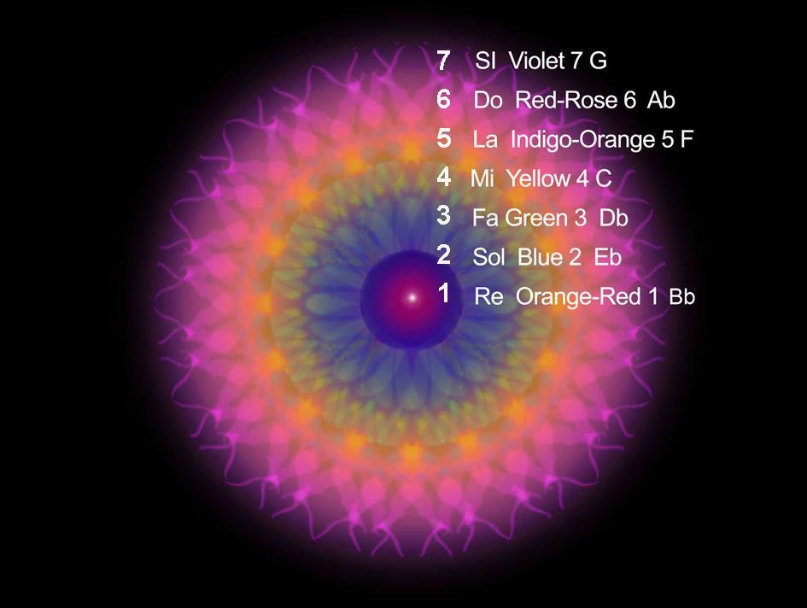
figure 7

Figure 7 is the same image just shared in figure 6, but seen more from a top down view and shows the seven rays working from the center out, and with certain designated sound values. No claim is made on the accuracy of the sound relationships shown above. It is for students to experiment and explore on their own. The important search for the lost word, spoken of by The Tibetan, which each disciple must eventually recognize, is no vague metaphor, but an exact statement of fact and stands as an important area of research each disciple should initiate.
When the knowledge of one’s personality and soul ray, and their respective notes or colored qualities of light are known, the building of the antahkarana bridge can go forward scientifically and with greater speed. It is with and through these seven ray qualities of the soul that all healing alignments or techniques can be initiated or devised.

ETHERIC VISION AND THE EVOLUTION OF COLOR FOUND IN THE ULTRAVIOLET SPECTRUM OR RANGE
A second discovery will grow out of the present investigations as to light and color. The effect of color on people, animals and units in the vegetable kingdom will be studied and the result of those studies will be the development of etheric vision or the power to see the next grade of matter with the strictly physical eye. Increasingly will people think and talk in terms of light, and the effect of the coming developments in this department of human thought will be triple.
A Treatise on White Magic, p. 335

This recognition of etheric vision and its use in the medical profession will revolutionize the practice of healing which is largely, in spite of good intensions, to a large degree just guess work and speculation. This etheric sight will constitute one of the basic principles of a new Aquarian type of healing that sees more of the whole person and how we are all interdependent and aligned with a whole hierarchy of inner energies and forces that need to be first recognized before they can be creatively used.
DK has also stated that by humanity developing sensitivity to the ultra-violet range of light that the devic kingdoms will become recognized and known and is one of the keynotes to planetary healing that will be initiated by the reappearance of the Christ and His host of angelic and planetary healers when he reappears.
These are important charts and tabulations presented here in this commentary because they outline the key colors of the devic and angelic kingdoms that can be explored and used when working with their powerful healing energies and forces. From one point of view healing is the result of building into the inner bodies or spiritual sheaths colors of a higher grade of transparency and luminosity.
This next quote by DK outlines the importance of refining our sense of color perception.

"AND IN THY LIGHT SHALL WE SEE LIGHT"
In speaking about the increased radiance of light seeping in from the etheric and astral planes DK has this to say: "The light from the astral plane (a starry radiance) and the light of the planet itself will be more closely blended, and the result upon humanity and upon the three other kingdoms in nature cannot be over-emphasized... It will bring within the radius of our range of contact the infra-red and ultra-violet gamut of colours...
Esoteric Psychology I, pp. 103-104

THINK INCREASINGLY IN TERMS OF ELECTRICITY AND VOLTAGE
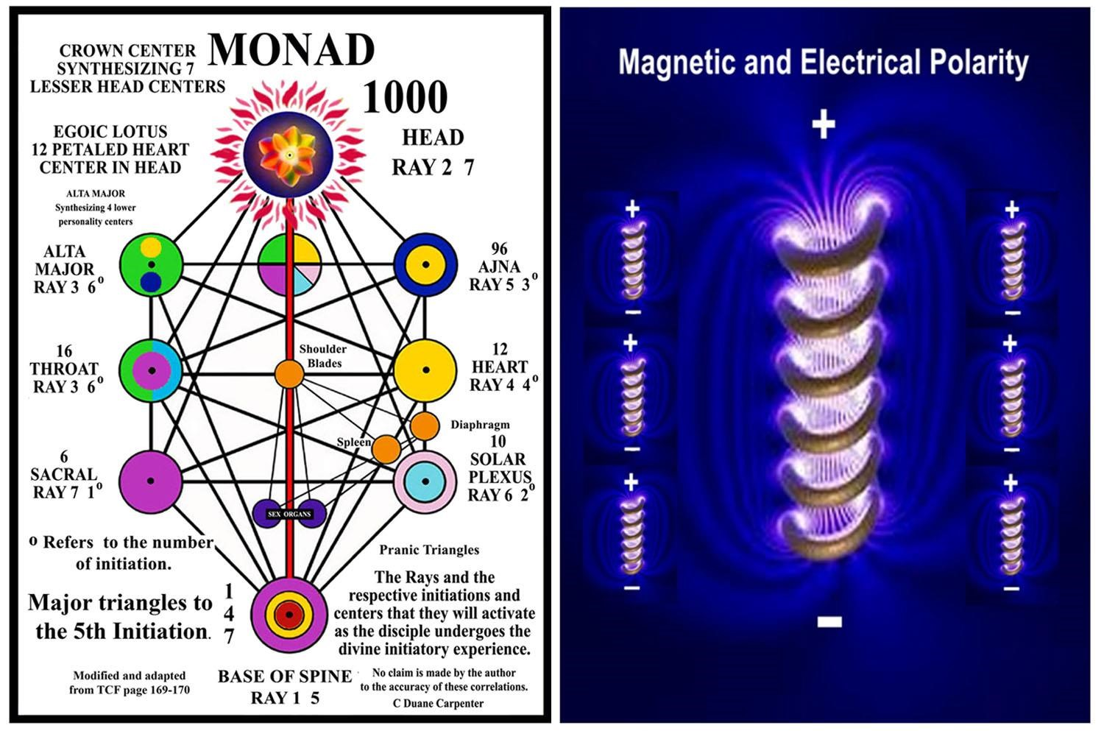
figure 8
We shall see each other and all forms of divine manifestation as light units of varying degrees of brightness and shall talk and think increasingly in terms of electricity, of voltage, of intensity and of power. The age and status of men, in regard to the ladder of evolution, will be noted and become objectively apparent, the relative capacities of old souls, and young souls will be recognized, thereby re-establishing on earth the rule of the enlightened. Note here, that these developments will be the work of the scientists of the next two generations and the result of their efforts. Their work with the atom of substance, and their investigations in the realm of electricity, of light and of power, must inevitably demonstrate the relation between forms, which is another term for brotherhood, and the fact of the soul, the inner light and radiance of all forms.
A Treatise on White Magic, pp. 335-336

If this was written in the 1940s, we are dealing with the time frame of two generations, which are generally estimated to be twenty to thirty years each, which puts this prophecy in the range of 1980 to 2000.
The work of groups like the Electric Universe, and the Thunderbolts Project have taken this penetration into the higher ethers with their new electrical and magnetic exploration and theories. https://www.thunderbolts.info/wp/ . The Electric Universe group and their exploration into plasma are an example, as well as hundreds of other research groups that can clearly be put into this same time frame and category.
Those who would doubt the accuracy of this time frame have simply not done the necessary research, and may have become over-reliant on the contemporary medical profession, as well as the mainstream scientific community for guidance and healing information. Advanced alternative healing techniques that are based on the idea that man is an electrical unit are emerging historically now, and these exist for the benefit of all humanity.
These new modes of spiritual healing based on DK’s prophecies, and instructions on working with electricity, color and sound in his Esoteric Healing manual, have largely been either suppressed or slow to be recognized by conventional medicine.
The previous quote from A Treatise on White Magic, where DK indicates that many scientists are now studying the fourth ether and it is already somewhat harnessed to the service of man, applies also to the different scientific groups who study quantum levels of reality, which clearly demonstrate that at some rudimentary level we are all fused into one primary energy source. The theory of occult holism is one of the key laws that govern both the material and spiritual worlds. It is also one of the primary links between cause and effect, and between mind and matter, which have been veiled since the beginning of time.
Many other groups are also making advances along these progressive lines in politics, social change, finance, as well as preservation of the environment, but not without the attending resistance from the established status quo, and the complications that always come from the impact of new and higher energies. From humanity’s standpoint, etheric recognition and evolution is painfully slow and tedious, because to understand and use its new found potencies and powers you must first change your consciousness.
WHAT IS THE ELECTRIC UNIVERSE THEORY IN ITS MOST SIMPLE FORM?
There are energy channels that are electrical in nature, and these electric currents flow along plasma filaments and shape and power galaxies, planets, and this includes all natural phenomenon. https://www.thunderbolts.info/wp/
These plasma filaments shape and power galaxies, planets and all other natural phenomenon. These electrical currents stream into stars, powering them like fluorescent bulbs. The "Electric universe" theory is at odds with almost everything modern science has determined about the universe. ... And in EU theory, the truth is that electricity rules, and influences such as gravity are actually minor.
On a human level there is a slowly-emerging esoteric science based upon the recognition and understanding that everything is electrical in nature and that energy and force are all simply different grades and variations of one higher, and more primary electrical charge, which we call Fohat, Cosmic electricity or God, for the lack of a better definition.

THE NADIS
An additional aspect of these new discoveries in the physical sciences and the Electric Universe theories is that the human physical organism is also supported and vitalized by what the ancient yogis have designated for thousands of years as a series of energy channels that are electrical in nature and called nadis. Nadis are a lower correspondence to even higher electric currents found on the emotional and mental planes and have their linking origin from fohat, or what is called in the esoteric tradition cosmic electricity as earlier outlined.
Nadis contribute to the hidden divine circulatory flow of any spiritual organism and when blocked or diverted improperly in the wrong channels lead to ill health and many problems with disease that man is presently experiencing on such a large scale.
It [nadis] is made of substance or of that which "substands," or underlies, every part and particle of the dense physical vehicle. This is a point which will later receive attention from healers and from enlightened medical men in the New Age. When this relationship existing between the nadis and the nerves, and their joint relationship to the centres and spinal column is recognised, we shall see a great revolution in medical and psychiatric methods. Experience will tend to show that the more closely the interplay between these two—the nadis and the nerves—can be brought about, the more rapidly will the control of disease also be implemented. Esoteric Healing, p.197

THE ANCIENT FORMULAS FOR A NEW GENERATION OF SPIRITUAL HEALERS
The new and coming terminology will throw light on the ancient formulas, and in time you will see how much can be conveyed to the intelligent healer of that new generation by what seems to you both disappointing, without use or significance, and needlessly abstruse. . . .
The physical body is not yet generally recognized as an electrical unit; its nature as pure atomic energy is not yet realized; the fact of the energy body, the etheric vehicle, is not at this time recognized in the teachings of the modern medical schools, though the fact has been discussed; the explosive nature of energy, when in contact with force, or of the soul in relation to substance, is completely unknown or veiled in mystical language. Until such time as the new scientific formulas and the new approach (which the discovery of the release of atomic energy has made possible) have become more generally understood, are a familiar subject of discussion and couched in familiar language, the coming science of healing must remain behind a veil of unsuitable language and hidden by inappropriate words.
Esoteric Healing, pp. 714-715

On the positive side of this electrical development is the internet and the electronic highway that have allowed many alternative types of research into these different areas of color, sound, and electrical healing to be shared and better understood. These new and more spiritualized modalities have been forced to bypass the current stranglehold that conventional science, as well as the pharmaceutical and medical professions have imposed upon any new and more advanced information about human and planetary healing.
Many who read this commentary may be more able to operate outside of the standard medical model because of a higher education and a more robust income that allows them to access these alternative healing sites and techniques. For most of average humanity, however, who are ignorant of these many alternative modalities and lack the necessary resources, they can be easily swayed and influenced by the pharmaceutical and medical professions monopoly on information, and are easy targets for the juggernaut of mass influence through the media. Marshall McLuhan, considered the high priest of the internet and mass communications, stated back in the 1960s that those who control the media will eventually control the world.

SOUND HEALING
What we have outlined about the healing uses of color and light can equally be stated about sound. Sound healing, either through exposure to the best music of any historical period, or certain forms of direct exposure to different ray frequencies or healing sounds (mantra) will also be a part of these new and more progressive spiritual modalities.
Note here, that these developments will be the work of the scientists of the next two generations and the result of their efforts. Their work with the atom of substance, and their investigations in the realm of electricity, of light and of power, must inevitably demonstrate the relation between forms, which is another term for brotherhood, and the fact of the soul, the inner light and radiance of all forms.
The third development, which will be the last probably to take place, will be more strictly in the realm of what the occultists call magic. It will grow out of the study of sound and the effect of sound and will put into man's hands a tremendous instrument in the world of creation. Through the use of sound the scientist of the future will bring about his results; through sound, a new field of discovery will open up; the sound which every form in all kingdoms of nature gives forth will be studied and known and changes will be brought about and new forms developed through its medium. One hint only may I give here and that is, that the release of energy in the atom is linked to this new coming science of sound.
A Treatise on White Magic, pp. 335-336

NEW AND ADVANCED HEALING TECHNIQUES THROUGH SOUND
Another quote from the Tibetan before we review and explore the more esoteric side of sound:
Does this injunction surprise you, brother of old? You are on the verge of release from the struggle of the past and can enter upon a more constructive and happier phase of living if you permit music to play a major part in your life rhythm; choose only the best music, such as that played by the great symphony orchestras. God created by the power of sound, and the "music of the spheres" holds all life in being (note that phrase). The soul on its tiny scale can create "the new man" by the power also of sound, and a musical rhythm can usefully be imposed upon the personality life by the disciple.
This is what you need—music in your life, literally and figuratively. I have here given you a most important hint. Let the great music of the masters of sound enter (in a new and powerful way) into your consciousness.
Discipleship in the New Age, II, pp. 700-701

CYMATICS, MAKING SOUND VISIBLE
The next picture is one created by a Cymatic machine that has captured and transferred into sound patterns the purr of a cat. It has been known and recognized for some time that a cat’s purr is of a certain healing frequency that can help heal wounds, cuts and abrasions of all types.

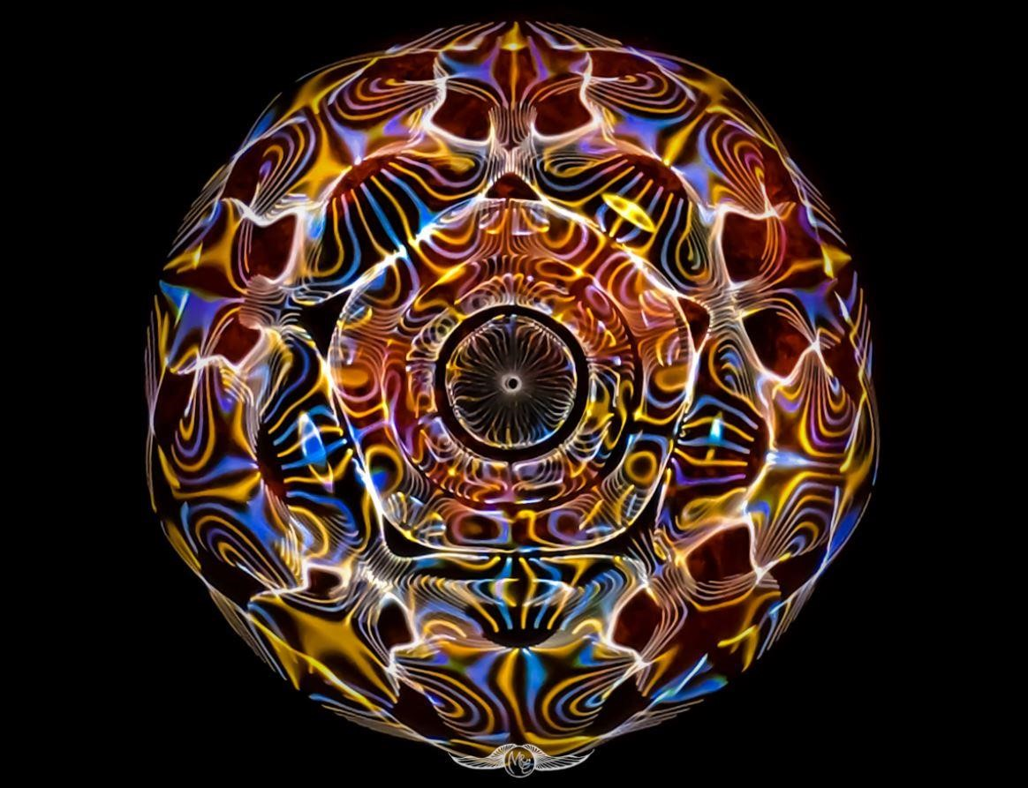
figure 9
Mr. E-Shcolar https://www.facebook.com/photo/

Cymatics, the study of wave phenomena, was pioneered by the Swiss physician, artist and natural scientist, Dr. Hans Jenny (1904-1972). Inspired by Rudolf Steiner, Dr. Jenny's penetrating observations of patterns in nature led to these dramatic experiments animating inert substances with audible sound. The stunning array of images seen in these programs are actual physical phenomena: these life-like, flowing forms result from sound frequencies stimulating various liquids, powders, pastes and iron filings. There are no computer-generated images. Adapting these principles for therapeutic treatment, British medical doctor Peter Guy Manners explains the theory behind using audible sound to balance acute and chronic conditions in body tissue. In the final segment, he demonstrates the Cymatic Applicator, a device which he designed for this purpose. https://www.amazon.com/Cymatics-Healing-Nature-3-Part-Composite/dp/1888138017

Sound healing, as the name suggests, involves using tones—whether music, speech or vibrations—to promote health. The ancient technique has been practiced for centuries, initially as a way to treat mental illness in ancient Greece. Today, sound therapy is used to promote physical and mental health, and the benefits are multifold. Different approaches vary based on the desired result. These techniques can reduce stress, mood swings and blood pressure, lower cholesterol, help manage pain and improve sleep. Although there are many methods, a few common sound healing techniques include binaural beats, tuning fork therapy, vibrational sound therapy and music for healing. There’s plenty of research still to be done, but studies have demonstrated its ability to boost relaxation and overall well-being.

SOUND AS MEDICINE
According to the Guardian:
Sound therapy is based upon the belief “…that our bodies contain ‘energy frequencies’ and that sonic frequencies can be used to reattune these energies when they go off key. All you have to do is lie down and bask in the tuneful beauty of ‘pure’ sound”.

Sound has been a tool for promoting the physical and emotional health of the body for as long as history can account for, deeply rooted in ancient cultures and civilizations. The ancient Egyptians used vowel sound chants in healing because they believed vowels were sacred. Tibetan monks take advantage of singing bowls, which they believe to be “a symbol of the unknowable” whose “vibrations have been described as the sound of the universe manifesting.”. Also, when some American Indian medicine men and women were called upon to heal an ailing tribe member, they would fast in order to receive a song in a dream or vision instructing them how to carry out the treatment of their patient.
Psychoacoustics is the scientific study of the perception of sound, and it has fueled researchers to better understand how it can be used as medicine. To understand the fundamentals of sound in healing, we must first understand our brain waves. The nucleus of our thoughts, emotions, and behaviors, is the communication between neurons. Brain waves are generated by way of electrical pulses working in unison from masses of neurons interacting with one another. Brain waves are divided into five different bandwidths that are thought to form a spectrum of human consciousness. The slowest of the waves are delta waves (.5 to 3 Hz), which are the slowest brain waves and occur mostly during our deepest state of sleep. The fastest of the waves are gamma waves (25 to 100 Hz), which are associated with higher states of conscious perception. Alpha waves (8 to 12 Hz) occur when the brain is daydreaming or consciously practicing mindfulness or meditation.
Introduction of Cymatics and its history in this short TED TALK: https://www.youtube.com/watch?v=CsjV1gjBMbQ
Sound signatures of the human voice:
https://www.youtube.com/watch?v=stMCW6L5GXA
See the next video in the link provided below. Here we can see Beethoven’s Moonlight Sonata put to music by a cymatic machine: https://www.youtube.com/watch?v=dv9UMJbU1kIIn
Vibrational healing devises: https://www.youtube.com/watch?v=SGAKxT_c_3w
In these next few videos we can see how cymatics can be applied to music and the entertainment industry. 2nd ray disciples often have an ability to visualize certain types of energy and spiritual force more easily if they can first see some outer representation of those hidden and illusive dynamics. https://www.youtube.com/watch?v=Q3oItpVa9fs And here: https://www.youtube.com/watch?v=yojDu3E9jls
Cymatic Holograms: https://www.youtube.com/watch?v=BtXYzj-iDRs
This next video was made using a blender and gives additional insight into the sound and form relationship: http://blender.org
What is unique about these videos is that the observer can see how physical sound relates to vibration and hidden geometric forms that are fluidic in nature. Through proper visualization certain diseases which have a certain broken etheric pattern can be rebuilt and restored to optimal health.
Sound is liquid matter that is so refined it lies just outside of our normal range of sight but can be seen in the ultra-violet range of vibration when the healer is properly trained.
DK had this to say about the ultra-violet range of colors and how it relates to the eventual perception of the light of the soul if followed back through the law of analogy. It is in this recognition of soul light reflected and grounded in the physical-etheric constitution that one becomes naturally immune to inimical forces and one becomes inoculated from the inside out and more perfect health is found.
It will bring within the radius of our range of contact the infra-red and ultra-violet gamut of colours, (the Devas) and we shall see what at present is hidden. All this will tend to destroy the platform upon which the materialists stand, and to pave the way, first, for the admission of the soul as a sound hypothesis, and secondly, for the demonstration of its existence. We only need more light, in the esoteric sense, in order to see the soul, and that light will shortly be available and we shall understand the meaning of the words, "And in Thy light shall we see light."
Esoteric Psychology, I, pp. 103-104

The Cymascope can be a useful tool to make sound visible and when used creatively help the student or the observer to use the imaginative faculties in new and creative ways. This Cymatic machine can help the student better understand how variations of sound can be used to literally build geometric forms, dissipate them, and then rebuild newer and more refined structures on the inner planes.
Through the right and creative use of the visualization capacity, the student can literally rebuild the new man or women they seek to become. Over time they occultly step into that new spiritual self when the esoteric laws of building and destroying are more widely practiced and know. Spiritual growth and healing are initiated by the right use of the picture-making faculties in man, and eventually leads to a strong and resilient personality as well as optimum health in its three lower instruments.
In Tibetan Buddhism, sound is a sacred science (mantra), which has been used for thousands of years to help propel the student forward through the divine initiatory experience. This advanced work not only insulates the disciple from illness and disease, but eventually frees them from the wheel of reincarnation and a complete emersion or entry into unconditional love and total bliss.
The Oxford Scholar W Evans-Wentz, in what is considered the first English translation of The Tibetan book of the Dead (Bardo Thodol), stated on pages 220-221:
Mantras or Words of Power
A clue to the power of mantras, as referred to throughout the Bardo Thodol, lies in the ancient Greek theory of Music; namely, that, if the key-note of any particular body or substance be known, by its use the particular body or substance can be disintegrated. Scientifically, the whole problem may be understood through understanding the law of vibration. Each organism exhibits its own vibratory rate, and so does every inanimate object from the grain of sand to the mountain and even to each planet and sun. When this rate of vibration is known, the organism or form can, by occult use of it, be disintegrated.
For the adept in occultism, to know the mantra of any deity is to know how to set up psychic or gift-wave communications similar to, but transcending wireless or telepathic communications with that deity. For example, if the adept be of the left hand path, that is to say, a black magician, he can, by mantras, call up and command elementals and inferior orders of spiritual beings, because to each belongs a particular rate of vibration, and this being known or formulated as sound in a mantra gives the magician power to even annihilate by dissolution the particular elemental or spirit to whom it belongs…
… on account of this supreme power of sound, when formulated in mantras corresponding to the particular rate of vibration of spiritual beings and of spiritual and physical forces, the mantras are jealously guarded.

In the next video (link below), we see a young child using this same principal just outlined on a somewhat reduced scale to break a wineglass with just his voice. Everything in the universe has its own sound signature as outlined by our previous quote, and when duplicated, and then artificially stimulated above its normal resonate frequency causes the atomic structure to speed up to the point the form breaks apart and shatters. When dealing with the energies of the inner planes when this shattering occurs the white magician rebuilds or constitutes the atomic structure to create new and more advanced forms that better reflect the indwelling light. What people don’t understand is that emotions and thought are also malleable substances of a very advanced form and can also be manipulated and controlled when the right techniques of spiritual training are administered.
The time has not yet arrived for this advanced science of mantra to go mainstream or fully implemented here in the West due to their somewhat lower vibrations, as well as overdevelopment of the lower mind, but are nevertheless being slowly explored and will constitute one of the key areas of esoteric healing that is coming in the future. https://www.youtube.com/watch?v=sH7XSX10QkM
What is interesting about this simple video, and others that are similar and can be found on YouTube, is that the straw inside the wineglass can be seen starting to spin when the young man’s voice is increased to a certain volume and intensity. This clearly demonstrates one of the secrets of spiritual growth, initiation and advanced healing which is the creation of a vortex that can breakdown the confining walls of diseases and let more spiritual light in. A vortex when created in the meditative state through the creative use of sound, (mantra) creates a vacuum, this vacuum pulls down higher devic and angelic force down into the auric field of the student from the next higher level, while simultaneously throwing out through rotary and cyclic-spiral motion heavier and more dense elemental lives.
The next several quotes give some insight into the dynamic of the vortex and how it can be used in healing.

THE THIRD RAY TECHNIQUE
The healer stands and weaves. He gathers from the three, the five, the seven that which is needed for the heart of life. He brings the energies together and makes them serve the third; he thus creates a vortex into which the one distressed must descend and with him goes the healer, and yet they both remain in peace and calm. Thus must the angel of the Lord descend into the pool and bring the healing life.
The "pool of waters" figures here and may cause much questioning as to its significance. Its elementary interpretation relates in reality to the central and major cause of much disease (as we have earlier seen), the emotional nature, which it is the task of the third aspect of divinity to control. Ponder on this, for much enlightenment may come. Esoteric Healing, pp. 709-710

This must obviously be so when the vast number of energies and forces which constitute man's being and form his environment are brought into relation with each other. Every human being is, in reality, like a miniature whirlpool in that great ocean of Being in which he lives and moves—ceaselessly in motion until such time as the soul "breathes upon the waters" (or forces) and the Angel of the Presence descends into the whirlpool. Then all becomes still. The waters stirred by the rhythm of life, and later stirred violently by the descent of the Angel, respond to the Angel's healing power and are changed "into a quiet pool into which the little ones can enter and find the healing which they need." So says the Old Commentary.
Esoteric Healing, p. 141

This next video shows the idea of the vortex in motion and how it can have multiple semi-permeable membranes (conical shells) which, although independent from each other, make up one greater spiritual life. In esoteric healing, one of the techniques is to transfer more advanced devic and angelic life from the inner center where the soul and monadic life reside, and draw that redemptive force out or down to purify and cleanse the outer rings of the auric field where the personality and the lower elemental life reside.
This is all part of a new Aquarian super-human physics that will become a standard model of approach and eventually supersede the limited healing modalities that most contemporary medical professionals are now using.

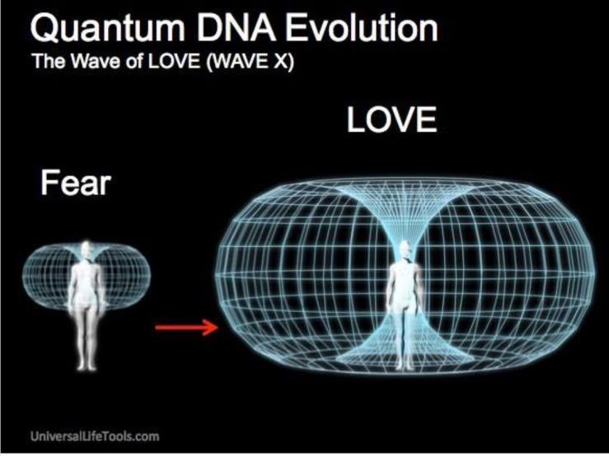
Gayatri Mantra sung by Deva Premal
Also see the authors’ outline on the vortex and vacuum link: http://www.light-weaver.com/LW-old/vortex/1vortex.html Technically speaking, when the disciple meditates he creates a vortex on the inner planes. A vacuum is created In the center of this vortex. This vacuum is the means by which the meditator is able to draw or pull atomic substance from the next higher level or grade down into his different vehicles or auric sheaths. The fast moving vortex, composed of rotary and cyclic-spiral whirling motion, throws out heavier elemental substance from the auric field, much like a child is thrust outwards towards the periphery of a fast moving carousel, while simultaneously drawing in more advanced devic energy and force from the center which pours in from the next higher level.
To properly understand this concept, the reader must see multiple vortices all connected one into the other and all as an intimate part of one greater and more overriding spherical organism that has mutable inlets and outlets. It is through these inlets and outlets (vortexes) that energy passes through the center only to circulate back around the outer periphery with the experienced gained.
Some additional images that can help clarify this idea:
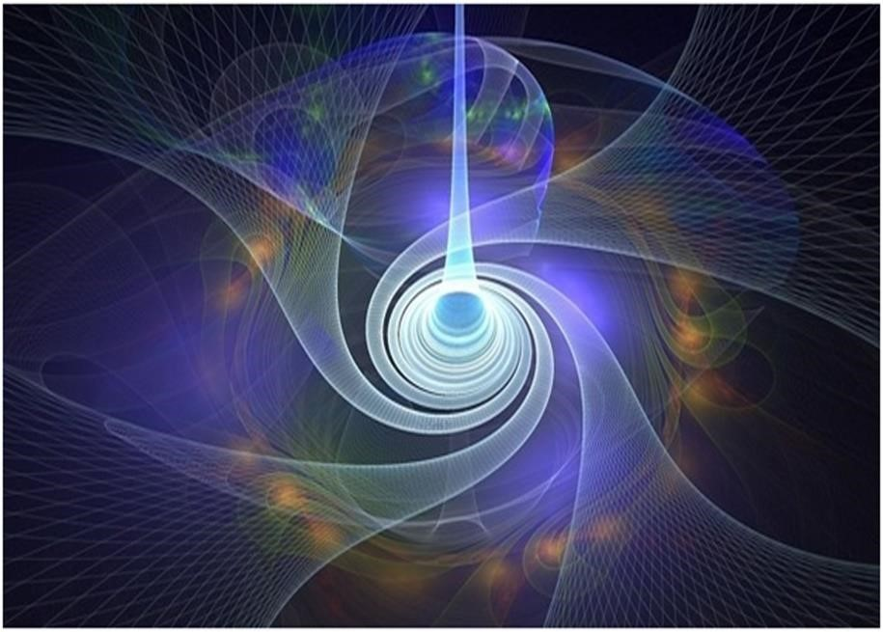
figure 10 artist unknown

From the center of this vacuum we can see how energy or force can now be pulled down through its central channel, or throat, stimulating and energizing the entire organism.
From this graphic image we can also see how a vortex can sweep multiple forces or energies (four) by its greater and more powerful magnetic and electrical draw into one larger and greater spiritual organism that now combines all the lesser or peripheral forces into one overriding parent organism. Textbook definitions of this process can create an important foundation for this understanding, but can later become a hindrance since the lower mind separates and divides what is essentially organic and holistic in nature. When seen graphically like the image above the higher mind and intuition are invoked and we can come to see a larger and more expanded view, one that is both seamless as well as in motion.
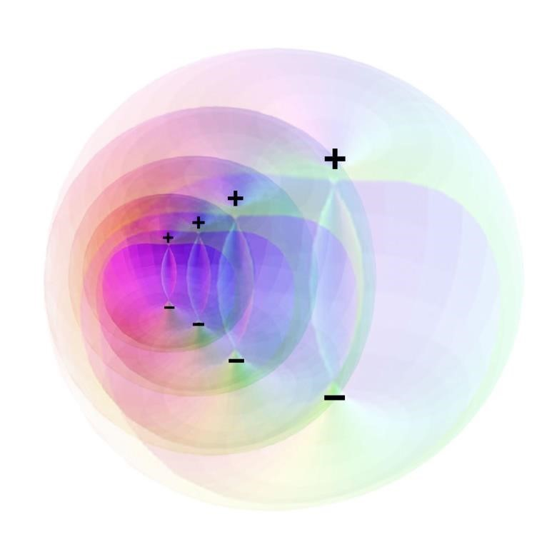
figure 11

The figure 11 shows a series of semi-permeable envelopes that connect multiple spheres. As energy descends from the top of the northern vortex (+), it then circulates throughout the entire organism and eventually exits at the southernmost vortex (-). What was a negative exiting pole then flips its polarity 180 degrees and becomes positive to the next vortex-sphere.
The same process of alternating electrical poles is repeated with each individual sphere. This all happens within a more closed system then graphically rendered, but for demonstration purposes we have expanded the image for a more composite or 3-D view. This dynamic is much like when a closed accordion is opened it shows multiple bifurcations, and we see each fold is now distinctly different from all the others, but when compressed back into its original position all the bifurcations come back together making one greater entity or organism.

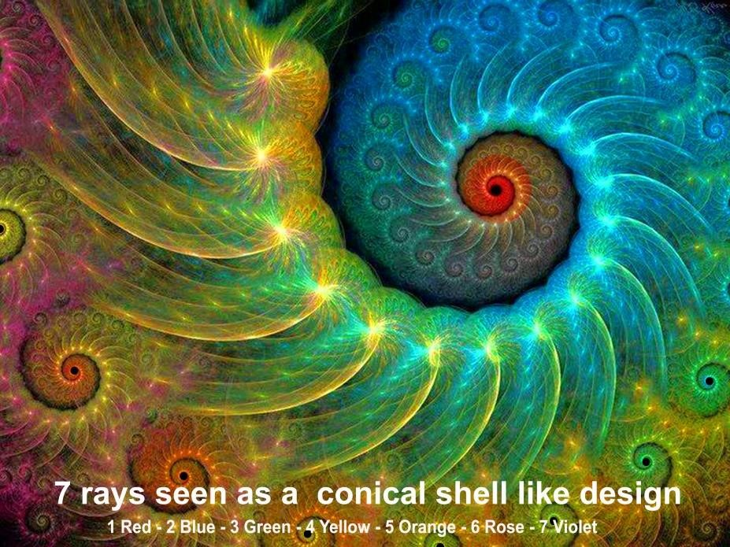
figure 12 artist unknown

Not only do these spheres have multiple semi-permeable sheaths that overlap, much like an onion skin that keep alternating in polarity, they are all a part of a greater organism: wheels within wheels, or spheres within spheres, all corkscrewing and spiraling through multiple dimensions to the will of some greater entity.(see black dot at the center of each rotating sphere which symbolizes Fohat or some aspect of cosmic electricity in its highest and most abstract form). Each vortex-sphere is placed according to some greater spiritual design and some greater mathematical and geometric law.
The following quote from A Treatise on Cosmic Fire refers to the ideas of mutable wheels, which when seen on their own plane by the Initiate or Master are spherical in composition and follow a certain predetermined geometric pattern or order.
In the wheel, forming that wheel, are all the lesser wheels from the first to the tenth dimension. These in their cyclic turn hold in their spheres of force other and lesser wheels. Yet many suns compose the cosmic One. Wheels within wheels, spheres within spheres. Each pursues his course and attracts or rejects his brother, and yet cannot escape from the encircling arms of the mother.
A Treatise on Cosmic Fire, p. 1085
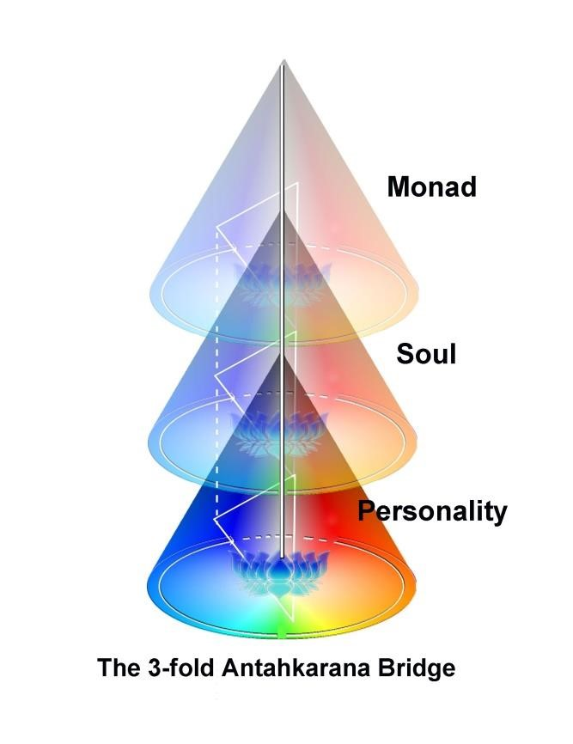
figure 13

Monad, soul and personality are superimposed one upon the other, by many petaled lotuses, the cone or vortex, and all are linked by multiple linking triangles. Three separate and sequential dynamics that make up an organism that is essentially “One Life” expressing itself in three different ways and through three different processes of energy transference.

LINKS TO SOUND HEALING
John Stuart Reed Sound Healing with Cymascope: https://www.youtube.com/watch?v=2-drCWgHg4g
http://science.hq.nasa.gov/kids/imagers/ems/visible.html
UV light kills bacteria: https://www.abc.net.au/news/2021-01-04/coronavirus-uv-lighthttps://www.abc.net.au/news/2021-01-04/coronavirus-uv-light-research-to-be-trialled-in-aged-care/13029358research-to-be-trialled-in-aged-care/13029358 http://sonatherapy.com/portfolio-item/moonlight-sonata-cyma
Beethoven’s Moonlight Sonata: https://www.youtube.com/watch?v=yojDu3E9jls https://www.medicinanarrativa.eu/sound-therapy-and-well-being-some-scientific-studies
Beethoven's Pathetique Piano Sonata made visible by CymaScope: https://www.facebook.com/watch/?v=568782517381032

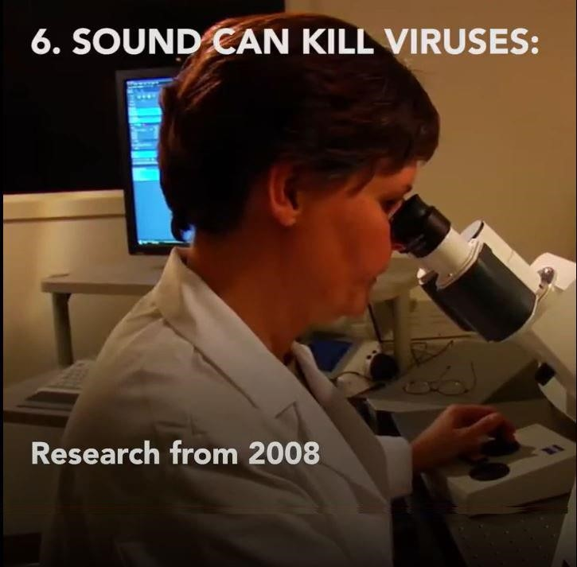

See Six Sounds: https://www.youtube.com/watch?v=7naHq_Jz5Ac
See the Dawning 4th Mountain School for a more esoteric outline of sound and how it will be used in the new Aquarium Age to further progress on the spiritual path:
http://www.light-weaver.com/content/%EF%BB%BFdawning-4th-mountain-school Rose
link

ON PRANA AND THE ETHERIC BODY
Until the medical profession can acknowledge the existence of the etheric body within man he will be forever stumbling in the dark with his many quick-fix solutions. On this subject of prana, DK had this to say in the next quote. (The links below open the two books of the publisher, Lucis Trust. All books available for purchase here: https://www.lucistrust.org/store/category/alice_bailey_books_p)
You can discover much on the nature of prana if you use the books which you possess and should possess. In my book A Treatise on Cosmic Fire, and in A.A.B.'s book The Light of the Soul, the whole subject is considered.
Suffice it to say that:
1. There is nothing in manifestation except energy, taking form, using and actuating forms and dissipating forms.
This energy is divided into three types of so-called electrical phenomena, called in The Secret Doctrine and in A Treatise on Cosmic Fire, fire by friction, solar fire, and electrical fire.
- Prana is the name given to the energy which is drawn upon the physical plane from the etheric aspect of all phenomenal life. That etheric aspect of the divine energy is a synthesis of energies. If the energy in which an individual primarily lives and moves and has the focus of his being is, for instance, predominantly astral, then the major expression of energy in his equipment will be astral or emotional feeling energy. He will react all the time to physical energy or prana and to astral energy or the many sentient emotional forces. These work out pre-eminently through the spleen, the solar plexus and the throat, and affect in different ways the physical spleen, the stomach and the thyroid gland.
[See comments and chart on the different centers outlined under figure 1]
- Interest in these two types of energy, when evidenced by an individual, is based on the fact that they are the two in which he himself is habitually immersed and to which he most easily and normally responds.
- The current of energy used in healing will be a synthesis of the energies with which the healer normally works, with that type of energy predominating which is, for him, the paramount energy of his life. The average unintelligent healer is usually simply a transmitter of prana itself, which is the energy of the planet. This combines with the etheric physical energies of the patient, passing through the healer's body. These stimulate the patient sufficiently so that he is enabled to throw off the enfeebling disease. Esoteric Healing, pp. 327-328

(Some of these quotes are rather long and technical, but are necessary to show a wider perspective and will save many lives if understood and the correct healing meditations and techniques followed.)
- The supply of the right chemical properties to the physical body will be studied—a science of chemistry which is yet in its infancy, though it is becoming a flourishing infant.
- An understanding of the laws of vitality will be regarded as of prime importance, and of this the emphasis today on vitamins and the influence of the sun are wholesome indications.
Esoteric Healing, p. 220
So much nutritional research has been done into the healing properties of certain herbs, flowers, vitamins and minerals since this passage was written by Alice A. Bailey in the 1940’s, all of which, amongst other healing properties, help bring in different types of prana. It is a wonder, and yet a disgrace, how the pharmaceutical industry, as well as much of the mainstream medical profession, have successfully keep these new healing influences out of the mainstream consciousness when COVID-19 is considered.

THE REFINING OF THE ETHERIC BODY
This coincides with that of the physical body. The method consists principally of living in the sunlight, in protection from cold, and in the assimilation of certain definite combinations of vitamins which before long will be given to the race. A combination of these vitamins will be formulated and made into tabloid form, with direct effect upon the etheric body. This will not be until that etheric vehicle is recognised by science, and definitely included in the training offered by the faculty of medicine. The study of etheric diseases—congestion and atrophy—will ere long be a recognised study, and will lead to definite treatments and formulas. As before said, all that you can now do in sensitising the dual physical is to attend to the above rules, and allow time to bring about the remainder of the work.
Letters on Occult Meditation, p. 338

This type of research on vitamins and chemical compounds referred to here by DK has been progressing for 75 years since this comment was first written, but most medical practitioners still refuse to administer vitamins and in many cases are outright banned by the CDC and medical profession as dangerous and no substitute for their vaccines and a long litany of drugs that are profitable. Even drugs such as Ivermectin, which is derived from natural and organic sources like penicillin are banned by the CDC when 39% of the world population is using this alternative successfully. An example of advances made in vitamin therapy can be seen in hundreds of recently publishes papers on the subject. An example of one is Dr. Levy who has explored and experimented extensively with vitamin C. Here is a short excerpt from one of his books on this subject, from here: https://madisonarealymesupportgroup.files.wordpress.com/2021/04/rapidvirusrecovery. pdf
Dr. Levy was vitamin C famous too. His Curing the Incurable: Vitamin C, Infectious Diseases, and Toxins was first published in 2002. Now, in its 4th edition, it has been translated into 7 languages. The title of Dr. Levy’s symposium presentation was The Optimization of Vitamin C and Antioxidant Therapy… Dr. Levy was an MD with certification as both a cardiologist and an attorney. Having read several of his now 12 books, I commented on their crispness and clarity of thought. One other major characteristic stood out: this doctor/ attorney was not afraid to challenge a pervasive medical bias against proven nutrient-based therapies. Dr. Levy had also come a long way in his scientific thinking in order to break free of the rigid medical school paradigm that all too often squelches original thought and insight. Over the next decade we were invited to travel to more than a dozen countries on four continents to educate open-minded clinicians on the numerous benefits of Intervenus Vitamin C (IVC). Coincidentally, the more we talked about high dose ascorbate, the more we questioned our basic understandings of just how IVC worked its medical magic. This evolving dialogue on the foundations of what we now know as Redox Medicine led Dr. Levy to pen several new books (including this one) that have dramatically pushed the envelope of our scientific understanding of both acute and chronic illness. His profound insights into the real ROOT CAUSES OF ILLNESS have resulted in the development of an array of simpler, more effective, and much less expensive treatments and lifestyle practices that cut at the etiologic heart of ALL respiratory viral illnesses, most infectious diseases, and the vast majority of complex chronic illnesses.

Standard medical protocol are often good at cutting out failing and diseased organs that could have been healed or regenerated first by the right application of certain healing techniques given by the Master DK in many of his books and outlined here.

ETHERIC HEALING
That disease, in its immediate cause, can be traced to the individual etheric body when the difficulty is purely local, or to the planetary etheric body (in particular the etheric body of the fourth kingdom in nature) where epidemics are involved, or to such a condition as war, affecting large masses of men.
Esoteric Healing, p. 275

The pandemic that is raging across the planet at this time historically is the result, as DK has outlined in the previous quote, because the planetary etheric body is congested and diseased and this is the result of the many imbalances in the psychic eco-system created by humanities refusal to honor the planetary life and its many diverse life forms, through excessive pollution as well as his incorrect and selfish thinking.
Alice Bailey had this additional statement to say on future alternative methods of exploration and healing as well as the need for alternative forms of medicine to become more professional and open to collaborate with the standard medical industry.

THE TRAINING OF THE PHYSICAL BODY
This involves certain definite requirements:—
The building in of matter of the higher subplanes and the elimination of the lower and coarser matter. This is needed because it is impossible for those with coarse bodies to contact high vibration. It is impossible for the (Spiritual) Ego to transmit the higher knowledge and guidance through a coarse physical body. It is impossible for the loftier currents of thought to impact the little evolved physical brain. Hence the refinement of the physical body is an essential. It is effected in various ways, all of them reasonable and utilitarian.
By pure food. This involves a vegetarian diet, chosen with wise discrimination; it requires the eating of only those vegetables and fruits that vitalise. Careful judgment shown in the choice of food, wise refraining from too heavy eating, and a little pure good food perfectly assimilated are all that a disciple requires. You ask what foods? Milk, honey, whole wheat bread, all the vegetables that contact the sun, oranges (above all, oranges), bananas, raisins, nuts, some potatoes, unpolished rice, and may I again reiterate, just as much of all the above as to insure activity.
Letters on Occult Meditation, pp. 335-356

Why does Alice Bailey make particular reference to oranges in this previous quote? Is it because they are like miniature suns and are one of the most potent foods that are surrounded and permeated by prana that comes directly from the etheric body of the sun? It is this prana, which has several manifestations, that vitalizes the etheric body which is man’s first line of defense from debilitating viruses and numerous illnesses.
These foods clearly have an important hidden dimension that cannot be understood nor scientifically proven by mere mental lower analyses. Vitamin C was only recognized by science in the 1930s when Albert Szent-Györgyi discovered the chemical ascorbic acid—also known as vitamin C—that enables the body to efficiently use carbohydrates, fats, and protein.
For hundreds of years, ocean going vessels that spent months at a time crossing vast expansions of water knew that the illness of scurvy could be avoided by eating fruits and vegetable. So here is a case where the proof was there, at least proof by a practical common sense definition, but there was no technical scientific proof until relatively recently. But it clearly worked. We will take up the idea and the difference of what has been called science and scientism somewhat later in this commentary.
It is clear from this line of inquiry that it is only in the recognition of newer forms of healing that we can reconcile this apparent impasse between conventional science and esoteric science. I say apparent, since the greater always includes and is aware of the lesser, but the lesser may not necessarily be aware of the greater until there is an expansion of consciousness.
When Alice Bailey states that many alternative techniques of healing are not yet
“scientifically proven”, she is also attempting to warn the reader of the necessity of dismissing or filtering out the fraudulent practitioners that could do them harm which are many. Yet clearly behind and woven in her commentary is the necessity of the medical establishments to train themselves in new and more advanced Aquarian techniques that incorporate the best that the standard medical profession has already developed. Added to that body of important knowledge must be the new and progressive discoveries in radiatory, electrical and magnetic healing techniques, as well as the recognition of new and dynamic forms of light pouring into our world from higher dimensions.
What we need for the 21st Century is the emergence of a group of trained mental intuitives and psychics that can peer behind the outer manifestations of things and see how energy and force make up the true man or woman, and the body for all of its temporary focus in our lives is just a shadow of far more important inner happenings.

ETHERIC VISION
The vital or etheric body, lying as the inner structure of the outer forms, will be seen and noted and studied in all kingdoms of nature.
c. This will break down all barriers of race and all distinctions of color; the essential brotherhood of man will be established. We shall see each other and all forms of divine manifestation as light units of varying degrees of brightness and shall talk and think increasingly in terms of electricity, of voltage, of intensity and of power. The age and status of men, in regard to the ladder of evolution, will be noted and become objectively apparent, the relative capacities of old souls, and young souls will be recognized, thereby re-establishing on earth the rule of the enlightened. A Treatise in White Magic, p. 335

HEALING DEVAS AND ANGELS
The Christ consciousness impacting the planet at this time will bring many grades of healing devas and angels to help purify humanity on an individual and collective level. This purification will also take place on an even larger scale because of certain Avatars who reside out of our system altogether and will come to the planets aid. Man’s invocative cry has been heard in high places, but without correct orientation and proper training these forces will disrupt and destroy the many impediments to a new wave of spiritual growth. http://www.light-weaver.com/content/devas-part-2.
This first wave of healing work is clearly under the stewardship of the first ray of the destroyer, in conjunction with different masters, and will bring a type of cleansing to the race of men by first lifting the unredeemed elemental substance to the surface and making it visible, then drive it out of the individual, group or planetary auric field. Only then can the soul apply the healing fires of the second ray.
“PURIFICATORY FIRE IS THE ONLY CURE FOR THIS MAGNETIC CORRUPTION”
A Treatise on Cosmic Fire, p. 839

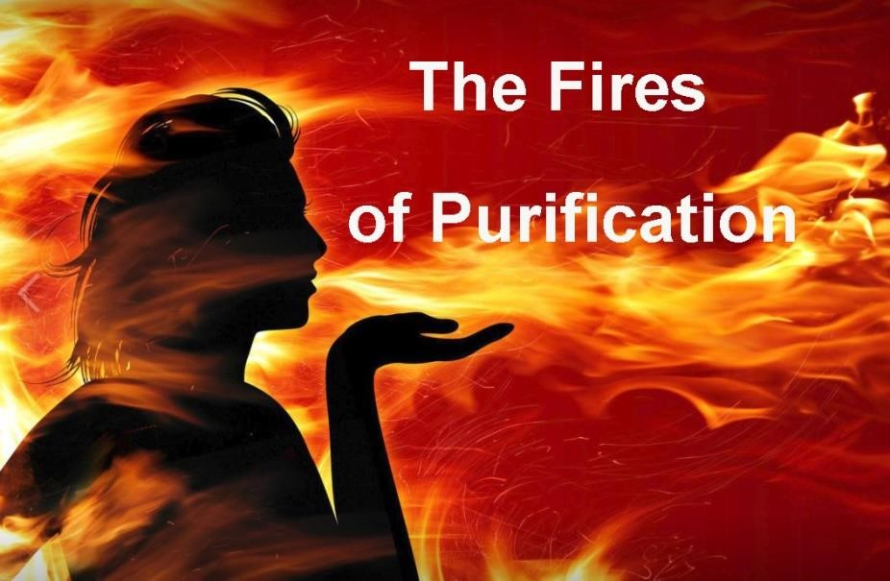
artist unknown

See this next link for a purifying meditation: Music, Gayatri mantra by Deva Premal

Fire Healing Video.mp4

The impact of Shamballa prophesized to emerge in its full power in 2025 is clearly a part of this planetary healing now taking place and can be felt by many in the New Group of World Servers as well as the advanced of humanity.
The current pandemic that is sweeping the world, as bizarre and incomprehensible as this may sound to the casual reader, is an intimate part of this planetary healing in its first phase. Over time these new spiritual forces will be seen to have brought numerous changes in the entire political, economic and religious systems that have become crystalized. What is needed above all else is a shift of consciousness by humanity onto the higher etheric levels of perception.
- That the etheric body has not hitherto been considered as an existent fact, from the angle of orthodox medicine, though there is a modern drift towards emphasis upon vitality, upon the vital qualities in food, and the giving of vitamin products in order to build up a vital response. This is the first indication of an unrealised need to increase the potency of the vital body.
- That the condition of the etheric body predisposes the subject to disease or protects it from disease, making man resistant to the impact of deteriorating or epidemic factors, or failing to do so because of inherent etheric weakness.
- That the etheric body is the mechanism of vital, pranic life, and "sub-stands" or underlies the outer, familiar equipment of the nervous system, which feeds and actuates all parts of the physical organism. The relationship existing between the centers/, the nadis and the entire nervous system comprises the field of the new medicine and indicates the new major field of research.
- That the main causes of all disease are two in nature:
a. They are to be found, first of all, in the stimulation or the nonstimulation of the centres. This simply implies the overactivity or the underactivity of any centre in any part of the body. Where the flow of energy is commensurate to the demands of the physical body at any particular stage of development, then there will be relative freedom from disease.
Esoteric Healing, pp. 274-275

(See chart titled Science of Centers, figure 1 where DK clearly outlines the linking triangles of energy and force that must be made from between the 1st and 5th initiation. Each progressive triangle when sufficiently developed insulates the student or disciple from certain emotional, psychological types of illness or disease that also has a corresponding physical organ, nerve, and glandular relationship. See also https://www.makara.us/05ref/03charts/charts_toc.htm)
We talk of the necessity of increasing human vitality and the vitality of animals and plants; the quality of the vitality-producing factors—food, sun and the coloured rays so widely used now—is creeping slowly into all medical thought, whilst even the advertisers of the tinned goods of our modern civilization lay the emphasis upon the quota of vitamins. This, esoterically speaking, is due to the shift of human consciousness onto etheric levels. Paralleling the growth of modern knowledge as to the "soul as intellect", we find a growth of understanding as to "the soul as life", though it remains as yet the great and apparently insoluble mystery.
Esoteric Psychology, I, pp. 375-376

DK spoke of the new schools of medicine that would be coming in the future and the areas of work they would initiate. To do this work would also be of assistance not only to humanity but the masters as well. These outlined requirements for the newer types of esoteric healing are over 75 years old and still to this day the medical profession is either unaware or deliberately hindering the majority of attempts to get this information out on the healing power of vitamins, natural minerals and herbs. This hindering is very easy for the medical profession under the stewardship of the huge pharmaceutical industry to do since they have such huge financial resources to create any law that sides or supports their work. All that is required to keep these advanced techniques out of the mainstream is to find a number of charlatans and quacks, who unfortunately are many, and point out how dangerous to the health of the public they are.
When this covid 19 panic finally begins to subside and reason begins to return and eclipses the present fear and paranoia there will be additional information on how counterproductive the vaccines actually were in many cases. See the next link. https://www.ncbi.nlm.nih.gov/pmc/articles/PMC9012513/
In this paper, we explore the scientific literature suggesting that vaccination with an mRNA vaccine initiates a set of biological events that are not only different from that induced by infection but are in several ways demonstrably counterproductive to both short- and long-term immune competence and normal cellular function. These vaccinations have now been shown to down regulate critical pathways related to cancer surveillance, infection control, and cellular homeostasis."

Let us give a small example of where the conventional medical professional, medical doctors, stand as opposed to Naturopathic medical doctors, to gain a wider historically perspective.
A Failure to Look at the Whole Person

NATUROPATHIC MEDICINE
It must be considered that the recent emergence of the Licensed Naturopathic Physician is a relatively new phenomenon. LNPs are comprised of those who have gone to medical school and are clinically trained, and they therefore can offer additional training through their alternative and preventative medicinal techniques that their standard medical doctor counterpart cannot. Most naturopathic doctors have some background in the idea of prana and the etheric body, or some variation of ancient yogic traditions that understand the importance of an electrical theory of man and the universe. The wide use and recognition of acupuncture, as well as the Rife machine, are two simple examples.
As of September 2021, the total number of professionally active physicians in the United
States amounted to 1,062,205 physicians. Compare that number to the 6,000 licensed Naturopathic doctors practicing in the U.S. Naturopathic physicians attend a naturopathic medical college, where they study the same coursework as traditional medical doctors. They also take a professional board exam to become licensed, but they aren't always recognized as medical doctors because they have a whole new dimension to their medical healing work. Most licensed Naturopathic doctors are familiar with the etheric body outlined here although it can be spoken of as Chi, Prana, Life Force, Energy, Qi, all of which generically speaking are the same force from different traditions.

FIRST ACCREDITED NATUROPATHIC MEDICAL SCHOOL IN OREGON OPENED IN 1956
Since Alice Bailey’s comments, licensed medical naturopathic healers have gained much momentum and influence in the medical profession – in spite of serious opposition by the standard medical establishment. Established in 1956, the National University of Natural Medicine (NUNM) was the first accredited naturopathic medical university in North America. Currently, 25 jurisdictions, 22 States, the District of Columbia, Puerto Rico, and the U.S. Virgin Islands have licensing or registration laws for naturopathic doctors (NDs/NMDs). In these jurisdictions, naturopathic doctors are required to graduate from accredited four-year residential naturopathic medical programs and pass an extensive post-doctoral board examination (NPLEX) in order to receive a license or registration.
When Bailey states that many alternative techniques of healing are not yet “scientifically proven”, she is attempting to warn the reader of the necessity of dismissing or filtering out the fraudulent practitioners that could do them harm. Yet, clearly behind and woven in her commentary is the necessity of the medical establishments to train themselves in the new and more advanced Aquarian techniques that incorporate the best that the standard medical profession has already developed, but adds to that body of important knowledge the new and progressive discoveries in radiatory, electrical and magnetic healing, as well as the recognition of new and dynamic forms of light pouring into our world from higher dimensions. There is a slowly emerging esoteric science that is based on the recognition and understanding that everything is electrical in nature and that energy and force are all simply different grades and variations of electrical charge or voltage.
The question I ask my reader is, why would a homeopathic medical doctor go to the trouble of prescribing homeopathic remedies if they are already a conventionally licensed MD? It must be a case where the conventional remedies prescribed may not have worked and they needed to do something additional. It appears that the naturopathic MD and their additional holistic training gives them additional resources and healing techniques the conventional MDs do not have and clearly do not understand. When you compare the conventional route of a standard MD to a naturopathic MD, it is clearly about different levels of sensitivity and evolution of consciousness.
https://www.irishtimes.com/news/health/why-are-doctors-so-against-alternative-medicinehttps://www.irishtimes.com/news/health/why-are-doctors-so-against-alternative-medicine-1.1881771.188177
In Britain, there are now more alternative medical practitioners than GPs, a remarkable development considering that, while the British public does not have to pay to visit their GP, they do have to pay to visit alternative medical practitioners. Clearly, alternative medicine is providing a valuable service.

The majority of medical doctors are quite dismissive of alternative medicine, and many doctors are positively hostile towards it. Doctors say publicly that this is because there is no scientific proof that alternative medicine actually works. I believe this is a smokescreen; the real reasons doctors are so against alternative medicine are much, much deeper. Doctors are scared of alternative medicine: they feel deeply threatened by it. Doctors have spent years of their lives studying and working within the modern medical health system. They feel entitled to reap the financial and other rewards that go with being a medical doctor. I believe it galls doctors to think that, after all their years of study, sacrifice and hard work, their patients are flocking to alternative practitioners whose beliefs about health are very different from those of the standard medical profession.
Ironically, in many ways doctors have only themselves to blame for the astonishing growth in alternative medicine. It is the medical profession's own dismissive attitude to alternative medicine; their almost total reliance on drugs as the only valid form of therapy; the major inadequacies of the medical system; and the medical profession's failure to look at the whole person that has driven people to look elsewhere to have their health needs met.
The question that we will continuously come back to in this paper is who can set the real criteria for understanding which therapies or practitioners are legitimate and which ones are bogus and fake? The medical profession has a huge incentive to throw them all into the same category. Who are the legitimate authorities who can be relied upon in a time of historical crises such as right now with COVID-19? Who can be impersonal and spiritually objective, and have the required training and esoteric skills to know the real difference between an esoteric healer and their fraudulent counterparts? Certainly not most of those who now reside in the standard medical profession, which are clearly dominated by the lower mind and lack any of the psychic or intuitive faculties of their naturopathic and alternative health counterparts and are largely controlled by the pharmaceutical industry and their profit model.
The answer to these previous questions that have been raised it is obvious to those who have studied the occult and esoteric sciences in great depth. It is clearly a great benefit to have a standard medical license, but until additional training in the perceptions of the subtle bodies is achieved there will always be serious limitations. What we need today in the healing profession are those individuals who are clearly of initiate status. And how will we recognize them? By their lifetime contributions to service, to the clarity of their thinking, and to the positions that they occupy in their esoteric groups and communities around the world, and lastly, which is clearly the most importantly quality and characteristic, by their capacity to love humanity.
These naturopathic healers that are emerging are a good sign of evolutions’ urge to go forward to the next level, as Alice Bailey has outlined, but they are clearly of a small minority and are emerging into a hostile environment.
Who reading this actually thinks that the medical profession, the pharmaceutical industry, as well as many huge corporations, would ever willingly support advanced healing techniques, which they have clearly demonstrated that they do not understand? The one true Spiritual Hierarchy which is poised to externalize in the coming cycle has to contend with what Bailey called “group selfishness” where they exhibit all those undesirable qualities on a group level that any individual person can exhibit personally, only on a larger and more inclusive scale.

VITAMINS AND HERBS
Putting esoteric orientation and treatments aside, in spite of decades of research on the value of vitamin supplements, such as vitamin D, A, zinc and C to boost the immune system, most medical authorities still refuse to recognize the scientific basis for the recommendation of certain supplements to reinforce and build a strong immune system.
As early as the end of September 2020, data from 14 observational studies— summarized in Table 1 of our paper—showed that vitamin D blood levels are inversely correlated with the incidence and/or severity of COVID-19. Many critics of vitamin D will claim that these associations are not causal. However, there are statistical tools such as the Bradford Hill criteria that can actually prove causation when these associations are strong enough. https://www.theepochtimes.com/florida-surgeon-general-promotes-nutraceuticals-forhttps://www.theepochtimes.com/florida-surgeon-general-promotes-nutraceuticals-for-covid_4166126.htmlCOVID_4166126.html
Here is an update and a report on the CDC’s position on vitamins. What is interesting is that this CDC summary stands in stark contrast to Dr. Fauci’s own recommendations in an interview with the actress Jennifer Garner.
Video of interview to be added later
ACP Internist Weekly | CORONAVIRUS | FEBRUARY 23, 2021

CDC UPDATES GUIDANCE ON COVID-19, STUDIES SHOW VITAMINS DON'T IMPROVE OUTCOMES
The CDC offered new guidance on immunocompromised patients and pulse oximetry's accuracy, and recent trials showed that vitamin D, zinc, and ascorbic acid didn't help COVID-19 patients but prophylactic anticoagulation did.

The CDC made multiple small updates to its guidance on COVID-19. On Feb. 18, it alerted clinicians that… Vitamin D3 did not improve outcomes in hospitalized patients with COVID-19, according to a study published by JAMA on Feb. 17. It included 240 Brazilian patients, half of whom were randomized to a single oral dose of 200,000 IU of vitamin D3 and half who were randomized to placebo. There were no significant differences between groups in median length of stay, in-hospital mortality, ICU admission, or need for mechanical ventilation. Mean serum levels of 25-hydroxyvitamin D were higher in the active treatment group (44.4 ng/mL vs. 19.8 ng/mL), suggesting that higher levels do not help. “The findings do not support the use of a high dose of vitamin D3 for treatment of moderate to severe COVID-19,” the authors concluded, although they cautioned that the results cannot necessarily be extrapolated to other geographic regions, which could have more vitamin D deficiencies.
Zinc and ascorbic acid don't help either, according to a trial of outpatients with COVIDhttps://jamanetwork.com/journals/jamanetworkopen/fullarticle/277630519 published by JAMA Network Open on Feb. 12. It randomized 214 U.S. patients with positive tests and symptoms in a 1:1:1:1 ratio to 10 days of zinc gluconate (50 mg), ascorbic acid (8,000 mg), both, or neither. The study was stopped early for futility. There was no significant difference among the four groups on the primary end point, the number of days required to reach a 50% reduction in symptoms. The authors concluded that these supplements should not be recommended for patients with COVID-19. “Most consumers of ascorbic acid and zinc are taking significantly lower doses of these supplements, so demonstrating that even high-dose ascorbic acid and zinc had no benefit suggests clear lack of efficacy. In addition, administering supplements with unproven benefit can be detrimental due to adverse effects,” they wrote.
One can only wonder why there is such a serious disconnect between Fauci’s own statements and the CDC’s standard medical protocol and approach to the use of vitamins, particularly D and C.
Let us take a small excursion into the past before proceeding into a number of healing traditions that use herbs, flowers and different organic condiments. There was once a practice in certain provinces in China a hundred years ago, where medical practitioners were only paid if they healed their patients. If their patient remained sick or died they were simply not paid. This is also true in certain indigenous groups where healing shamans were elevated to high positions of authority because of their ability to serve the community and heal other members in their group.
Motive is everything, and is clearly outlined in the first two stages of Raja Yoga by Pantanjali called yama and niyama which includes strict ethical guidelines.
This previous statement may sound utterly bizarre to a person or culture that is fully indentured to a capitalist system of corporate monopolies where everyone is stressed out by a medical system that fails to deliver what their profession is supposed to give, which is healing. This shocking reversal of roles that we have just outlined by alternative and earlier types of Chinese medical practitioners, even if only recognized as something theoretically, can give the reader a potential window into another reality and perhaps a better way to serve the people and heal certain viruses and illness.
The majority of their healing repertoire was invocation to healing spirits, ie (devas and elementals) herbs, flowers and natural organic compounds found in their native vicinity and forests. Who can remember far enough back in time when healing professionals such as medical doctors actually came to your house when you were in need of their help, and you knew them on a first name basis? This is not to say hospital and medical centers are not needed, but I ask my reader to compare that personal interaction of the past to the present huge medical industrial conglomerates we call the medical profession that now exists, with patients often treated as commodities or numbers. It has been estimated that the average time an MD spends with a patient in modern times ranges from eight to eighteen minutes.
I understand we would not want to roll back the advances of modern science to some previous era, but it is noteworthy that these many indigenous groups around the world, for all of their obvious limitations and lack of academic education, often had the right motives, as well as access to numerous healing modalities that were known to be effective. Here in the next section is a list of healing herbs and flowers that have been used in healing for thousands of years taken from the Bible as well as Jewish and Chinese traditional healing techniques.

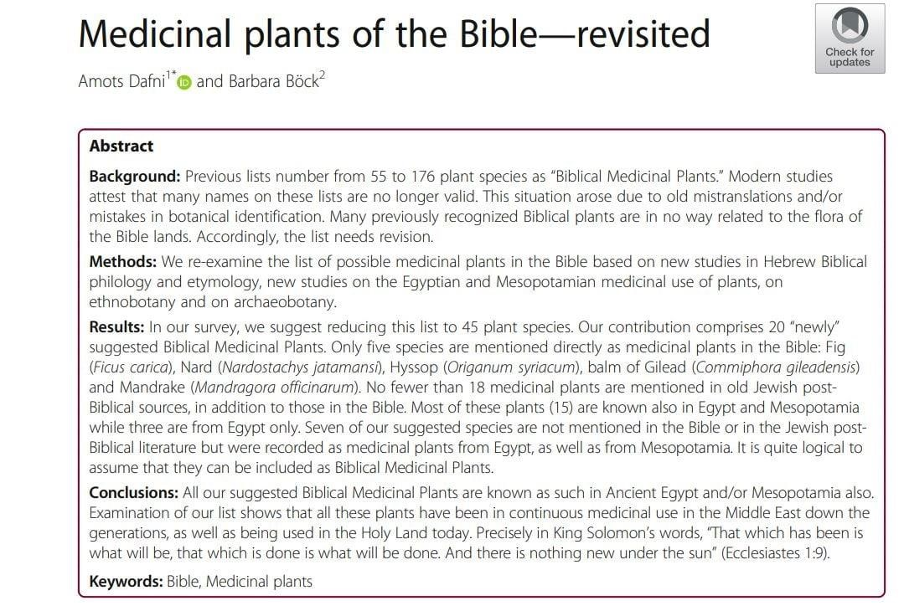

HIPPOCRATES: “LET FOOD BE YOUR MEDICINE”
The next few quotes no doubt can be taken metaphorically as well as literally. I have posted this information on Facebook numerous times and it was removed each time because it violated “community standards”.
I am neither for vaccines nor specifically against them in many instances. Itt all depends on so many factors and it would be imprudent to over generalize. I am simply interested in alternative forms of healing and finding what might be best for me.
Purge me with hyssop, and I shall be clean; wash me, and I shall be whiter than snow. Revelations 22:1-2 ESV

JEWISH INCENSE AND HERBS
And another angel came and stood at the altar with a golden censer, and he was given much incense to offer with the prayers of all the saints on the golden altar before the throne. (Frankincense, Myrrh gum resin, onycha and galbanum – and pure frankincense)
The book of Exodus lists four components of the incense, and the Talmud lists seven additional components from the oral Torah. The four components from the book of Exodus are:
stacte (נָ ָטָָף naṭaf) onycha (שחֵלֶתְׁ sheħeleth) galbanum (ֶחֶלְׁבְׁנָהָ ħelbbinah)
pure frankincense (לְׁבוֹנָהָ ָזָךְ levonah zakh)
The components are still being studied and are not determined with absolute certainty. Stacte is variously described as being the extract of the transparent portion of the myrrh resin which exudes spontaneously from the tree, or a balsam from a tree such as opobalsamum or a styrax. Onycha, which in Greek means “nail,” is variously described as being the operculum from a shell found in the Red Sea (which are said to resemble a fingernail), the exudation from the rock rose bush called labdanum (both petals and markings which are said to resemble a fingernail), Styrax benzoin, bdellium, or even cloves. Galbanum is generally considered to be Ferula galbaniflua. Also considered is a milder variety from the Levant or possibly even a close relative of Ferula galbaniflua called narthex (or giant fennel). Pure frankincense is the resin of a tree of the boswellia species. https://en.wikipedia.org/wiki/Incense_offering

Pointed masks” worn by plague doctors in 17th-century Europe are the brunt of many jokes. While the costume has been popularized by cosplay, video games and historical depictions of plague times, the reason behind the beaked masks was a complete misconception about the origin of historical disease – one that highlights advancements in the understanding of germs and viruses on one hand, but on the other demonstrates a clear misunderstanding of advanced occult healing techniques through the use of certain herbs resin, and flower remedies.
Full coverage at CTVNews.ca/Coronavirus
Tracking every case of COVID-19 in Canada: CTVNews.ca/Coronavirus

THE PLAGUE COSTUME DESIGNED TO COMBAT ‘POISONED AIR’
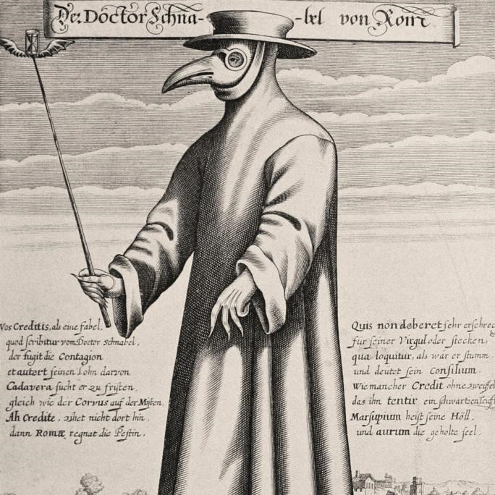
National Geographic

During the Middle Ages, an outbreak of the plague devastated Europe, killing around 50 million people… But the masks were more than just a barrier between doctors and patients.
Before the germ theory of disease, now the accepted scientific theory for many diseases, doctors believed that the plague was spread through poisoned air.
The beaked masks were filled with theriac, a mixture of more than 55 herbs and other compounds including ingredients such as cinnamon, myrrh, and honey. The shape of the beak was supposedly designed to give the air enough time to be cleansed by the herbs before it reached the nose.
According to the U.S. National Library of Medicine, theriac was widely used in Europe and the U.K. during the Black Death.
“The streets were to be kept clean and flushed with water in order to purify the air, fires were to be lit in streets and houses, and the burning of certain aromatic materials such as resin, tar, turpentine, juniper, cedar and brimstone was enjoined,” reads a document about the history of the compound.
“The use of perfumes on the person was recommended.”
Victims of the plague were also treated with variations of these herbal compounds.
These beaked masks were an attempt to kill or neutralize what was thought to be poison air which surely would fit into the current covid 19 mask requirements. The only difference is our contemporary use of masks today is simply to filter out the possible spread of the virus which was clearly know to become airborne, the other mask however bizarre its appearance actual did more than filter viruses (or what they thought at the time were poison gases) it actually killed the virus bacteria in spite of modern medical procedures that would find this idea utterly absurd and contrary to their protocol on how to deal with the subject.
https://www.ctvnews.ca/health/coronavirus/a-history-of-pandemic-masks-why-doctorshttps://www.ctvnews.ca/health/coronavirus/a-history-of-pandemic-masks-why-doctors-wore-beaks-during-the-plague-1.4890564wore-beaks-during-the-plague-1.4890564

TRADITIONAL CHINESE MEDICINE
(Natural News) The cures for SARS-CoV-2 have already been designed by God, prepared through evolutionary processes and synthesized by nature. More than 85 percent of COVID-19 patients in China are successfully treated using medicinal plants that have been studied extensively in the field of Traditional Chinese Medicine (TCM).
During the 2003 SARS epidemic, The National Health Commission of the People’s Republic of China studied hundreds of medicinal herbs and their principal constituents. These traditional medicines were also utilized in the COVID-19 treatment guidelines for treating hospitalized patients.
On February 17, Chinese health officials reported that all 60,107 cases of COVID-19 were successfully treated with TCM. The nation was exclusively using TCM to treat a vast majority of COVID cases at that time. Traditional Chinese Medicine utilizes thousands of synthesized molecular compounds that are extracted from various herbs, roots, barks, seeds, berries, flowers and other plant components. Many of these phytochemicals convey an anti-inflammatory effect on human cells, allowing the innate immune system to accurately surveil pathogens and effectively respond to those pathogens.
More than 16,500 plant compounds were studied to develop an effective treatment protocol for COVID-19.
Chinese scientists put 16,500 plant compounds to the test, measuring their individual and synergistic inhibitory effects against three viral proteins, 3-chymotypsin protease, papainlike protease, and RNA-dependent RNA polymerase. The plant compounds displayed vast antiviral and immune-modulating effects against these viral proteins and enzymes. Some herbs are capable of modulating the cytokine storm, observed in severe COVID cases.
The medical researchers conducted a pharmacology analysis on thousands of compounds isolated from each medicinal plant, and they discovered synergistic effects for a combination of these phytochemicals. The plants with the most effective combination of anti-inflammatory, anti-viral, immune-modulating phytochemicals were identified and studied for their therapeutic role in blocking viral attachment and mitigating the replication of SARS-CoV-2.
The plant-based compounds were studied in four critical areas:
- For impeding virus-cell receptor binding or suppression of virus self-assembly
- For stimulation of the host’s immunity through production of virulence factors
- For blocking virus entry into host cells through action on the host’s enzymes or cellular entry receptor
- For prevention of SARS-CoV-2 RNA synthesis and replication, through action on vital proteins and enzymes
The study put great focus on the plants that help mitigate hyper-inflammatory responses during COVID-19 infection. Covid-19 patients at greatest risk produce an uncontrolled number of cytokines, causing a “cytokine storm” of complications. The cytokine storm is the deadly, uncontrolled systemic inflammatory response. The medicinal plants with the most anti-inflammatory properties mitigate the cytokine storm and therefore save lives.
Top plants and phytochemicals for treatment of COVID-19
The top three most effective plants for treating COVID-19 included licorice root, (Glycyrrhiza glabra) chicory root, (Cichorium intybus) and hibiscus flowers (Hibiscus sabdariffa). Licorice root has history of effectiveness against multiple viruses. In randomized, controlled trials, licorice root also demonstrated both a reduction of mortality for COVID-19 patients and broad spectrum anti-viral activity against various causative agents.
The individual compounds with the greatest anti-inflammatory enrichment included quercetin, ursolic acid, kaempferol, isorhamnetin, luteolin, glycerrhizin, and apigenin.
Other powerful antiviral plants include olive leaf (Olea europaea), white horehound
(Marrubium vulgare), black cumin seed (Nigella sativa), garden cress (Lepidium sativum),
Judean wormwood (Artemisia Judaica), guava (Psidium guajava), chrysanthemum ( Glebionis coronaria), and Maryam’s flower (Anastatica). These plants contain all the correct compounds that target all three antiviral targets.
Plants that had action against two of the viral enzymes included: hairy willow herb (Epilobium hirsutum), chickpea (Cicer arietinum), and Kantarioun (Centaurea incana). Plants that had action against two of the viral proteins included: roselle (Hibiscus sabdariffa), German chamomile (Matricaria chamomilla), celery (Apium graveolens), and alfalfa (Medicago sativa).

https://www.naturalnews.com/2021-05-13-medicinal-herbs-effectively-treat-COVID19patients-chinese-hospitals.html

THE SUN: Benefits of Sunshine on Your Bare Skin
Analysis by Dr. Joseph MercolaFact Checked - June 04, 2022
STORY AT-A-GLANCE
Health care officials’ recommendations to avoid sun exposure unless you’re slathered in sunscreen have deprived humans of their fundamental need for sunlight
Dr. Paul Saladino, author of “The Carnivore Code,” delves into the many reasons why sunlight is so essential it could even be described as a nutrient
Nitric oxide is produced in response to UVA and this leads to vasodilation; there are also beta endorphins produced in your skin when it’s exposed to UVA and UVB
Exposure to UV light has benefits to the immune system; it affects cellular differentiation and can improve wound healing
Outdoor workers have been found to have a decreased risk of melanoma skin cancer compared to indoor workers; consumption of linoleic acid from seed oils may increase your risk of sunburn and skin cancer
The key to gaining the benefits of sunlight while minimizing the risk of sunburn is to gradually build up what Saladino refers to as your solar callus
Health care officials’ recommendations to avoid sun exposure unless you’re slathered in sunscreen have deprived humans of their fundamental need for sunlight. In the video above, Dr. Paul Saladino, author of “The Carnivore Code,” a book on nose-to-tail animalbased eating, and host of the Fundamental Health Podcast, delves into the many reasons why sunlight is so essential it could even be described as a nutrient.
“It’s been a critical part of our evolution throughout our existence,” he states.¹ “Sunlight, real sunlight, is essential for optimal human life. You cannot be an optimal human without … adequate levels of real outdoor ultraviolet infrared visible spectrum light from the sun in the sky when you are not wearing sunscreens.”²
If more people spent time in the sun — not getting sunburned, but getting gradual exposure and gradually building up your skin’s tolerance — Saladino explains that rates of many types of cancers would likely go down and there would be fewer cardiovascular disease deaths and fewer cases of seasonal affective disorder, while improvements would be seen in many other diseases, such as rheumatoid arthritis and schizophrenia.³ This is the power of the sun.
Cancer Rates Rise With Distance From the Equator
When you put on sunscreen to “protect” your skin from the sun, you’re not only exposing your body to toxic chemicals in the sunscreen but also inhibiting the complex interactions that occur between ultraviolet (UV) light from the sun and your skin.
Nitric oxide, for instance, is produced in response to UVA and this leads to vasodilation.
There are also beta endorphins produced in your skin when it’s exposed to UVA and UVB,⁴ and strong associations with cancer can be found depending on your location in relation to the equator.
“With increasing distances from the equator,” Saladino says, “we know that there are higher rates of colon, breast, pancreas, ovary, brain and kidney cancers, and the blood cancer multiple myeloma — as you move farther from the equator.”⁵ Tuberculosis is another disease that’s been correlated with sun exposure.⁶ In 1903, Niels Ryberg Finsen was awarded a Nobel Prize⁷ for his use of solar heliotherapy, or exposure to sunlight, to treat diseases such as tuberculosis.
“Once the anti-tuberculosis drugs were developed this type of therapy fell out of favor, but there were solariums there were these hospitals throughout the desert southwest. I went to medical school at the University of Arizona in Tucson and some of the places I did rotations were previously hospitals for tuberculosis patients who were put into the sun, and there was some improvement in their disease,” Saladino explains.⁸
Exposure to UV light also has benefits to the immune system. “It affects cellular differentiation. It can improve wound healing … I don’t think many people think about putting their wounds in the sun to help with healing, but the sun does help.”⁹
Sunlight Benefits From Vitamin D and Beyond
The fact that your skin produces vitamin D in response to sun exposure is another clue that it’s beneficial. Vitamin D upregulates your ability to fight infections, as well as chronic inflammation, and produces over 200 antimicrobial peptides (AMPs), one of which is cathelicidin, a naturally occurring broad-spectrum antibiotic.
The cathelicidin antimicrobial peptide, or CAMP, is made by immune cells and skin and gut cells, which act as a barrier to infection.¹⁰ A wealth of data also show that vitamin D levels are strongly correlated with the severity of SARS-CoV-2 infection.¹¹ Saladino has visited the Hadza tribe in Africa, who are among the best still-living representations of the way humans have lived for tens of thousands of years.
He credits their regular sun exposure, as well as their native diet, for their lack of chronic diseases seen in modernized societies:¹²
“There is good observational epidemiological research that levels of vitamin D above 30 nanograms per milliliter (ng/mL) were quite protective and if we think about this evolutionarily, groups like the Hadza and the Maasai evolve at the equator. They have a lineage there that is many hundreds, thousands of years old.
Their vitamin D averages around 46 to 48 ng/mL, which I suggest is an evolutionarily appropriate level and probably good for most humans.”
To ward off infection and prevent chronic diseases, the level you're aiming for is between 60 and 80 ng/mL, with 40 ng/mL being the low cutoff point for sufficiency to prevent a wide range of diseases, including cancer. The key is to get your vitamin D from the sun, not supplements. It’s important to understand that vitamin D is not the only benefit of sunlight. In fact, vitamin D is more than likely a biomarker or surrogate for sun exposure, which is also intricately involved in melatonin production.
During the day, if you get proper sun exposure, near-infrared rays from the sun penetrate deep into your body and activate cytochrome c oxidase, which in turn stimulates the production of melatonin inside your mitochondria. Your mitochondria produce ATP, the energy currency of your body. A byproduct of this ATP production is the creation of reactive oxidative species (ROS), which are responsible for oxidative stress and free radicals.
Excessive amounts of ROS will damage the mitochondria, contributing to suboptimal health, inflammation and chronic health conditions such as diabetes, obesity and thrombosis (blood clots). But melatonin essentially mops up ROS that damage your mitochondria. So by getting plenty of sun exposure during the day, your mitochondria will be bathed in melatonin, thereby reducing oxidative stress.^{13,14} Saladino adds:¹⁵
“I would advise you to get your vitamin D from real sunlight because of the other benefits of real sunlight — endorphins, nitric oxide, perhaps other cholesterol molecules like cholesterol sulfate. We don't even, I think, understand all of the benefits of being in the sun. There are so many associations with latitude that suggest it could be deeper than vitamin D.”
Sunlight May Affect Your Microbiome
To understand solar energy, it helps to be aware that 39% of the solar spectrum is what we see as visible light. The majority of the solar spectrum, 54.3%, is infrared,¹⁶ which is not visible but rather felt as heat. Ultraviolet light accounts for only 6.8% of the solar spectrum, and vitamin D is specifically produced in response to UVB radiation, which is only a small part of the ultraviolet spectrum.
It's the exposure to this full spectrum light that yields the most benefits, of which most are likely still unknown. Melatonin, for instance, is produced inside your mitochondria in response to near-infrared radiation, which is part of the infrared spectrum. Exposure to another type — narrow bank ultraviolet B, or NB-UVB — leads to another little-known benefit — modulation of the human intestinal microbiome.¹⁷
Study participants were divided into groups that took vitamin D supplements during the winter prior to the study and those who did not. They were then exposed to NB-UVB three times during a one-week period.
Not only did vitamin D levels increase in both groups, but the light exposure significantly increased alpha and beta diversity in the group that didn’t take vitamin D, and bacteria from several families were enriched. The researchers proposed that a skin-gut axis may exist that affects the gut microbiome, and it appears to be mediated by sunlight:¹⁸
“This is the first study to show that humans with low 25(OH)D serum levels display overt changes in their intestinal microbiome in response to NB-UVB skin exposure and increases in 25(OH)D levels, suggesting the existence of a novel skin-gut axis that could be used to promote intestinal homeostasis and health.”
Melanoma Is Not Always a Sun-Associated Cancer
The question many have with regard to sun exposure is whether it will increase skin cancer risk. Melanoma is considered to be the deadliest form of skin cancer, but data do not support the common rhetoric that it’s caused by sunlight.
In one study of outdoor workers and skin cancer risk in Europe, although they had more UV exposure both during work and leisure time and less sunscreen use compared to indoor workers, “No significant associations were found for melanoma.”¹⁹ “This finding is corroborated many times in the literature,” Saladino said. “There is a lot of literature to suggest that there are perhaps multiple roads to melanoma, not all of which are related to the sun.”²⁰
Likewise, in a rapid review published in The Lancet it’s noted that outdoor workers have been found to have a decreased risk of melanoma compared to indoor workers,
“suggesting that chronic sunlight exposure can have a protective effect.” It’s also noted that while some melanomas do form on areas of the skin exposed to sun, others form on areas that rarely see the sun.
“So clearly getting burned when you were a kid is a bad thing. You don't want that to happen, but is melanoma truly a sun-associated cancer? I would say no. I think there is clear evidence that melanoma is not always associated with the sun,” Saladino says.²¹
Melanoma Linked to Linoleic Acid
Saladino points out a study from 1987,²² during which samples of fat tissue were taken from 100 melanoma patients and 100 people without melanoma and analyzed for fatty acids.
Not only is there an increase in linoleic acid in the tissue of all the subjects, but the percentage of polyunsaturated fatty acids (PUFAs) is significantly higher in the melanoma patients’ tissue. “The suggestion is made that increased consumption of dietary polyunsaturates may have a contributory effect in the etiology of melanoma,” the researchers concluded.²³
Linoleic acid is the primary fat found in omega-6 polyunsaturated fats, including vegetable/seed oils, and accounts for about 80% of the fat composition of vegetable oils. Omega-6 fats must be balanced with omega-3 fats in order to not be harmful, but most Americans don’t eat that way.
Most of the omega-6 people eat, including seed oils, has been damaged and oxidized through processing. Once oxidized, it generates oxidized linoleic acid metabolites, which are mutagenic, carcinogenic, cytotoxic and atherogenic.²⁴ According to Saladino:²⁵
“Is it possible that increased linoleic acid consumption could be causing fragility to cell membranes and that could be leading to oxidative damage in the sun leading to DNA damage and then more melanocytic nevi precursor lesions or melanoma or could the same thing be happening with squamous and basal?
I would say yes. It's not supported by literature yet because there haven't been any studies looking at this. We need many more studies with linoleic acid … I have major concerns that linoleic acid found in seed oils is one of the biggest drivers of chronic disease in humans.”
Linoleic acid is found in virtually every processed food, including restaurant foods, sauces and salad dressings, as well as “healthy” foods like chicken, pork and some olive oil, so eliminating these foods in your diet is another stepping stone to good health.
Build Up Your Solar Callus
The key to gaining the benefits of sunlight while minimizing the risk of sunburn is not to use sunscreen, which typically contains endocrine-disrupting chemicals, but rather to build up what Saladino refers to as your solar callus:²⁶
“If you are light skin, cover up, get a small amount of sun exposure, develop your solar callus … get that UVA and UVB into the different layers of your skin. Get that UVBproducing melanin gradually dark and gradually think about being in the sun. As a piece of homework that is my prescription for you, get into the sun gradually … this is your chance to fill up your sun reserves.
That's vitamin D and other compounds that are produced from the sun in your skin and stored in your body but do that gradually. If you're going to be out in the sun too long to safely be in the sun without burning based on your relative amount of melanin in your skin, then cover yourself.”
Be aware, however, that your diet also plays a significant role in your propensity for sunburn. High intake of linoleic acid raises your risk for sunburn while eliminating seed oils from your diet will dramatically reduce your risk of sunburn and skin cancer, as susceptibility to UV radiation damage is controlled by the level of PUFAs in your diet.
It’s almost like a dial. The PUFAs control how rapidly your skin burns, and how rapidly you develop skin cancer. Saladino points out that psoralens, which are found in certain plant foods like celery and parsnips, can also be problematic, as they make your skin more sensitive to sunlight. The take-home message, however, that Saladino stresses is this:²⁷
“Do not fear the sun, my friends. Don't get burned, but do not fear the sun — put it on your whole body, see how it feels … If you are in a place where you cannot get sun for much of the year either consider moving or I would consider a tanning bed, look for perhaps a tanning bed that has some level of UVA and UVB that mimics the sun.”

A PILL FOR EVERYTHING
Alice Bailey mentioned that the best of progressive research into new healing modalities and use of vitamins should be fused with the advances in modern medicine, but this has clearly not happened to any appreciable degree.
Mankind has unfortunately become hypnotized by modern medical technology with its endless array of sleek and shiny machines and its endless medications that promises to heal every known illness. Many of these modern technologies are however often a testimony of how ineffective the medical professions’ actually is and their inability to address the deeper levels of illness. Preventive medicine has unfortunately been overshadowed and eclipsed with expensive therapies and drugs of every conceivable type that often prolong or extend the illness rather than curing the cause of it. The current medical professions have unfortunately replaced man’s knowledge of how to heal themselves and strengthen their own natural immunity rather than relying outside sources.
Because the current medical profession cannot find the source of true healing that clearly resides on deeper psychological and spiritually levels, it too often masks illness with an army of secondary and peripheral applications with their endless array of pills, drugs and mineral substances.
Alice Bailey had this to say about mineral substance and how they are often incompatibility with the human constitution”
One of the great errors into which the human family has fallen has been the endeavour to administer mineral drugs to man for medicinal purposes. It has resulted in a combination of deva substances which was never intended. The relation of man to the lower kingdoms, and particularly to the animal and mineral, has brought about a peculiar condition in the deva world and has tended to complicate deva evolution. The use of animal food (and the use of minerals as medicine in a lesser degree) has produced a commingling of deva substance, and of vibrations which are not attuned to each other. A Treatise on Cosmic Fire, p. 646

This previous quote if correctly understood sums up the key to understanding one of the main arguments by many white magicians, alchemists and esotericists who are against many types of vaccines and inoculations.
There is a hierarchy of energies and forces in the universe, like a type of hidden periodic table of psychic elements that one needs to know and understand to be able to maintain the correct order, balance and sequence of things.
There are human laws and protocols, and there are spiritual laws and protocols. These can easily be confused; one for the other, and only an initiate or adept of white magic will clearly know the differences.
See the next two images. Every twist or turn of the spiral leads to a higher or more expanded principal, law or life form.

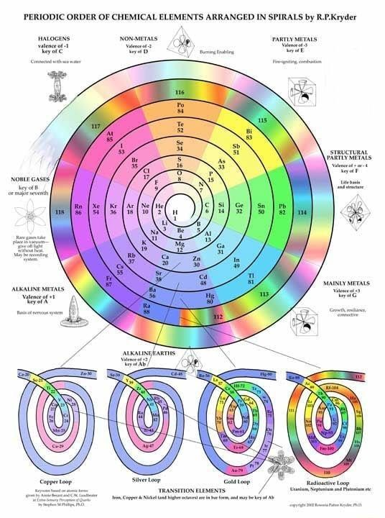
figure 14

_{FFFigu re} ₁₄
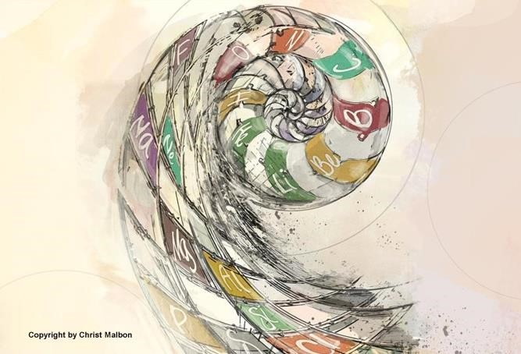
figure 15

The scientific periodic table of elements should be seen as a reflection of an inner hierarchy of an even greater outline of energies and forces that are almost impossible to understand without direct subjective contact or at least some type of tabulations or charts that however limited in scope will help galvanize the higher mind and intuition into greater comprehension.
Compare the two images above titled figure 14 and 15, with the image titled figure 12, to see a linking parallel of the exoteric and known scientific principals with a parallel but higher set of spiritual principals, which are veiled and hidden. It is only through the power of analogy, or through the law of correspondences that any light can be shown on the vast and complex details of the occult path. One needs to understand that certain energies or forces are not compatible with other energies and forces, and their incorrect fusion or mixing can throw the whole inner etheric eco-system out of balance and bring much suffering, illness and death.
Is there anyone who cannot see the obvious contradiction between humanity getting proportionately sicker and sicker every year, while the medical and pharmaceutical industries keep getting more robust and healthy with their huge profit margins and economic bottom lines?
This is not to say that there are not millions of healthcare workers who have not dedicated their lives to assisting those in need, and are often the real unsung heroes of this present pandemic situation, but it must be taken into consideration that when all is said and done that they get their directions from higher up the economic ladder and not from their conscience.

VITAMINS, HERBS, AND ETHERIC CONTROL
Why is the medical establishment so unresponsive to the value of vitamins on one hand and so outright antagonistic and hostile on the other? According to DK, there are principal factors in establishing true etheric strength and have a direct and reciprocal effect on the immune system, hence the physical body. Strengthening and purifying your immune system is always your first and most important front line defense against viruses and diseases.
The principal factors in re-establishing or making a better etheric control are:
- Sunshine.
- Careful diet, with the emphasis upon the proteins and vitamins.
- The avoidance of fatigue and worry.
A normal, sane, regulated life is the best means for establishing a better measure of vitality...
Esoteric Healing, p. 327 (Truncated and reduced)

Prana is the energy that floods the entire etheric body and its many channels, sweeping aside any obstructions which bring vitality to the entire physical organism.

THE PROPHECY OF DJWHAL KHUL
How many reading this commentary have felt that the order or timing of certain things that DK prophesized has not been on schedule, or not actually taken place in the time frame he outlined?
If there is any element of truth to this idea, it is surely not the responsibility of the masters of wisdom who periodically meet in cyclic conclaves to decide what energies or forces should be the next in line to be precipitated down to humanity to stimulate their next level of spiritual development. It is the result of humanity’s actions – or perhaps I should say re-actions – to these high Aquarian energies pouring into the world and which are being incorrectly responded to. Humanity has free will, although from an esoteric or occult perspective this personal will hardly expresses or embodies true occult freedom, and will often delay certain aspects of the spiritual plan if not keyed up to the will of the soul. Until the third initiation, according to DK, we are all prisoners of the planet and are dominated by one or more involutionary elementals we call the physical-etheric, astral, and lower mental bodies.
The following is a quote by DK that can bring some additional insight onto this subject of how the masters of wisdom can never know entirely in the short term how humanity will respond to their great gifts and down pouring of spiritual light, love and power.
All these planetary developments are attended by risks, and none more so than that of the absorption of light—on a world-wide scale—by humanity, with a subsequent reflex action on the three subhuman kingdoms. Nothing which affects humanity or which stimulates it to a forward-moving activity is without its inevitable effect upon the three lower kingdoms in nature.
Discipleship In The New Age, II, p. 328

It is not unusual, as we have outlined in previous sections of this commentary, that when high devic and angelic force, wielded by the Reappearances of the Christ, (and to a lesser degree the New Group of World Servers) interfaces or impacts directly with unredeemed lower elementals, there is a temporary crises and clashing of opposites as well as an upswing in lawlessness. This crisis can be felt in the mineral kingdom, the animal kingdom, and the human, and is what is meant as a “subsequent reflex action on the three subhuman kingdoms” in DK’s previous quote.
In other areas of development, certain members of humanity have clearly created a surge forward and excelled well beyond the hierarchy’s anticipation. This is a subject we will address in another commentary, but let us leave the reader for now with a brief window of insight into this idea.
Because of recent developments in new communications technology through the internet and electronic information highways (a direct expression made possible by the recent evolution of the planetary etheric body) many individuals and groups that have been marginalized, or would have remained obscure and hidden from public view, now have a forum to share their important spiritual contributions and insights. This newer method of communication can bypass the retrogressive groups and their limitations and inertia.
Economically, as an example, we can see this in the stimulus behind the new blockchain technologies and crypto-currencies that will eventually replace fiat money in the coming years. The old established monetary systems will try to hold this new technology back, as they are now doing, since it will clearly undermine their exclusive control of monetary transferences and distribution. While in the early stages they may have been somewhat successful in stalling out its development, or even integrating parts of it into their old corrupt models of economic governance, time will prove the wisdom and accuracy of this statement.
We must always keep in mind that many new innovations and technological developments are invariably used for selfish purposes at first but in time they will find their rightful place as these new toosl can now assist in humanities moral and spiritual growth. The computer is such an example. Now in 2022, the computer is clearly a revolutionary tool for the transference of information and knowledge in inconceivable ways, and although unrecognized by most, it has created a spiritual electronic grid that is a direct expression of the planetary etheric body. See this site for greater clarification of the idea of an etheric grid: http://www.light-weaver.com/LW-old/vortex/2triangles.html

TRIANGLES AND HIDDEN DIMENSIONS
The triangle as well as the different polyhedral forms it makes has been one of the keynotes of all esoteric schools and their line of research and study.
According to The Tibetan, the triangle is the geometric form behind all manifestation and underlines all spiritual development. It represents the divine triplicity of will, love and intelligence. The planetary logos in its high estate must eventually replace its present etheric body of squares with a finely knit grid of triangles. By changing this geometric structure of the planetary body powerful spiritual forces can now pour unimpeded into the planetary etheric body.

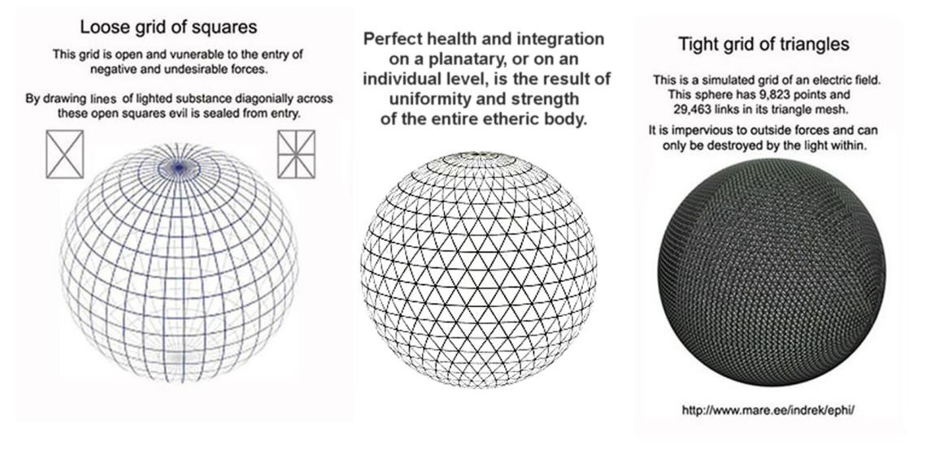

The next illustration links the science of triangles to the vortex and how these vortices are built or positioned upon the outer surface of any sphere.
The most esoteric definition of the nadis that make up the lattice work of the etheric body is tubular vessels. Spheres or vortices, as we have demonstrated, have entrances and exits on multiple levels and these spherical lives are intimately communicating amongst themselves when tightly connected with each other. We have discussed extensively the different techniques to insulate the individual person or group from illness and disease through natural immunity and the strengthening of the etheric body by certain types of orientation. This work however is only a stepping stone and prelude to a wider and more progressive type of healing that involves the entire planet.

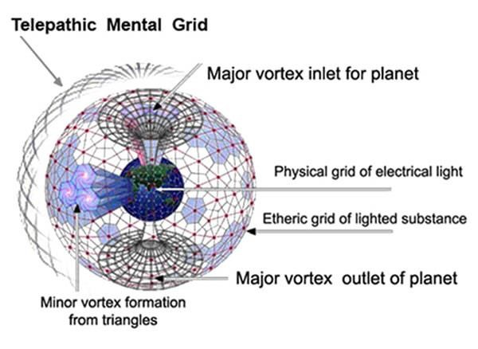

On even higher levels than the etheric plane, Master DK said that by surrounding the planet with buddhic light and saving magnetism the hierarchy prevents the influx from cosmic evil or decaying constellations from periodically overflowing onto the planet, the closeness of the moon to our planet and its magnetic corruption is just such an example on a much diminished scale.
The only cure for "magnetic corruption" according to DK is "purification by occult fire". See A Treatise on Cosmic Fire, p. 838
When the idea of "sealing the door where evil dwells" is linked with all of the information given here and in other commentaries by the author on the vacuum, vortex, and triangles, a key hint will be provided for advanced individual and group work.

ADVANCED HEALING TECHNIQUES
Let’s review another quote by the Master DK that gives us a glimpse into what might be taught or explored in the new healing schools of medicine. Alice Bailey stated (under the heading “application of the laws of magnetic vibration”: A Treatise on Cosmic Fire, stated that the use of drugs and surgical operations will be eventually replaced by a focus on preventative medicine.
This revelation will come when medical men accept this teaching as a working hypothesis, and then begin to note, for instance, the powers of endurance shown by the great souls of the earth, and their capacity to work at high pressure, and to remain practically immune from disease until (at the close of a long life of usefulness) the Ego deliberately chooses to "die-out" of physical existence. It will come when the medical profession concentrates upon preventative action, substituting sunshine, a vegetarian diet, and the application of the laws of magnetic vibration and vitality for the present regimen of drugs and surgical operations. A Treatise on Cosmic Fire, pp. 812-813

It is only possible at this time to cover some of the most superficial aspects of the
Tibetan Master’s ideas and his extensive outlines on healing techniques. It will require that the reader research for themselves these important ideas and come to their own conclusion.

NEW HEALING SCHOOLS OF MEDICINE
On the different levels of healing, DK had this to say:
The inference then is that there are two sets of powers latent in his human equipment— the lower one being recoverable if he deem it desirable, the other and higher one to be developed. These two sets of powers are:
The ancient powers and faculties which humanity developed and possessed in past ages and which he drove into the background of his consciousness and below the threshold of his current awareness in order to develop the mind and thus become himself a conqueror and a personality.
The higher powers and faculties which are the prerogative of the conscious soul. These are the greater powers to which the Christ referred when He promised His disciples that someday they would do greater things than He had done.
It should be remembered, however, that all the psychic powers are the powers, faculties and capacities of the One Soul but that, in time and space, some of them are expressions of the animal consciousness or the animal soul, some of the human soul, and some of the divine soul.
The following condensed tabulation and outline in there order of development shows these three classifications of the developing psychic powers that can be used in healing when developed.
Animal: Healing through animal magnetism
Human: Healing through science
Divine: Healing through spiritual magic.
(condensed and truncated)
Esoteric Psychology, II, pp. 559-560

One can see from this previous outline the important position conventional science occupies between the past and the future; it is clearly an intermediary bridge. It’s not that scientific techniques of healing are going to disappear because of new and more advanced healing treatments or techniques are adopted. Rather, they will be fused together as a totally new science that will include all of man’s bodies and not just the physical.
Before sharing additional insights by Alice Bailey, let us expand slightly and give some additional insights into how she saw conventional and esoteric healing progressing into the future:
Naturopaths of many kinds, professors of methods of healing by electricity or light and colour, food dietitians with infallible cures for all diseases, the many who practice systems founded on the Abrams mode of diagnosis, and many advocates of the chiropractic methods, as well as the various healing systems which are completely divorced from medicine but which undertake to bring about cures, are all indicative of new and hopeful trends; they are nevertheless extremely experimental in nature, and are so fanatically endorsed, so exclusive of all recognized methods of healing aid (except their own), so violently opposed to all the findings of the past, and so unwilling to cooperate with orthodox medicine that, in many cases, they constitute a definite and real danger to the public. It is largely their own faulty approach which is responsible for this; their undoubted ignorance of the nature of the human body, their attack on existent medical practices (even of proven value), and their biased belief in the infallibility of their experimental techniques, have brought them under the attack of the rigidly orthodox medical practitioners and of the fundamentalists within the ring-pass-not of academic medicine. Yet within the ranks of medicine are many enlightened men who would gladly cooperate if the small and vociferous cults would relinquish their exclusiveness and be willing to cooperate and accept that which the divine instinct in man down the ages has taught in connection with the healing of the human body. It will be through the collaboration of the new experimental schools and the older and proven methods that the medicine of the future will be developed. The value of all the many groups—good and indifferent—lies in the fact that they point the way towards new trends and indicate the lines along which the medicine of the future can enrich itself and become better adapted to man's need. They are too experimental as yet to be trustworthy, and are not yet scientifically proved. They are pioneering groups, and have a real contribution to make, but this will only be possible if they refuse to divorce themselves from the past and are willing to compromise in the present. Academic medicine is the result of the God-given gifts of the human mind; it is a proven divine expression and a most beneficent force in the world, in spite of human weakness, commercial exploitation and many mistakes. It is the same with religion. Both of these great sciences must eliminate the reactionary and fundamentalist positions, and then proceed with an open mind into the new ways of approach to divinity and of approach to physical well-being.
It might therefore be said that the main contribution which I am making at this time is to indicate the causes of disease and ill health which are not recognized by orthodox medicine, which deals with the effects of these subtle causes as they work out in the physical body and the nervous system. I am not dealing (as I have earlier warned you) with the symptoms of disease, with medical diagnosis or with systems of applied physical means to bring about cures or to ameliorate conditions. These have kept pace with man's growing capacity to discover and to know.
Let me reiterate that I am laying the foundation for an approach to the subject of the physical body in health and disease which will deal primarily with the etheric body. This should eventually lead to an accumulation of knowledge anent energy, its focal points and distribution in the etheric body, which will equal that already gained in the field of exact physical knowledge, and that exact knowledge is a fact.
Esoteric Healing, pp. 280-281

When Alice Bailey states that many alternative techniques of healing are not yet
“scientifically proven”, she is attempting to give credibility to these new alternative types of healing but always with the important discriminatory faculties that can filter out the fraudulent practitioners that could do harm.
There is a slowly emerging esoteric science that is based upon the recognition and understanding that everything is electrical in nature, and that energy and force are all simply different grades and variations of electrical charge or voltage.
On this subject, Bailey stated:

ETHERIC VISION
. . . b. The vital or etheric body, lying as the inner structure of the outer forms, will be seen and noted and studied in all kingdoms of nature.
c. This will break down all barriers of race and all distinctions of color; the essential brotherhood of man will be established. We shall see each other and all forms of divine manifestation as light units of varying degrees of brightness and shall talk and think increasingly in terms of electricity, of voltage, of intensity and of power. The age and status of men, in regard to the ladder of evolution, will be noted and become objectively apparent, the relative capacities of old souls, and young souls will be recognized, thereby re-establishing on earth the rule of the enlightened.
Note here, that these developments will be the work of the scientists of the next two generations and the result of their efforts. Their work with the atom of substance, and their investigations in the realm of electricity, of light and of power, must inevitably demonstrate the relation between forms, which is another term for brotherhood, and the fact of the soul, the inner light and radiance of all forms.
The third development, which will be the last probably to take place, will be more strictly in the realm of what the occultists call magic. It will grow out of the study of sound and the effect of sound and will put into man's hands a tremendous instrument in the world of creation. Through the use of sound the scientist of the future will bring about his results; through sound, a new field of discovery will open up; the sound which every form in all kingdoms of nature gives forth will be studied and known and changes will be brought about and new forms developed through its medium. One hint only may I give here and that is, that the release of energy in the atom is linked to this new coming science of sound.
Treatise on White Magic, pp. 335-336

Since Bailey wrote this, Licensed Naturopathic healers have gained much momentum and influence in the medical profession, in spite of serious opposition by the standard medical establishment.
Keeping in mind, Licensed Naturopathic physicians have gone to medical school and are clinically trained; therefore, they can offer additional training through their alternative and preventative medicinal techniques than their standard MD counterpart.
From these statements by Bailey, we see the need for further integration and cooperation from both regular MDs and naturopathic medicine, the later which has made many important inroads into understanding what Bailey outlined as prana, the etheric body, as well as hidden energy centers within the inner man.

HEALING WITH COLOR AND LIGHT AND SOUND
As you will note from the above, colours will be applied in two ways:— on the subtler planes by the power of thought, and by means of coloured lights applied to the physical body.
Letters on Occult Meditation, pp. 247-248

THE LAW OF VIBRATION AND COLOR
Burning out of corruption.
You ask, just what is the point at which these groups may now begin to work with colour? The thing that now lies ahead to be mastered and done is to develop the knowledge necessary anent the etheric, to inculcate the building of pure bodies, and to study the effect of different colours on the dense physical. It has been but little studied as yet. It will be found that certain colours will definitely affect certain diseases, cure certain nervous troubles, eradicate certain nervous tendencies, tend to the building of new tissues, or to the burning out of corruption. All this must be studied. Experiments can be made along the line of vitalisation and magnetisation, which involve direct action on the etheric, and this again will be found hid in the law of vibration and of colour.
Letters on Occult Meditation, p. 248

Inspiration is a process of qualifying, vitalising and stimulating the reaction of the personality—via the centres—to that point of tension where soul control becomes present and apparent. It is the mode whereby energy from the soul can flood the personality life, can sweep through the centres, expelling that which hinders, ridding the aspirant of all remaining glamours and maya, and perfecting an instrument whereby the music of the soul and, later, the musical quality of the Hierarchy can be heard. Forget not that sound permeates all forms; the planet itself has its own note or sound; each minute atom also has its sound; each form can be evoked into music and each human being has his peculiar chord and all chords contribute to the great symphony which the Hierarchy and Humanity are playing, and playing now. Every spiritual group has its own tune (if I may employ so inappropriate a word) and the groups which are in process of collaborating with the Hierarchy make music ceaselessly. This rhythm of sound and this myriad of chords and notes blend with the music of the Hierarchy itself and this is a steadily enriching symphony; as the centuries slip away, all these sounds slowly unite and are resolved into each other until some day the planetary symphony which Sanat Kumara is composing will be completed and our Earth will then make a notable contribution to the great chords of the solar system—and this is a part, intrinsic and real, of the music of the spheres. Then, as the Bible says, the Sons of God, the planetary Logoi, will sing together. This, my brother, will be the result of right breathing, of controlled and organised rhythm, of true pure thought and of the correct relation between all parts of the chorus.
Think out this theme as a meditation exercise and gain inspiration thereby. Glamour a World Problem, pp. 260-261

Link to healing videos and music: See index for a longer list.
The Christ and the music of Sanat Kumara
https://www.facebook.com/duane.carpenter.988/videos/10219455590728782/

DINGALI: https://amsterdampublishers.com/books/color-war/
It is common knowledge that healers like Dinshaw Dingali were put out of business by the standard medical profession. Dingali did extensive experiments with colored baths with a high rate of success, which he initiated in the 1930s.
Often advanced healing techniques are hijacked by opportunists and charlatans who see a financial incentive to divert attention from these original innovative devices or techniques to inferior ones that can throw the emerging alternative healing industry under more careful scrutiny. This is a legitimate and frequent criticism by the standard medical profession. Unfortunately, the medical profession can unfairly put all work or new innovative developments along those lines into this same category.
COLOR THERAPY
https://www.ncbi.nlm.nih.gov/pmc/articles/PMC1297510/#__sec2title

HISTORY OF CHROMOTHERAPY
In Esoteric Healing, p. 813, Bailey stated that one of the advanced healing techniques is titled “application of the laws of magnetic vibration”. It is only possible at this time to cover some of the most superficial aspects of the Tibetan Master’s ideas and outlines on advanced spiritual healing techniques. These concepts will require the reader to research for themselves these important ideas and come to their own conclusion.
How did the present secular and modern life diverge so radically from the original patterns of creation in the biological healing techniques that are all around us – in forest mushrooms, tree bark, flower petals, and most of all in the healing power of the sun in its seven chromatic healing colors?
DK’s Esoteric Healing treatise is full of invocations and alignments to the healing spirits of nature (elementals) as well as advanced devas and angels. (http://www.lighthttp://www.light-weaver.com/content/devas-part-1weaver.com/content/devas-part-1 and http://www.light-weaver.com/content/devas-parthttp://www.light-weaver.com/content/devas-part-22.) These are concepts the average medical practitioners would clearly classify as pure nonsense or some new age hype.
Continuing with our outline on new forms of healing that are emerging historically.
General Principles to Consider When Treating Chronic Illness
Analysis by Dr. Joseph Mercola
Oxygen therapy stimulates your body to heal itself. You can stimulate joint cartilage to grow, strengthen your immune system, kill off pathogens, keep viral infections at bay and much more
Alternative treatment modalities that can help facilitate healing where conventional medicine fails include prolotherapy, ozone therapy, prolozone (a combination of prolotherapy and ozone), hyperbarics, chelation, UVBI (ultraviolet blood irradiation), EBOO (extracorporeal blood oxygenation), photobiomodulation and more.
https://articles.mercola.com/sites/articles/archive/2022/05/01/david-minkoff-optimalhttps://articles.mercola.com/sites/articles/archive/2022/05/01/david-minkoff-optimal-health.aspx?ui=71a3ab025069b3a362bc5de679633fe37e66cac267ad1459e51e3ccdf6ab63e2&sd=20220131&cid_source=dnl&cid_medium=email&health.aspx

THE COOKIE CUTTER MEDICAL PROFESSION
When did this multidimensional universe of our forefathers become so corrupted by this cookie cutter medical profession, where a simple diploma displayed on the wall now gives absolute authority over life and death situations of millions of people? The diploma attests not to a depth of true spiritual understanding, but how many facts and information were crammed into one human mind in the least amount of time. This is a profession, which for all of its value and necessity, knows practically nothing about the inner constitution of man, the divine ecosystem that connects one and all to the starry heavens, the planets, and even the tiny amoebas and earthworms that crawl in the dark and fragrant earth.
How did the medical profession and pharmaceutical industry drive out any previous holistic gains in such a few short years, with its army of pills, mineral substances, and surgical operations?
- P. Blavatsky summarized this sentiment:
Spheres unknown below our feet; spheres still more unknown and more unexplored above us, and between the two a handful of moles blind to God's great lights and deaf to whispers of the invisible world...
H.P. Blavatsky, Isis Unveiled, Vol I, p. 612
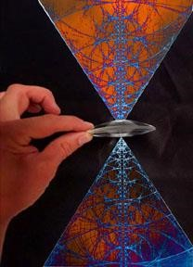
artist unknown

Is there not a contradiction in the idea that, if one’s illness is extended, the medical and pharmaceutical industry can reap greater and greater financial rewards? The medical profession should answer to and serve the people, not the bottom line from a board of directors or shareholders who are always demanding more and more profit.
Many may see this short departure from our main outline as naïve, overly critical, or simply unworkable in the modern society in which we live. Perhaps when the medical profession can finally incorporate alternative types of healing in their work – methods that have been proven to work – that they will finally move forward in their science and art expediently, and there will be far less need for all the pills, medications and different types of unnatural treatments that are now standard procedure.

FEAR, AND THE MISGUIDED IDEA THAT WE MUST FIGHT AGAINST A DISEASE, RATHER THAN UNDERSTAND ITS DEEPER MEANING
The idea of modern science when it comes to disease is often to attack and fight the disease aggressively, like a sports competition, as if the disease were some external condition we could remedy simply by dosing the illness with huge amounts of radiation, pills, or vaccines. To create a very simple analogy, this approach is equivalent to cutting a weed down at ground level, and then thinking that the weed is now entirely gone and will not grow back.
In the case of a medical professional, they may erroneously think that the patient has been healed and the disease eradicated after they have prescribed some medication, because they can no longer see the patient’s illness. But in many cases, time proves otherwise, since the root of the disease, like the root of the weed, has never been completely addressed nor removed at its source, hence it is a condition that will keep coming back until addressed properly. The medical profession, for all of is many achievements, which granted are many, unfortunately often excels in delaying the patients’ recognition as to what may be the deeper layers of the human psyche or inner spiritual bodies that must be healed first and foremost.
The medical profession also excels at masking illnesses by inadvertently overlaying the original problem with some new and more subtle form of toxin or disease. In this way the original illness may still exist, but has now manifested in new or additional ways, which may seem to have no connection to the original illness. These counterindications, or what I will call for a lack of better words deferred illnesses, are often the result of misinformation that leads to incorrect diagnoses. Since medical doctors can only work with the information currently available to them, and being devoid of any deeper esoteric or occult training, their oversights and errors are simply a problem of misinformation or a lack of deeper understanding of the whole healing process.
Many who do not have a reoccurrence of their disease after being medically treated and who actually heal, upon closer examination are often those individuals who have changed some aspect of their medical orientation towards the disease and adopted some variation of an esoteric technique independently of the physician.
Anecdotally, I have known dozens of people over a fifty-year period, who developed some type of debilitating disease, and after trying every modality offered to them by the medical profession, eventually turned to some alternative healing techniques when all other approaches had failed. Many of these people were convinced that their medical treatments were either not working, or making their condition worse and eventually sought out other alternative methods for final healing.

ENERGY FOLLOWS THOUGHT
Energy follows thought is one of the first principals or laws that must be understood for deeper healing to take place on a personal level or within groups. The quality of our thoughts has a direct relationship to our physical and emotional health. Each person who develops any illness must always ask themselves if their treatment is addressing the deeper cause of the illness or simply masking it.
The great poet Rumi, in one of his immortal poems, summarized this idea somewhat cryptically when he stated that “illness is not a problem to be solved, but a mystery to be revealed.”
Only when the deeper layers of the illness are unearthed and properly understood can any real or lasting healing emerge. DK has this to say on the subject:
His intense antagonism to disease, only tends to energize the difficulty. When he reorients his thought to truth and the soul, physical plane ills will begin to disappear. This will become apparent as we study later the method of eradication. Disease exists. Forms in all kingdoms are full of inharmony and out of alignment with the indwelling life. Esoteric Healing, pp. 14-15

DK further stressed the importance of mind control for proper healing to take place in this next quote.
The use of the mind will be regarded, above everything else, as a factor of major importance: the mind will be seen as the prime influence as regards the centres, for people will be taught to work on their centres through mental power and thus produce a right reaction from the endocrine system. This will necessarily involve the right directing of thought to a centre, or the withdrawal of attention from a centre, with consequent effect upon the glandular system. This will all be based upon the occult law that "Energy follows thought”.
Esoteric Healing, p. 220

See figure 1 one for an expanded idea of the centers and their correct order of progression or activation.
Moving from the importance of right thought in our lives to the importance of right emotions or high aspiration, DK further outlined one of the key links between disease and the emotions:
It might be stated as a basic generalization that personal physical trouble has its seat at present in the emotional body, and that that vehicle of expression is the one predominant predisposing agent in the ill health of the individual, just as group ills and the sweep of epidemics of any kind through the masses are founded in some condition in the etheric substance of the planet. Those diseases which are general, national, racial and planetary find their way to an individual via his etheric body, but are not so personal in their implications.
Esoteric Healing, pp. 24-25

WARS
The planet’s power to absorb the negative forces that result from humanity’s psychological condition often breaks down in the aftermath of wars. Conflict took place in every year of the 20th Century; the world was free from the violence caused by war for only very short periods of time. It has been estimated that 187 million people died as a result of war from 1900 to the present. The actual number is likely far higher.
The following article list highlights from some of the conflicts that have impacted the lives of people from the United Kingdom, the British Empire and the Commonwealth since 1900. The museum records and preserves stories from many of these conflicts amongst its collections, which you can search here: https://www.iwm.org.uk/collections/search.
You will find that each conflict is described with a set of dates, which implies a defined beginning and end. While this is useful to help with classification, it is important to note that the causes and consequences of individual wars or conflicts extend far beyond these narrow ranges. Frequently, there are wider issues which connect many of them together; exploring and documenting these links through our collections is an ongoing process. https://www.iwm.org.uk/history/timeline-of-20th-and-21st-century-wars
Here we have a strong indication as to the reason why humanity (the fourth kingdom in nature) succumbs with such rapidity and such ease to disease. The conflicts to which humanity is so constantly summoned, both in group form and as individuals, lead—until understood and used as a means to triumph and progress—to a condition of constant devitalisation. Where this is present, resistance to disease fades out and practically all forms of ill health and bodily ills become possible. Diffusion of energy leads to a constant lessening of this resistance. As a result you have debility, quick and bad reaction to the disease indigenous in the planet itself, and a rapid taking on of infections and of contagious diseases. It is this energy which lies behind what we call epidemics, and influenza is one of its main expressions.”
Esoteric Healing, p. 301

What Alice A. Bailey is outlining here about wars may equally be said of periods of great stress due to economic change, social upheavals and different types of revolutions. We must also consider the fact of new and powerful energies pouring into our tiny system from cosmic sources. See article on the current relationship of Betelgeuse, a star of the 2nd order, and our Solar Logos of the 4th order: https://souledout.org/cosmology/keys/betelgeuse.html)
See short article on Sirius and Polaris.
https://www.facebook.com/duane.carpenter.988/videos/10219879824894371 https://www.facebook.com/groups/186496818144228/posts/2169437156516841/
Those advanced disciples and initiates who are working for world rehabilitation should give this next quote by DK some additional thought for future reference. Only advanced occult groups can begin to understand the wider implications of planetary stress and the planetary dweller on the threshold. These groups, although unrecognized, are helping in some small way to (as the famous occultist from the turn of the century, Gurdjieff, stated:) “we must all help lift the common burden of our ‘Father in Heaven’.”

SOME INITIATE HEALERS WORK WITH EPIDEMICS
Certain healers—few and far between…have set up a relation with the spirit of the earth, the Ruler of all the lunar lords. Under certain formulas and given a certain amount of practice, these healers can invoke his aid and—in fact—command it. I do not advise any interested student to ponder overmuch along this line or to endeavour to set up a contact or to invoke his aid. Only initiates of high degree can deal safely with this powerful involutionary Elemental; they do so only in connection with epidemics and international catastrophes such as the world war, in which thousands and thousands of bodies were involved. An individual not highly developed who endeavoured to establish rapport would probably only succeed in stimulating the lunar lords of his own little system to such an extent that his lower nature would be unduly energised—sometimes even to the point of death.
Esoteric Healing, pp. 646-647

ADDITIONAL MASTERS AND INITIATES ON VIRUSES AND PANDEMICS
Here are some disciples and initiates from different spiritual traditions with important insights into pandemics and viruses. One of the common threads that link them all together is the idea that the misuse of the thinking principal, as well as the visualization capacity, leads to fear and ill health. Fear at this time historically is having a crippling and debilitation effects on individual people, groups, as well as humanity collectively.

THE LAST SONG OF THE SWAN
The causes that produced influenza were rather cosmical than bacterial and can have an abnormal condition of the oxygen in the atmosphere.
All this is very significant. A disease which is epidemic, yet not contagious; which acts everywhere, in clean as in unclean places, in sanitary as well as in unsanitary localities, hence needing very evidently no centres of contagion to start from; an epidemic which spreads at once like an air current, embracing whole countries and parts of the world; striking at the same time the mariner in the midst of the ocean, and the royal scion in his palace; the starving wretch of the world’s Whitechapels, sunk in and soaked through with filth, and the aristocrat in his high mountain sanitarium (like Davos in Engadine*), where no lack of sanitary arrangements can be taken to task for it—such a disease can bear no comparison with epidemics of the ordinary common type, e.g., such as the cholera. Nor can it be regarded as caused by parasites or microscopical microbes of one or the other kind. To prove the fallacy of this idea in her case, the dear old influenza attacked most savagely Pasteur, the “microbe-killer” himself, and his host of assistants. Does it not seem therefore, as if the causes that produced influenza were rather cosmical than bacterial; and that they ought to be searched for rather in those abnormal changes in our atmosphere that have well-nigh thrown into confusion and shuffled seasons all over the globe for the last few years—than in anything else?
When HPB refers to ozone and oxygen levels experienced during pandemics being affected by comic forces rather than bacterial additional research has indicated there may be much truth to this idea that needs to be further explored. See authors articles on Solar Minimums refered to on the previous page. Also new healing therapies of ultra-violet light and ozone that have just emerged for treating illnesses. ????
It is not asserted for the first time now that all such mysterious epidemics as the present influenza are due to an abnormal exuberance of ozone in the air. Several physicians and chemists of note have so far agreed with the occultists, as to admit that the tasteless, colourless and inodorous gas known as oxygen—“the life-supporter” of all that lives and breathes—does get at times into family difficulties with its colleagues and brothers, when it tries to get over their heads in volume and weight, and becomes heavier than is its wont. In short—oxygen becomes ozone.
That would account probably for the preliminary symptoms of influenza. Descending and spreading on earth with an extraordinary rapidity, oxygen would of course produce a still greater combustion; hence the terrible heat in the patient’s body, and the paralysis of rather weak lungs. What says Science with respect to ozone: “It is the exuberance of the latter under the powerful stimulus of electricity in the air, that produces on nervous people that unaccountable feeling of fear and depression which they so often experience before a storm.” Again: “the quantity of ozone in the atmosphere varies with the meteorological condition under laws so far unknown to science.”
A certain amount of ozone is necessary, they wisely say, for breathing purposes, and the circulation of the blood. On the other hand, “too much of ozone irritates the respiratory organs, and an excess of more than 1% of it in the air kills him who breathes it.” This is proceeding on rather occult lines. “The real ozone is the Elixir of Life.”
H. P. Blavatsky, The Secret Doctrine, Vol. I, p. 144, 2nd footnote
Blavatsky Collected Writings, Vol. 12, p. 104
Lucifer, Vol. V, No. 30, February 1890, pp. 445 453

Let the reader compare the above quote from HPB with what is stated from the hermetic and occult standpoint on ozone, and better comprehend what some Theosophists think of the present influenza:
It thus follows that the mystically inclined correspondent who wrote in Novoye Vremya (No. 4931, Nov. 19th, old style, 1889) giving sound advise on the subject of the influenza, then just appeared—knew what he was talking about. Summarizing the idea, he stated as follows:—
… It becomes thus evident that the real cause of this simultaneous spread of the epidemic over all the Empire under the most varied meteorological conditions and climatic changes—are to be sought elsewhere than in the unsatisfactory hygienical and sanitary conditions …The search for the causes which generated the disease and caused it to spread is not incumbent upon the physicians alone, but would be the right duty of meteorologists, astronomers, physicians, and naturalists in general, separated officially and substantially from medical men.
This raised a professional storm. The modest suggestion was tabooed and derided… Vide Vol. II, pp. 113-114
Those who believe that they have every mystery of nature at their fingers’ ends, as well as those who maintain that official science alone is entitled to solve for Humanity the problems which are hidden far away in the complex constitution of man—will never understand us. And, unable to realize our true meaning they may, raising themselves on the patterns of modern negation, endeavor, as they always have, to push away with their scientific mops the waters of the great ocean of occult knowledge.

H.P. Blavatsky Collected Writings, Vol. 13, p. 223

Madame Blavatsky and the Grippe, Lucifer, Vol. X, May 1892, p. 196 [Although not an actual text from the pen of H. P. Blavatsky, the following note should be incorporated with the present series on account of the valuable point under discussion.]
Madame Blavatsky, being asked what was the cause of the Grippe, answered that it was “an abnormal condition of the oxygen in the atmosphere,” or words to the same effect. I concluded that, in that case, artificially-produced oxygen might prove valuable as a remedy. My mother having been laid up with this disease, I searched the United States dispensary for some easy means of producing oxygen, and stumbled across “Peroxide of Hydrogen” (H₂O₂). I administered it internally in drachm doses well diluted with water three times a day, also spraying some through the sick room, with undeniably favorable results. I found upon advising the use of it to a friend, it had also upon him a like effect; and also find that the Philadelphia papers contain advertisements of an oxygen treatment for the Grippe. To all those who question the qui bono of Theosophy I would like to say, “Study Madame Blavatsky’s writings, and then judge.” — F.T.S.

Recent scientific discoveries have brought to light how Cosmic forces pouring into our solar system with new potency and power have an important and previously unknown influences on our atmosphere, different weather phenomena, as well as ozone, as HPB has pointed out in the previous quote by her. Here is an article found in two parts, titled Solar Minimums, which gives us some additional insight why this historical period and the suns descending radiation, or what is referred to in conventional science, as the entry into a solar minimum period, and how this entry will have a major effect on viruses, pandemics and diseases.
see video Thunderbolts of the Gods Black Death by Peter Mungo Jupp https://youtu.be/lvOHBjkBpyM

FEAR: STEINER’S VIEWS
The following material is from Rudolph Steiner’s writings on fear, outlined and paraphrased by Anna Sclar. Steiner’s reference to inimical spirits can range all the way from involutionary elemental life, to Devas that work with the 3rd or matter aspect of creation, hence without the correct orientation can be considered undesirable and dangerous.
A vaccine for the emotions and the mind.
Negative emotions are food for inimical spirits.
Nearly 100 years ago, in a series of fourteen essays published under the title, The Fall of the Spirits of Darkness, Steiner issued a warning to future generations about a possible measure of mass control, quite similar to the visions presented by Orwell and Huxley.
Steiner foresaw a future when vaccines when misused could thwart our spiritual nature.
First, some background:
In these fourteen lectures, given at the end of 1917, following four years of war in Europe, Steiner speaks on the complex spiritual forces behind the World War I, humanity’s attempts to build theoretically perfect social orders, and the many divisions and disruptions that would continue on Earth into our own time. Humanity in general was asleep to the fact that fallen spirits (lower devic and elemental life) cast from the spiritual worlds, had become intensely active on Earth. This manifested mainly in human thinking and perception of the surrounding world.
Fear and low vitality
Anxiety, depression, and fear ravage so many today, but few pause to consider that in addition to the material influences in our lives, we may be also under the influence of beings which exist in dimensions outside of our ordinary perception.
A concept such as this isn’t readily accepted into the everyday conversation steered by a rigid skepticism and scientific materialism. Dealings with extra-sensory or hyperdimensional beings have long been a part of our history, and are directly accessible to any of us when proper practice and attention is given to the matter.
Finding oneself in the rut of spiraling negative self-talk, depression, crippling anxiety, or uncontrollable, irrational fear, is a sign, as Steiner points out, of a disconnection from our true spiritual nature, exacerbated by beings who operate in other inner subjective realms.
This is why some consider disorders like this to be spiritual illnesses, and until the rift is healed with proper attention given to the development of spirit, the feelings tend to exacerbate and drive one further into distress.
The traditions of today have sought to expel ancient metaphysical wisdom and its practical application, however, though scientific inquiry is exceptionally valuable, spiritual perception has always been a part of our experience.
Very few scientists today are willing to explore metaphysics to examine life beyond ordinary perception. Rudolf Steiner, though, devoted much of his work to the task of peering behind the veil, sharing his insight into the deeper nature of life and of the world beyond. Regarding anxiety and depression, Steiner spoke of hostile beings (negative energies) in the spiritual world that influence and feed off of human emotion; a concept flatly rejected by most contemporary science today. Yet this analysis also holds true for shamans, healers and others who access the spiritual dimensions in order to alleviate mental and physical suffering for their patients.
Many are familiar with the notion of people who suck your energy and feed off your negative emotions. (Anna Sclar) Steiner wrote:
There are beings in the spiritual realms for whom anxiety and fear emanating from human beings offer welcome food. When humans have no anxiety and fear, then these creatures starve.
But for those who are familiar with this phenomenon, it is a reality. If fear and anxiety radiates from people and they break out in panic, then these creatures find welcome nutrition and they become more and more powerful. These beings are hostile towards humanity. Everything that feeds on negative feelings, on anxiety, fear and superstition, despair or doubt, are in reality hostile forces in supersensory worlds, launching cruel attacks on human beings, while they are being fed.
Therefore, it is above all necessary that the person enters the spiritual world and overcomes fear, feelings of helplessness, despair and anxiety. These are exactly the feelings that belong to contemporary culture and materialism; because it estranges people from the spiritual world, it is especially suited to evoke hopelessness and fear of the unknown in people, thereby calling up the above mentioned hostile forces against them.
The spirits of darkness are now among us. We have to be on guard so that we may realize what is happening when we encounter them and gain a real idea of where they are to be found.
The most dangerous thing you can do in the immediate future will be to give yourself up unconsciously to the influences which are definitely present.
It is indeed true, and initiates have always said so: When human beings are filled with spiritual wisdom, these are great horrors of darkness for the ahrimanic powers and a consuming fire.
It feels good to the ahrimanic angels to dwell in heads filled with ahrimanic science; but heads filled with spiritual wisdom are like a consuming fire and the horrors of darkness to them.
Rudolf Steiner: https://rsarchive.org/Lectures/GA177/English/RSP1993/19171020p01.html
[Editor’s note – Ahriman is the name of one of two extreme forces which pull humanity away from the centering influence of Christ. Steiner associated Ahriman, the lower spirit, with materialism, science, heredity, objectivity, and soul-hardening.]
The fall into such destructive slumber would be marked by an age of materialism and centralization of power, during which the influences of spirits of darkness would inspire humans to devise new technologies and new means of oppression.
Steiner’s additional comments:
I have told you that the spirits of darkness are going to inspire their human hosts, in whom they will be dwelling, to find a vaccine that will drive all inclination toward spirituality out of people’s souls when they are still very young, and this will happen in a roundabout way through the living body. Today, bodies are vaccinated against one thing and another; in future, children will be vaccinated with a substance which it will certainly be possible to produce, and this will make them immune, so that they do not develop foolish inclinations connected with spiritual life – ‘foolish’ here, or course, in the eyes of materialists. …
… a way will finally be found to vaccinate bodies so that these bodies will not allow the inclination toward spiritual ideas to develop and all their lives people will believe only in the physical world they perceive with the senses. Out of impulses which the medical profession gained from presumption – oh, I beg your pardon, from the consumption [tuberculosis] they themselves suffered – people are now vaccinated against consumption, and in the same way they will be vaccinated against any inclination toward spirituality. This is merely to give you a particularly striking example of many things which will come in the near and more distant future in this field – the aim being to bring confusion into the impulses which want to stream down to earth after the victory of the [Michaelic] spirits of light [in 1879].
~Rudolf Steiner, The Fall of the Spirits of Darkness, GA 177 — 14

Some of these statements by Steiner we have just shared are also echoed by Master Morya as well as Alice A. Bailey in the next quotes.
It will be obvious that the problems of worry and irritation (called by the Master Morya "imperil") are many and must be considered.
Why are these difficulties of the astral body so "perilous" and so serious? Worry and Irritation are dangerous because:
1. They lower the vitality of the man to such a point that he becomes susceptible to disease. The scourge of influenza has its roots in fear and worry, and once the world settles down to freedom from the present "fearful" condition, we shall see the disease die out.
Sri Aurobindo on Influenza
Epidemics, or so-called epidemics, like those which are raging at present—ninety-nine times out of a hundred they come from fear: a fear, then, which even becomes a mental fear in its most sordid form, promoted by newspaper articles, useless talk and so on.
Collected Works of The Mother, Vol. 09
Questions and Answers 1957-1958, p. 122-123
It is a kind of vibration made up of a mental suggestion, a vital force of disorder and certain physical elements which are the materialization of the mental suggestion and the vital vibration. And these physical elements can be what we have agreed to call germs, microbes, this and that and many other things.
What is the difficulty [in understanding how the subtle forces of illness attack the body using bacilli and viruses for their purpose]? You are like the scientists who say or used to say that there is no such thing as mind or thought independent of the physical brain. Mind and thought are only names for brain quivering’s. Or that there is no such thing as vital Force because all the movements of life depend upon chemicals, glands and what not. These things and the germs also are only a minor physical instrumentation for something supra-physical.
They [the forces of illness] first weaken or break through the nervous envelope, the aura. If that is strong and whole, a thousand million germs will not be able to do anything to you. The envelope pierced, they attack the subconscious mind in the body, sometimes also the vital mind or mind proper—prepare the illness by fear or thought of illness. The doctors themselves said that in influenza or cholera in the Far East 90 per cent got ill through fear. Nothing to take away the resistance like fear. But still the subconscious is the main thing.
If the contrary Force is strong in the body, one can move in the midst of plague and cholera and never get contaminated. Plague too, rats dying all around, people passing into Hades. I have seen that myself in Baroda.
Complete Works of Sri Aurobindo, Vol. 31, Letters On Yoga-IV, pp. 568-569

AGNI YOGA COSMIC CURRENTS WILL INCREASE MANY DISEASES YOU CANNOT CHEAT EVOLUTION
These next quotes from the Agni Yoga series warrant further elaboration and clarification because of their revelatory implications. We will however only address a few that are more germane to the present COVID-19 pandemic of the 2019-2022 period. These Agni Yoga quotes often speak directly to the intuition, evoking an intuitive response, and not simply the lower minds comprehension.
The next quote by Master Morya from the Agni Yoga series is from the book Supermundane, p. 286.
286. Urusvati knows that certain conditions can be worse than the state of war. You certainly know that We consider war to be the shame of mankind, but one situation that can be considered as worse is the decay of humanity.
Armageddon should not be understood as only a physical battle. It is full of incalculable dangers, among which will be epidemics, but the most ruinous consequence will be psychic perversions. People will lose trust in one another, and will compete in doing evil. They will develop a persistent hatred of all except their own kind, and will sink into irresponsibility and depravity.
Let us remember that these years of Armageddon are the most intense, and one’s health should be especially guarded because the cosmic currents will increase many diseases. You must understand that this time is unique.
It is near-sighted to think that if war is prevented all problems will be solved! There are those who think so and imagine that they can cheat evolution, not realizing that the worst war is in their own homes. However, there do exist places on Earth where evolution develops normally, and We are always there.
Hierarchy
377. The transformation of the world is indeed affirmed in the highest tension. All perturbations, all shiftings, all diseases accompany this transformation. The most powerfully propelled energies bring fires into motion. Thus, in the Epoch of Fire darkness becomes dense, and everything is intensified in a fiery striving. Evil is created by the densified darkness. Light transforms the world. Thus, at the great time, the manifestation of the universal transmutation saturates space.
Supermundane
217. Urusvati knows that the poisoning of the atmosphere is increasing at this time. The consequences of this are evident in many aspects of life. People suffer from many bodily diseases because of their individual weaknesses, and society suffers from epidemics and social upheavals. We often warn about the need for unity, for harmony is the best prophylactic. Great equilibrium is necessary; if it could be achieved throughout the world, the most dangerous hours would pass without harm.
HOW DO WE PREVENT MENTAL EPIDEMICS?
Next, from a mainstream Theosophical article on COVID and viruses.
For entire article see these links: https://blavatskyhouse.org/news/corona-crisis-danger-and-opportunity/
Herman C. Vermeulen (truncated and reduced).
Lucifer No. 4, 2021: https://blavatskyhouse.org/magazine/
Consciousness underlies all manifestation, nothing excluded. This principle of the Theosophia is essential in this lecture in order to compare viral epidemics with mental epidemics. It is consciousness to which we attribute the ability to act and react…
These myriads of beings all interact with each other in numerous relations: no consciousness is on its own. Each consciousness, according to its qualities, functions only in co-operation with other consciousnesses. The Theosophia assumes universal laws, patterns that apply on all planes of manifestation. On each plane they are expressed according to the development of the beings or consciousnesses living there.
We will see that for our material realm and other less material realms, the universal laws run parallel. This can also be understood if we consider that spirit and matter are the higher and lower states of a consciousness. This consciousness expresses itself, manifests itself, according to the qualities it has already developed, and always does so in cooperation with other consciousnesses.
This picture applies to all ten Kingdoms in Nature, whereby the distance between a virus and a thought, as we shall see, is not really that big. And we shall also see that man, as a cooperation of lower and higher developed consciousnesses, has his specific place within the hierarchy of the Kingdoms of nature …
But if we start from the Theosophical idea that everything is a living being – think of the definition of life, saying that something must be able to act and react, and viruses can do that very well – then that particle is in fact a living being: albeit at a very primitive level. A number of viruses are harmful to humans, but there are also good viruses that protect us against harmful bacteria.
What is a thought? A thought is also a living being, a consciousness, as you can read in the definition above. An elemental being that can only become active if it can cooperate with a more advanced (thinking) being, a host, thus manifesting itself in a cooperative relationship. We create this cooperation. Human beings think thoughts and those thoughts – living beings – go through a development in cooperation with us. This allows them to behave in a certain way and have influence. Like a virus, some can be called harmful to us, but there are also many good, often selfless thoughts. In both cases, of both the virus and the thought, you have a living being which can enter a host, which serves as a breeding ground and gives the invader an opportunity to multiply and spread again…
Jumping involutionary elementals
In addition, a virus has the ability to jump. We know the phenomenon of zoonosis, where a bacterium or virus is transmitted from an animal to a human. Among these are several wellknown viruses, such as, for example, the Ebola virus, the Zika virus, the avian flu and also COVID-19. Now, to a certain extent, thoughts can also cross over to such a disparate level. We can become receptive to thoughts – living beings – that are far below our general quality of thought, but for which we can still act as a breeding ground.
The world knows terrifying examples of this as far as viruses are concerned. We may not yet know scientifically what viruses are potentially capable of, but the fact that viruses are also being developed as biological weapons means that we, as thinkers, have first built up the ideas for this. It is needless to say that when such a virus becomes active, it will often be extremely difficult to control again.
Thought streams around the earth. The maintenance and nourishment of our astral painting of the thought atmosphere that we as humans create, takes place in the thought streams around our earth. We sometimes speak of the thought atmosphere or the mental bloodstream of the earth. The wide range of thoughts, thought by the wide array of thinkers, circulates the earth. Streams that flow from all the thoughts we have about life, society, and ourselves. From fantastic, elevated ideas full of compassion, to sometimes very negative, evil ideas, such as author Stephen King knows how to describe in his horror stories.
Impact of COVID-19
Looking now at the COVID-19 virus, we see that the current pandemic has two main aspects: a physical one, and a mental/spiritual one. In addition to the physical infections and all their physical consequences, we see how people allow their mental health to be affected by the fear and uncertainty that comes with the physical spread of the virus. The anxiety about COVID-19 and its impact can be overwhelming. With the thought patterns surrounding the virus, and if people unconsciously feed those fears and insecurities, they can become even more susceptible to mental and physical infection than one may have otherwise been. It is much wiser to keep our thoughts consciously clear so that we can approach the situation calmly, and be prepared to face the need for physical measures as well. As far as this discipline of balanced thinking is concerned, we as a society still have quite a few steps to take.
From the foregoing we can clearly see the parallels between a virus and a thought. The processes of keeping them alive, and growing, multiplying, and exchanging them, are identical.
The word epidemic, derived from the Greek epidémios or ‘over the (entire) population’, which has mainly a negative association as something beyond our control. However, there are certainly also examples of a more positive epidemic, such as thoughts of peace and optimism flowing over parts of the earth. The word pandemic, with the Greek pan (whole), is similar to the term epidemic, but the phenomenon then takes place worldwide…When a particular pattern of thought infects people who then pass it on to each other, the process is almost impossible to control.
Mental Resistance
I have outlined some examples of the creation of mental epidemics due to the pollution of our thinking and the disastrous consequences of this. What can we do about it? Let us take a simple example of physical contamination. If we would drink water from a river, we could get all sorts of infections as we know such water must be purified first, so we do not drink it. But we do not apply this insight to the world of thoughts. We often drink indiscriminately from many astral streams of thought. We should purify those streams. This is a kind of mental vaccination to gain immunity against harmful thoughts.
A better antibody against contamination of thought streams is, of course, the gathering of knowledge of one’s self. Sober facts can adjust our colored impressions, but we then must be open to that. If we are prepared to do so, we can build up a mental resistance and strengthen our mental immune system.
Changing an uncritical, lazy attitude into an alert self-awareness, however, requires a solid mental effort. To go from believing to knowing, each person will have to actively ask some primary questions. Examine the habitual thinking with its familiar assumptions. What are the backgrounds of what is happening, what are people’s statements based on, what are my own impressions based on, how do I get reliable facts and how should I interpret them?
Mental Hygiene and Emotional Inoculations
We must not only learn to control our thinking process for ourselves, but certainly also consider of what benefit are our thoughts and emotions to our fellow human beings. After all, with our thinking we are a receiver and transmitter at the same time.
Our susceptibility to thought images is reflected to the degree we believe, trust, or know that any information or substance is valid or healthy. What do you believe, what do you trust, and what do you know? This determines how receptive we are. And that knowing – building truth – is an individual process. From a certain authority like a well-known scientist, we may be more inclined to assume that the information is valid than from an actor in a commercial. But even if we trust that scientist, it has not yet become knowledge for us. Sometimes we need a long time to get knowledge through experience or various forms of insight. This requires active, personal research. It is a challenge to go from believing to knowing. In doing so, we must also be very conscious of our thought processes.
Therefore, to build group immunity against polluting thoughts, mental and spiritual training is also essential. It involves learning to understand thought processes and the world of our consciousness. there are, in addition to the mainstream educational systems, schools based on the ideas of, for example, Rāja-Yoga, as taught at the Theosophical Society Point Loma over the period 1900-1942. And now we have Maria Montessori and Rudolf Steiner Schools, in which some of the basic theosophical thoughts still resonate.
Learning is actually much more than schooling. Education we usually translate as upbringing, but Theosophically, it also means leading outwards what is already in us. The educator is the midwife who helps give birth to what is already within. Theosophia teaches that we essentially have all possibilities within us. What we have developed, life after life, we can re-activate during our youth. Learning is re-membering. In addition, we can develop anew (for us) capabilities in this lifetime, which involves growth in consciousness.
In the Pāramitās from Buddhism, we find described what qualities we should live without thinking evil or acting evil. This is an important challenge for us. We have already learned many lessons in previous lives; we can use that wisdom. Therefore, we do not have to do everything to know what is not wise to do. We are able to act from wisdom and insight if we practice it. Let us continue to follow that path.
Fear
The forces of evolution vibrate more rapidly than those of involution and in this fact lies a recognizable security. Fear causes weakness; weakness causes a disintegration; the weak spot breaks and a gap appears, and through that gap evil force may enter. The factor of entrance is the fear of the man himself, who opens thus the door. Letters on Occult Meditation, p. 69

See this more expanded view for a greater comprehension of what Alice A. Bailey designates as a break or a gap appearing in a person’s etheric or auric field. http://www.light-weaver.com/LW-old/vortex/2triangles.html
Fear and uncertainty are two of the hidden energies that feed the present COVID-19 virus and make the average man far more susceptible to its debilitating influence. Fear that has swept over the planet and engulfed it like a paralysis. Not since the second world war has there been such a universal cloud of darkness. Even though the COVID19 pandemic is presently waning, this fear is a condition that exists in the planetary astral and etheric body and will be a long time before purified or eliminated.
While in a state of crises and fear, humanity loses its ability to think clearly and will be obedient and conform to any of the directives and proclamations coming from those around them, such as the medical profession and pharmaceutical industry, who they think know more than they do, however outrageous or against their own deeper instincts or logic. Logic and clear thinking are always the first things that adverse forces which oppose a new and more spiritual civilization will attempt to subvert or destroy.
Like the Sword of Damocles, fear is held over the heads of average humanity at all times: the fear that there is not enough to go around; the fear of not obtaining a fair share of the so called good life amidst all the real or perceived scarcity, and the fear of death, the uncertainty that we will not make it through life without numerous reoccurring and debilitating crises that cannot be controlled or effectively dealt with.
These economic profiteers whom we are discussing are masters at spreading fear and uncertainty amongst the average people, and often deliberately set different groups of people one against the other as a clever distraction and smoke screen so that they can continue with their master plans of world dominance and the creation of a One World Order – with them clearly at the helm for complete control.
To those who are not called upon karmically to deal with these larger and more difficult issues, and who do not see a larger landscape, this will all be relegated into the domain of just another conspiracy theory. To those who have drawn back the curtain of contemporary historical events and can see today’s conflicts and crises in a larger context, they will see that these crises are the result of competing principalities or involutionary and evolutionary forces that are in direct opposition and conflict to each other.

FEAR AS AN ASTRAL EVIL
Alice Bailey described fear in this way:
Fear. This is one of the most usual of the manifestations of astral energy, and is put first because it constitutes, for the vast majority, the Dweller on the Threshold and also in the last analysis is the basic astral evil. Every human being knows fear and the range of the fear vibrations extends from the instinctual fears ….to the fears so prevalent today of loss of friends and loved ones, of health, of money, of popularity and on to the final fears of the aspirant—the fear of failure, the fear which has its roots in doubt, the fear of ultimate negation or of annihilation, the fear of death (which he shares equally with all humanity) the fear of the great illusion of the astral plane, of the phantasmagoria of life itself, and also fear of loneliness on the Path, even to the very fear of Fear itself. This list could be largely extended but suffices to indicate the prevalence of fears of all kinds. They dominate most situations and darken many happy moments. They reduce man to a timid and frightened atom of sentient life, standing afraid before the stupendousness of the problems of existence, aware of his insufficiency as a man to cope with all situations and unable to leave his fears and questionings behind and step into his heritage of freedom and of life. Often he is so ridden by fear that he becomes afraid of his very reason. The picture cannot be too blackly coloured, for fear is the dominant astral energy at this time and sensitive humanity succumbs all too easily to it.
Treatise on White Magic, pp. 298-299

THE TWO OPPOSING NEW WORLD ORDERS AND THE ILLUMINATI
The idea of a New World Order has many complex facets and the author has no intention of making an attempt to elaborate on them. We will be confining our comments primarily to the NWO as outlined by AAB and the present opposition to her thoughts and ideas on the subject. There are many types of globalism emerging on the world stage at this time historically, as well as a number of intermediary dynamics that have a curious mix of both the progressive and the regressive as we will explore.

THE FIRST TYPE OF NEW WORLD ORDER OR GLOBALISM IS INSPIRED FROM ABOVE DOWNWARDS
This action is by the hierarchy of spiritual masters as they attempt to influence a new spiritual rhythm into the ranks of humanity, and are requiring uniformity of approach to their lofty centers of energy and light. This uniformity, which is never rigidly imposed, will eventually unify all the countries in the world into one common body. Until there is complete unification into the planetary whole, the parts will continue to fight against and amongst themselves, and compete for energy and world resources.
Although these changes will be far into the future (in man’s terms) before this synthesis is achieved, the groundwork is clearly being carefully laid right now. Paradoxically, the retrogressive groups (outlined in this paper) will often contribute to this unification in certain ways. Not because they can see the end goal of a united and enlightened humanity all working in unison, but because it will benefit them economically in the short term and give them even greater control than they now have.
These retrogressive groups are clearly oblivious to the long term plans of this unification that will allow the spiritual hierarchy to find its rightful place directing the affairs of man with their high ethics and greater wisdom. This is no utopian ideal that we now speak of, but a practical necessity as we move into the 21st century and beyond.
An example of the idea of spiritual uniformity of approach would be the massed group meetings at the time of the full moon. These gatherings involve large numbers of people who simultaneously invoke the spiritual hierarchy we are speaking of, and do so with power because they follow the principal that energy follows thought, and that there is greater potency in numbers. That is not to say that individual meditations at these full moon approaches are not useful, but because of the lack of uniformity of approach to the Spiritual Hierarchy their potency is far less.

THE LESSER NEW WORLD ORDER OR GLOBALISM IS MOTIVATED FROM LOWER LEVELS
This lesser new world order (NWO) or globalist movement is by elite groups of third ray economic profiteers who have much to gain by controlling and manipulating humanity into a herd type mentality. They control the banking and financial system, the military, as well as much of the political machinery, and mass media. Under these systems individual autonomy is violated and certain types of restrictions are imposed upon them against their free will, and always under the premise that it is for a greater good, or greater collective.
This third ray type or group of globalist will clearly lack the love vibration, but they will cleverly disguise themselves as the type found in the higher spiritual groups through false narratives and rhetoric designed to twist certain spiritual ideals to their lesser motives. The stark contrast between good and evil is not always easy to discern in the early stages of their activities and expressions since humanity is so enamored with power, prestige and money. Until further research and inquiries are made, during this interim period between the old passing out and the new emerging much of what appears or passes for good is simply a façade or a mask used by these regressive types to obscure their more selfish and devious intents. This is also one of the greatest tests for the divine initiatory experience and many would-be disciples often fail.
In addition to these two groups that we will explore, there are also many types and levels of hierarchy in the world at this time that is a mix of both of these. The true divine hierarchy, working from above down, is attempting to establish the rule of spiritual law as well as the rule of the righteous and spiritually advanced.
The other more material groups are attempting to rule by fear, intimidation, control of monetary and financial institutions, and is attempting to fully exploit the world’s natural resources without any understudy or concern about the ultimate consequences environmentally, or how their actions are contributing to global warming and an ecosystems that has been severely thrown out of balance.
Global warming or climate change can have roots in multiple causes, some of which are unknown, and others more obvious, such as man-made weather modification, human mismanagement of the environment through massive pesticides, and the dumping of plastics and artificial chemicals into the earth, oceans, and atmosphere.
Some of those associated with the material groups we have outlined may actually, to the surprise of the reader have good intentions, but since their vision or understanding is so limited they invariably do great harm to the physical as well as the divine ecosystem that is attempting to form at this time on the planet. These errors of the more materialistic groups are the result of being unable to see that humanity is essentially one organism struggling to unify itself into one organ of perception, or into one center of light. The more material groups fail to see that the earth is a living entity with many diverse components or ecosystems, and that when not interfered with are naturally balanced and harmonized. These material hierarchies, in their arrogance and pride, as well as their Newtonian perceptions of the world, think they are the center of the universe and all things spring from or circle around them.
According to the ageless wisdom teachings and the theory of holism, man is simply a cell in a greater being we call the planetary life or the planetary logos. Many of the materialistic groups cannot embrace or accept the idea of a spiritual hierarchy, because paradoxically they think that they already are a spiritual hierarchy. So, by their limited standards of what is spiritual, why would they look or seek to build something new or better then what they are already providing?
Obviously this hierarchy, or banded materialistic groups that I am referring to, are not the spiritual hierarchy that the esoteric student of the ageless wisdom has come to honor and understand. These organizations are a stepped down and more lineal expression of a type of material unity, composed of some highly powerful and intelligent groups of individuals spawned from previous periods, those whose main polarization lies along more of the first, third, fifth and seventh rays lines of expression. These groups and individuals are often out of balance with the more feminine line of energies we know to be along the 2, 4 and 6th ray line and their lower minds are often over developed which unfortunately shuts out spiritual impressions from entering.
Many of these materialistic individuals and groups we are outlining we are told are a residue of advanced initiates from a previous materialistic solar system. These materialistic groups that we are outlining here generate their own lesser light and as we have indicated, are also an expression of a type of unity, only in a limited and more inferior form.
These lesser, materialistic hierarchies dominate the political landscape and influence many large corporations, the military-industrial complex, as well as other groups that have funded global wars and regional conflicts for thousands of years – supporting both sides with credit, capital, munitions and arms. Each of these groups has a persona or facade that at first makes them appear as a group of good and responsible citizens or businessmen, especially when they support humanitarian and philanthropic projects such as education, the sciences, and the arts.
Some of the biggest criminals in history walk around in a three-piece suit, support numerous non-profit programs, and are highly-respected members of their community. Some of these groups will not only receive tax exemption status but often receive grants from local, state, and government agencies that are directly subsidized by taxpayers.
These forces of retrogression and cleavage have cleverly gained a powerful foothold on the world’s economies by posing as agents of light who are working for positive and creative change. These material hierarchies are masters of deception and their apparent good works often veil a deeper and more selfish intent. These material entrepreneurs with their legions of attorneys have devised hundreds of clever ways to give away endowments, donations or token gifts, which curiously circle back around and benefit them.
These groups control the majority of media outlets of the world and can spin their false narratives with only limited opposition. Agents and members of the spiritual hierarchy are attempting to counteract these lies and deceptions of these materialistic groups with their own spiritual narratives, but can only do so when there are alternative and open levels of communication that can bypass the mainstreams narratives with an open and transparent level of exposure and communications.

THE GREAT MEDIA WARS OF THE 21ST CENTURY
This period in history will be looked upon by future historians as the time of the great media wars of the 21st century. The black lodge has many representatives who spin false information and narratives with great facilities, and even light workers can be duped or temporally deceived and diverted from their larger and more spiritual goals, which they have been instructed to support and uphold by the masters of wisdom.
The New Group of World Servers (NGWS) – a spiritually-based alliance – is attempting to gain more influence over the internet and the information highways to help neutralize these huge ministries of propaganda and material power.
Those who have done limited research on this subject will dismiss these statements as just one more conspiracy theory or fake news, but further investigation will reveal many important insights that support this outline. Much of the hidden manipulation by the material groups we speak of is shrouded in secrecy and they are largely anonymous because they are masters of deflection and camouflage.
When any revelations or information surface about their dark and devious activities, they quickly obscure and redirect the narratives into more flattering profiles by their media monopolies. One of their primary techniques to maintain secrecy is through projecting the idea that any contrary views or opinions other than their own are simply the result of false information and are therefore conspiratorially in nature. They often use false flag incidents to manipulate public opinion or to rally support for their objectives such as the Gulf of Tonkin incident prior to the Vietnam conflict, or the purported weapons of mass destruction prior to the invasion of Iraq, both of which were fabricated stories and based on extensive and false propaganda.
When any of these materialistic groups or individuals are exposed to members of the real spiritual hierarchy, they are invariably stimulated negatively by their spiritual presence since they have not purified their three lower bodies (lower mind, emotional and physical-etheric). Their pride and need to control the public narrative will by natural inclination see these members of the spiritual hierarchy or The New Group of World Servers as weak, unrealistic, ungrounded, overly feminine, naive, utopian, communistic – and simply incapable of appreciating their important contributions and effort. It is for this reason that many spiritual groups are a threat to these materialistic groups, hence they will be ridiculed, marginalized and thwarted at every turn.
Often these materialistic groups will war amongst themselves, each group claiming their superiority through their unique ethnic, religious or political affiliations. At first these groups will use the power of distraction or doublespeak to influence others. If this doesn’t work they use different types of blackmail. If that fails they resort to even more overt threats, and eventually if all else fails they have no qualms about taking out of incarnation those who oppose their master plans.

THEY ARE COMING FOR YOUR DEMOCRACY
https://www.yesmagazine.org/economy/2016/03/18/more-confessions-of-an-economichttps://www.yesmagazine.org/economy/2016/03/18/more-confessions-of-an-economic-hit-man-this-time-theyre-coming-for-your-democracyhit-man-this-time-theyre-coming-for-your-democracy
“See confessions of a professional hit man” for the CIA, outlined in Wikipedia for an overview of how these dark forces actually work by someone who was an intimate participant in their nefarious activities. Wikipedia, which does provide in many cases good basic information on numerous subjects of interest to the public, is unfortunately influenced and manipulated by segments of these more materialistic cartels that are always ready to discount and deflect any revelations around their devious intensions or work. https://en.wikipedia.org/wiki/Confessions_of_an_Economic Hit_Man

In contrast, let’s review some of the main objectives of a new spiritual and global world order and what some of its goals that have been outlined with great clarity by Alice Bailey:
The objective of their work can be summed up thus: the new world order will facilitate the establishing of right human relations, based on justice, on the recognition of inherited rights, on opportunity for all—irrespective of race, colour or creed—on the suppression of crime and selfishness through right education, and on the recognition of divine potentialities in man as well as the recognition of a divine directing Intelligence in Whom man lives, and moves and has his being.
The Externalization of the Hierarchy, p. 19

Nothing gives the forces of darkness a greater satisfaction, as well as advantage, than to pose as light workers, or an intimate part of the New Group of World Servers, when their motives and ideas are diametrically opposed to the NGWS’ core beliefs and ideals.
The free market – to anyone who operates in its complex and multifaceted web of manipulation, deception, and greed – soon realizes it is not as free as its name suggests. The free market, as many know who are intimate with its inner workings can see its ethical limitations, but unfortunately become seduced by a system of glamor and power that they know is inherently flawed. It is a philosophy and a system that is based largely on human selfishness: selfishness of an individual person, the selfishness of a group, or the selfishness of an entire country. In fact, we live, occultly speaking, on a selfish and unsacred planet where man exploits and manipulates not only his fellow man, but all of the other kingdoms for his own personal gain. As we have previously mentioned, in their need to bolster their status and to look good publicly, these material globalists often give away generous donations from their billions to at least give the appearance that they actually care.
It is important to understand that these material hierarchies have been tenured into the material plane for thousands of years and they are not about to allow themselves to be usurped by any new groups or individuals, no matter how high-sounding their rhetoric or good intentions. This is precisely why DK has said that when dealing with evil as well as the black lodge, that their energy or force, which is very powerful on the material plane, must be met with an even greater and more powerful spiritual fire that descends directly from the Will of God, and only when there are enough first ray disciples in incarnation, working cooperatively and receiving this Shamballic force, can the forces of evil and retrogression be forced back into their dark caves of self-absorption and inertia from which they first emerged.

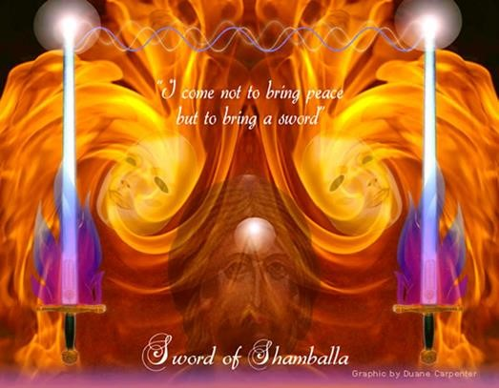

DK warned of the dangers of initiates from a previous solar system whose primary objective and motivation was to perfect the third, or matter aspect of creation. These initiates can be considered as a residue from past cycles of development and, however important their contributions may have been in the past, they should not be allowed to dominate modern civilization that is attempting to bring forth more of the love-wisdom vibration and its contributions of cooperation, compassion and higher light.
To give a simple illustration of these two different hierarchies (one working from above down, and the other from the bottom up), we need not look further than the work of the Master Jesus. While spreading His new ideas of unconditional love and compassion for one’s fellow man, He found it was not the ignorant masses that would come to cause Him so much difficultly and grief, as they were clearly more receptive to His deeper message. It was the existing Roman, political and military hierarchies, and the Jewish religious hierarchy, as well as the monetary groups, all of which had the most to lose if people en masse adopted Jesus’ new ideas of a spiritual democracy. The idea of the emergence of a new spiritual dispensation in which all people were seen as equal in the eyes of God, and therefore each person should be treated with the same respect and dignity, would clearly throw all of the existing systems and structures into total chaos.
What do we have today? Largely the same dynamic only on a higher turn of the spiral. Who are those who oppose this new spiritual dispensation and externalization of a new spiritual world order or hierarchy? The bankers, the huge corporations, the military and the pharmaceutical industries who have set themselves up as the exclusive custodians to guide and control humanity along lesser and more inferior lines.
Good intentions coming from a personal level, however well intended, should not be confused with the goodwill that comes from advanced disciples, the New Group of World Servers or the Will to Good coming from the masters and the spiritual hierarchy who understand a larger and more comprehensive plan. Yet the irony and paradox of this dynamic is that many of the individuals who work through these different materialistic organizations actually think that because they often have superior mental intelligence and an ability to manipulate and amass huge sums of money-prana, that they are making a huge contribution and advancing civilization forward. In some cases, and in certain ways, they actually are, but almost solely along the lines of the perfection of the form, as opposed to the perfection of the sprit destined to work through those evolving forms.
In summary, we could say that there are two opposing evolutions now taking place on the planet: the evolution of form and the evolution of the spirit. These two groups have become negatively polarized towards each other when they should be working collaboratively to found a new spiritual civilization and order, for a culture that would naturally include the best of the past as well as what is coming in the future.
Good people today are still being thrown to the lions and crucified under the same conditions in their belief and experience of a Living Christ who unconditionally loves all equally. One of the key things that has changed however is that the coliseum has been replaced with more subtle types of control, brutality and repression for any who go against the mainstream narrative and speak of a new and more powerful spiritual dispensation, or an age of enlightenment that is attempting to emerge.
In many respects, spiritual energy is impersonal and, as inconsistent as this next statement may seem, can actually (in the early stages of its influence or stimulation) bring out the negative in people long before the greater good actually takes hold or becomes incorporated into their way of life. It is a deep paradox that only an advanced student of the ageless wisdom teachings can fully understand – that good energy, in its early stages of impact on those initiates from a previous materialistic cycle, as well as average humanity, can be temporally used for selfish and materialistic gain. The personal weeds sometimes grow even faster and more abundantly in the human garden when the spiritual sun comes over the horizon and stimulates both the good and bad alike.
The paradox of this whole situation that we have outline here is that the materialistic hierarchies cannot see that their success has simply been the creation of a necessary foundation and infrastructure that advanced spiritual disciples and initiates will one day use to build and expand the real new world order and the new spiritual dispensation that will clearly be along higher and more noble lines. Each spiritual ray has its own inherent light and unique contribution, and each cyclically makes its mark on the spiritual history of humanity. However, there will always be friction and a clashing of opposites as one rises in ascendancy and another fades out, to become (what DK has designated in his momentous works as) simply a base or sub-note to the new emerging Aquarian energies and forces.
One of the inherent problem of this clash between the old order and the new spiritual dispensation is that this first wave of materialistic and selfish political and financial wizards that have become tenured on the earth (I am using my words with specific intent here), cannot see that they are just creating a foundation and that they in time, like all those who came before them, must pass the baton or evolutionary torch to those who are more advanced spiritually than themselves. Their children, and their children’s children, for all of their flaws and idiosyncrasies, will one day be seen and accepted as wiser and as more advanced than they are.
One conundrum of this situation is that because the people and organizations that have built this earlier material infrastructure have naturally become attached to what they created, there will be resistance and friction until they either have an interior revelation of a more spiritual future, or they cycle out of incarnation, thereby making way for the newer and more Aquarian egos.
CAPITALISM - WILL CAPITALISM EVER HAVE A HEART?
One need not go any further to show an example of this misuse of capital and political influence than the Second World War, where certain United States’ financiers funded both sides of the conflict granting credit for arms and munitions, which the warring parties would otherwise not have been unable to obtain by themselves. These financiers amassed huge profits at the expense of millions of young lives caught up in this mass conflict.
I understand this is an oversimplification of many complex issues that contribute to all wars, but it is nevertheless an accurate representation of those who have wielded financial power but lacked a sense of morality or ethics. The military industrial complex, including the military contractors, amass huge profits selling arms to nations all across the globe that only create more suffering and division. The US is clearly the leader in these arms sales and until more advanced people move into the political environment and make their voices heard this unfortunate situation will go on.
Uncontrolled capitalism and its unhealthy influence on the medical and pharmaceutical industries free and unbridled restraint brings the allure of quick profits and is often divorced from any type of ethics or conscience, and is a major contributing factor to the pollution and ecological crises the planet is now experiencing at this time.
Alice Bailey offered these insights into the problem of capitalism back in the 1940s:
… the cause of all world unrest, of the world wars which have wrecked humanity and the widespread misery upon our planet can largely be attributed to a selfish group with materialistic purposes … The responsibility for the widespread misery to be found today in every country in the world lies predominantly at the door of certain major interrelated groups of businessmen, bankers, executives of international cartels, monopolies, trusts and organizations and directors of huge corporations who work for corporate or personal gain.
Problems of Humanity, p. 71

The capitalistic spirit and the latent fascism of the United States are at this time a definite menace to world peace, and the capitalists are blocking the efforts of the men of goodwill. Esoteric Healing, p. 663

Power in the future lies in the hands of the masses. These masses are moving forward and by the sheer weight of their numbers, by their planned thinking and the rapidly growing interrelation now established between labor movements all over the world, nothing today can stop their progress. The major asset which labor has over capital is that it is working for countless millions whilst the capitalist works for the good of a few.

Problems of Humanity, p. 79

CAPITALISM TODAY
Another characteristic of the materialistic groups we have outlined throughout this paper is their creation of a social and business environment that pays people an absolute minimum to work in their factories, businesses or service industries, thereby encouraging dependence, not only upon them, but the additional stimulants or drugs that they often consume to keep the people going through an occupation that has become sheer drudgery. This minimum pay not only gives the employer more profit but creates a group of employees who are so overworked and underpaid that they cannot think of anything except what may be the next step ahead of them.
Add to this mix the improper eating habits (proper nutrition is often very expensive, particularly if you are vegan or vegetarian or take large amounts of healing vitamins, minerals and herbal supplements) and certain unhealthy addictions creates a vicious circle in which people become equally dependent on the medical profession, which is also prohibitively expensive. One dental filling, without insurance, costs on an average $200 to $600. If you’re making $15.00 dollars an hour at work your weekly pay does not go far.
These underpaid and overworked people often become apathetic over time, complacent and conforming to a system within which they are unknowingly held hostage. Working for corporations like Wal-Mart and McDonalds, we find many employees who are so underpaid that they are forced to rely on government food stamp programs. Imagine a huge corporation making profit margins of billions of dollars per year, as well, as their head CEOs making millions, yet relying on taxpayers to subsidize their employees’ meager wages.
Senator Bernie Sanders of Vermont, who commissioned a report on the Governments SNAP program described his findings as "outrageous" and called for companies to pay their workers more. Around 70% of people on Supplemental Nutrition Assistance Program (SNAP) food stamps and Medicaid work full-time, the watchdog found, and the majority of these worked for larger companies with 100 or more staff. Around 90% of SNAP and Medicaid beneficiaries worked for private sector employers such as restaurants, department stores, and grocery stores, the report found. On the upside, recent economic shifts due to the COVID-19 pandemic have finally given labor a chance to demand greater wages and better working conditions.
It is these same capitalistic economic and financial profiteers who think that global warming and the ecological crises we are presently experiencing is just another conspiracy theory, and if things do actually get difficult or go into a crises mode on a planetary level that they can just jump in their custom jets or yachts and hide out in their south seas paradises or hidden bunkers.
The recent discovery of micro-plastics in the environment are an example of the widespread pollution presently found in the world, much of which is the result of big industry’s failure to control their toxic discharges. Many micro-plastic as an example, that are known to cause numerous illnesses, are now found even in the human bloodstream as well as in the earth, air, and water, all over the world.
Capitalism has many creative and constructive facets and clearly gives people an incentive to forge ahead and be innovative, thereby reaping the benefits of their hard work and labor. A welfare state can clearly destroy people’s incentive to do their part and contribute to a greater whole. Communism and socialism clearly have their own problems and issues and no effort is made here to evaluate all of different political or economic systems. Perhaps if the very best qualities were distilled from all the major economic and political systems of the world, and their best qualities combined, we might have a better system. Until we have better people who are better informed we will never have better economic systems no matter who is in power and by what labels or names they go by.
https://www.businessinsider.com/bernie-sanders-walmart-mcdonalds-food-stampshttps://www.businessinsider.com/bernie-sanders-walmart-mcdonalds-food-stamps-medicaid-minimum-wage-2020-11medicaid-minimum-wage-2020-11
Duane Carpenter - Admin for the Reappearance of the Christ Facebook site:
Seoos5rl,h2611c0tM4 420ih30 a ·

EXTERNALIZATION OF THE 3RD RAY ASHRAM
The corona virus crises is estimated to be eclipsed by the financial losses from unemployment, decline in business and commerce, stock prices, and plunging consumer confidence – to name just a few of the most obvious. Many experts have considered this economic crises to be the perfect economic storm of this century with… creeping worldwide inflation, and the spread of fear concerning the corona virus on an international level.
The current U.S. administration that has been slow to respond to this crises may have further aggravated these condition by their failure to alleviate people’s fears and uncertainty about the future as this crises just widens and become more acute. This website is primarily an expression of the 2nd ray, although all of the 7 divine rays are expressed here in different ways and at different times.
The financial reconstruction of the world economies and the emergence of new systems of business will fall primarily under the 3rd ray and its ashramic expression. The old financial systems that have benefited the few, and marginalized the many are now in crises and under pressure to change. This economic crises for all of its difficulties and discomfort will help usher in and is a part of a new and more equitable system of financial governance. What the political progressives may have failed to achieve on their own with programs like medicare for all, may now emerge organically out of the practical need to control the corona virus that is clearly spreading exponentially.
The Master DK had this to say about the externalization of this 3rd ray ashram and the effect it would have on world economies.
The first Ashram to do so will be that of the third ray; by the time disciples appear from that Ashram the world will be ready for an all-over financial adjustment; the "principle of sharing" will be a recognized motivating concept of the new civilization. This will not involve beautiful, sweet and humanitarian attitudes. The world will still be full of selfish and self-seeking people, but public opinion will be such that certain fundamental ideals will motivate business, being forced upon business by public opinion; the fact that the new general ideas will in many cases be governed by the expediency of interplay will not basically matter. It is the sharing that is of importance. When the "adjuster of finances" (as an advanced disciple from this Ashram is called in the Hierarchy) appears, he will find conditions greatly changed from those now prevalent, and this to the following extent:
The principle of barter and of exchange (to the benefit of all concerned) will control. Owing to the development of atomic energy on behalf of human welfare, * national currencies will have been largely superseded, not only by a system of barter but by a universal monetary exchange [crypto-currencies?] representative of the bartered goods when they are relatively small and unimportant—and by a planned scale of related values. National material assets and the needed commodities will all be provided for under an entirely new system. 3. Private enterprise will still exist, but will be regulated; the great public utilities, the major material resources and the sources of planetary wealth—iron, steel, oil and wheat, for instance—will be owned in the first place by a governing, controlling international group; they will, however, be prepared for international consumption by national groups chosen by the people and under international direction.
Upon this subject I have no time to give, and besides this, anything I could say would be regarded as visionary and impractical in a world which has not yet been subjected to the educational processes of the disciples and initiates on the first, second and fifth rays or to the fundamental changes which the new generation of young people (now growing up) will shortly inaugurate.
Externalization of the Hierarchy, p. 582

* This may also refer to the harnessing of electricity in new and creative ways or the use of new types of fusion that produce no radiation or toxic by-products. See the Safire Project. https://www.safireproject.com/ and Permafusion.org at this link. https://www.youtube.com/watch?v=SmZ59U_oq-c
THE CAPITALISTIC SYSTEM HAS EMERGED AND WRECKED THE WORLD
From the feudal barons of Europe and Great Britain in the Middle Ages through the powerful business groups of the Victorian era to the handful of capitalists (national and international) who today control the world's resources, the capitalistic system has emerged and has wrecked the world.
This group of capitalists has cornered and exploited the world's resources and the staples required for civilized living, they have been able to do this because they have owned and controlled the world's wealth through their interlocking directorates and have retained it in their own hands. They have made possible the vast differences existing between the very rich and the very poor; they love money and the power which money gives; they have stood behind governments and politicians; they have controlled the electorate; they have made possible the narrow nationalistic aims of selfish politics; they have financed the world businesses and controlled oil, coal, power, light and transportation; they have controlled publicly or sub rosa the world's banking accounts.
The responsibility for the widespread misery to be found today in every country in the world lies predominantly at the door of certain major interrelated groups of business-men, bankers, executives of international cartels, monopolies, trusts and organizations and directors of huge corporations who work for corporate or personal gain. They are not interested in benefiting the public except in so far that the public demand for better living conditions will enable them—under the Law of Supply and Demand—to provide the goods, the transportation, light and power which will in the long run bring in heavier financial returns. Exploitation of man-power, the manipulation of the major planetary resources and the promotion of war for private or business profit are characteristic of their methods.
In every nation, such men and organizations—responsible for the capitalistic system— are to be found. The ramifications of their businesses and their financial grasp upon humanity were, prior to the war, active in every land and though they went underground during the war, they still exist. They form an international group, closely interrelated, working in complete unity of idea and intention and knowing and understanding each other. These men belonged to both the Allied Nations and the Axis Powers; they have worked together before and through the entire period of the war through interlocking directorates, under false names and through deceptive organizations, aided by neutrals of their own way of thinking. Today, in spite of the disaster which they have brought upon the world, they are again organized and renewing their methods; their goals remain unchanged; their international relationships remain unbroken; they constitute the greatest menace mankind faces today; they control politics; they buy prominent men in every nation; they insure silence through threat, cash and fear; they amass wealth and buy a spurious popularity through philanthropic enterprise; their families live soft and easy lives and seldom know the meaning of God-ordained work; they surround themselves with beauty, luxury and possessions and shut their eyes to the poverty, stark unhappiness, lack of warmth and decent clothing, the starvation and the ugliness of the lives of the millions by whom they are surrounded; they contribute to charities and church agencies as a salve to their consciences or to avoid income taxes; they provide work for countless thousands but see to it that these thousands receive so small a wage that real comfort, leisure, culture and travel are impossible.
The above is a terrible indictment. It can, however, be substantiated a thousand times over; it is breeding revolution and a growing spirit of unrest. The masses of the people in every land are aroused and awakening and a new day is dawning. A war is starting between the selfish monied interests and the mass of humanity who demand fair play and a right share of the world's wealth. Problems of Humanity, pp. 71-73

HOW LONG WILL IT TAKE FOR
COOPERATION TO REPLACE COMPETITION?
Chris Hedges, the political and social reformer, in his book Americas Farewell Tour, states that there are three different types or levels of capitalism:
The local, where someone who lives in a given community and shares resources through a fair system of trade using services, goods or a fiat system of money and exchanges things of value. It is a local system of exchange in which everyone benefits.
The intermediate, where some business person in the larger community employs people at a living wage to assist in running or building their business. This individual reaps the benefit of this capitalist system but pours much of his profits back into the community to help those less fortunate than themselves or helps build certain social programs.
The corporate, a type of capitalism or huge mega-businesses who employ people at slave-wages, often from other third world countries and most profit is not poured back into the local community but is often removed from that community, state, or even country from which this wealth was originally derived.
More by Chris Hedges: https://www.youtube.com/watch?v=zV3HDZEkynM
https://carnegieendowment.org/2018/09/14/relentlessly-dark-indictment-of-globalhttps://carnegieendowment.org/2018/09/14/relentlessly-dark-indictment-of-global-capitalism-pub-77258capitalism-pub-77258

EVIL IS THE GOOD THAT SHOULD HAVE BEEN LEFT BEHIND
Everything outlined in this commentary around the tension or conflict between material and spiritual forces can be summed up in a quote extracted from DK’s works.
You have here a hint as to the nature of evil and a clue to a part (though only a part) of the mystery to be noted in the statement that evil and good are reverse aspects of the same one reality, and evil is that good which we should have left behind, passing on to greater and more inclusive good. Forget not that the black magicians of today were the initiates of a previous solar system. When the door of initiation is ready to open for the third time, the parting of the ways takes place. Some follow selfish intention and the fixed determination to remain with the separative condition of matter; and to others, the divine will is clearly impressed upon them and becomes the motivating power in their lives.

The Rays and The Initiations, p. 351
THE NEW WORLD ORDER AND ITS IMPORTANT REQUIREMENTS.
The Master DK had this to say on the idea of a new world order and some of its important requirements that should be met. This concept of a NWO has unfortunately been high-jacked by these lesser materialistic groups and given a whole different interpretation or twist which was never meant to be, and is far removed from the original concept put forth by Alice Bailey as far back as the 1940s.
Both of these two diametrically opposed NWO groups that we have outlined here are seeking to unify and amalgamate humanity into one corporate body but for completely opposite purposes, one to control and subjugate humanity, and the other to uplift and unify.
- The new world order will be founded on the recognition that all men are equal in origin and goal but that all are at differing stages of evolutionary development; that personal integrity, intelligence, vision and experience, plus a marked goodwill, should indicate leadership. The domination of the proletariat over the aristocracy and bourgeoisie, as in Russia, or the domination of an entrenched aristocracy over the proletariat and middle classes, as has been until lately the case in Great Britain, must disappear. The control of labour by capital or the control of capital by labour must also go.
- In the new world order, the governing body in any nation should be composed of those who work for the greatest good of the greatest number and who at the same time offer opportunity to all, seeing to it that the individual is left free. Today the men of vision are achieving recognition, thus making possible a right choice of leaders. It was not possible until this century. …
- The new world order will be founded on an active sense of responsibility. The rule will be "all for one and one for all." This attitude among nations will have to be developed. It is not yet present.
- The new world order will not impose a uniform type of government, a synthetic religion and a system of standardisation upon the nations. The sovereign rights of each nation will be recognised and its peculiar genius, individual trends and racial qualities will be permitted full expression. In one particular only should there be an attempt to produce unity, and that will be in the field of education.
- The new world order will recognise that the produce of the world, the natural resources of the planet and its riches, belong to no one nation but should be shared by all. There will be no nations under the category "haves" and others under the opposite category. A fair and properly organised distribution of the wheat, the oil and the mineral wealth of the world will be developed, based upon the needs of each nation, upon its own internal resources and the requirements of its people. All this will be worked out in relation to the whole.
- In the preparatory period for the new world order there will be a steady and regulated disarmament. It will not be optional. No nation will be permitted to produce and organize any equipment for destructive purposes or to infringe the security of any other nation. One of the first tasks of any future peace conference will be to regulate this matter and gradually see to the disarming of the nations.
These are the simple and general premises upon which the new world order must begin its work. These preliminary stages must be kept fluid and experimental; the vision of possibility must never be lost, and the foundations must be preserved inviolate, but the intermediate processes and the experimentations must be carried forward by men who, having the best interests of the whole at heart, can change the detail of organization whilst preserving the life of the organism.
Esoteric Healing, pp. 191-192

9. In the preparatory period for the new world order there will be a steady and regulated disarmament. It will not be optional. No nation will be permitted to produce and organize any equipment for destructive purposes or to infringe the security of any other nation. One of the first tasks of any future peace conference will be to regulate this matter and gradually see to the disarming of the nations.
Externalization of the Hierarchy, p. 192

CONCLUSION

THE CORONA VIRUS AND THE NEW LAW OF LOVE
Someday another phase of the Secret Doctrine will be given and the significance of the Heart of God and its vibratory quality of love will be presented, and will be seen as the attractive agent producing meaning, evolutionary possibility and coherence and this underlying the created manifested world.
Sept 21,1947. The Tibetan Master Djwal Khul’s Unpublished Writings

Humanity, collectively, is at the crossroads and man will either learn and incorporate this new Law or presentation of Love into his life or he will continue to slowly destroy the planetary eco-system and possibly perish with it. Master Morya in the Agni Yoga series of books indicated that if man continues at his present course of destruction it may be necessary to separate humanity and transfer large groups of spiritual disciples to another system and leave the chaos on the planet to those laggards who created it.
Is it possible that only a global world crises like the coronavirus can help people awaken from their united sleep and inability to see a larger group and planetary perspective? To help unite a race of men whose natural propensity is largely one of separatism and selfishness? A planetary crises of such immense proportions that it would dissolve the false ideas that there are existing boundaries between individuals, nations, and whole races of people?
When men cannot do with their own free will what is required to get to the next level of evolutionary development, certain restrictions may be levied upon them by the great Lords of karma whose deeper mission is not simply to extract due service for past or present errors, nor any type of retribution as it is commonly believed, but on a far higher turn of the spiritual spiral set in motion those adjustments that will help them to awaken to this new and greater Law of Love.

It is this condition of a loving constitution and an opening of the heart that will give the needed respect for this magnificent planet upon which we live and call our home. Simply accruing more information about these debilitating world and environmental conditions may be an important place to start, but without a parallel in actions, more knowledge has clearly demonstrated it is not enough. Men need to be inspired and motivated emotionally, and from the deepest recesses of their hearts and souls to take the needed actions to help restore balance and integrity to the planet.
It has been said by certain indigenous groups around the world that man is the only creature that will soil his own nest, whereas all other creatures or units of evolving life in the animal kingdom will keep their homes, be it a small nest high in the trees or a dark cave, free from contaminants.
This new Law of Love is not some vague idealism but the foundation of a new set of principles and laws that will govern the Age of Aquarius we are now moving into.
Let us now end this section with the eloquent words of H. P. Blavatsky who had more than her share of trials and tests but was still able to nevertheless persevere and finally find her true home amongst the stars.
... All the glories of Nature .. the aroma of the flowers ... the stars, flowers of the fire strewn over the sky; the glow worms ... all these have been created to render the Adept worthy of Nature, at the moment when for the first time she exclaims ... 'I am yours,' – words formed of a divine perfume of the soul, which, breathed forth, ascend to heaven together with the perfume of the flowers .. it is the moment which expiates and pays for a whole life of bitter regrets … that moment – it is the price of all our miseries.
The Secret Doctrine, H.P. Blavatsky

